Paragraph writing

Be Done by Edgar Albert Guest

It Couldn’t Be Done by Edgar Albert Guest
‘It Couldn’t Be Done’ by Edgar Albert Guest is a poem with an uplifting message about never giving up. The narrator of the poem encourages the reader not to be discouraged by the pessimism of others.
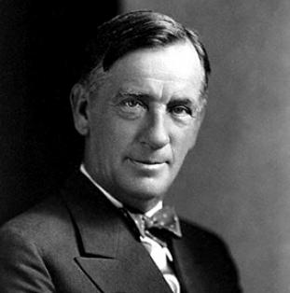 Edgar Albert Guest’s poem ‘It Couldn’t Be Done‘ is a motivational poem that encourages the reader not to give up easily. The poem is a warning that throughout life, people will tell you that certain things are impossible to achieve and that you should quit. The narrator of the poem states that many people have accomplished things that were allegedly impossible once they put their minds to it. The narrator argues that if you go into a task with a positive attitude and the will to succeed, you will be victorious.The poem ends with the narrator speaking directly to the reader about the message of the poem. The narrator states that there are thousands of things that people will say are impossible and that people will try to get you to give up before you even try. But, if you go in with a positive attitude, you can achieve it. ‘It Couldn’t Be Done‘ is a motivational poem that encourages the reader to never give up. The main theme of the poem is to believe in yourself. The poem is also a warning not to listen to negative or discouraging people.
In addition, the poem also tells the reader not to worry if something seems impossible to accomplish. Instead, give it your all, go in with a positive attitude, and you just may be able to do it.The poem begins with somebody telling the protagonist that something “couldn’t be done”. The protagonist then says that he would not say for sure until he gave it a try. He then goes into the task with a positive attitude and confidence, which produces positive results. He ends up proving that he could do it. The next stanza of the poem progresses very similarly to the first: someone tells the protagonist that a task is impossible, and he once again refuses to give up. He goes into the task with the same confidence, and he ends up completing it. The poem is 3 stanzas long, with each stanza being 8 lines long. The poem mostly follows an ABAB rhyme scheme, but doesn’t always follow a set formula throughout .Edgar Albert Guest was an American poet, though originally born in Britain. Guest’s poetry became extremely popular in the early half of the 20th century. He started his career writing poetry for a newspaper column, but eventually wrote his own poetry collections. His first poetry collection, “A Heap O’ Livin'” (1916) was incredibly successful. He released 4 other poetry collections; “Just Folks”(1918), “Rhythms of Childhood” (1924), “Life’s Highway” (1933), and “Living the Years” (1949).

By Abheek panigrahi class 8 section c school number 3571

