CLASS: VII
SUBJECT:BIOLOGY
LESSON-EXCRETION IN HUMANS
Date: 25/01/2022 HOMEWORK
What is structural and functional unit of kidney?
How do unicellular organisms excrete their waste?
Do plants have any particular excretory organ?
Name the excretory product and the excretory organ in: a) man b) bird c) fish.
Label the parts of Urinary system and give their role:
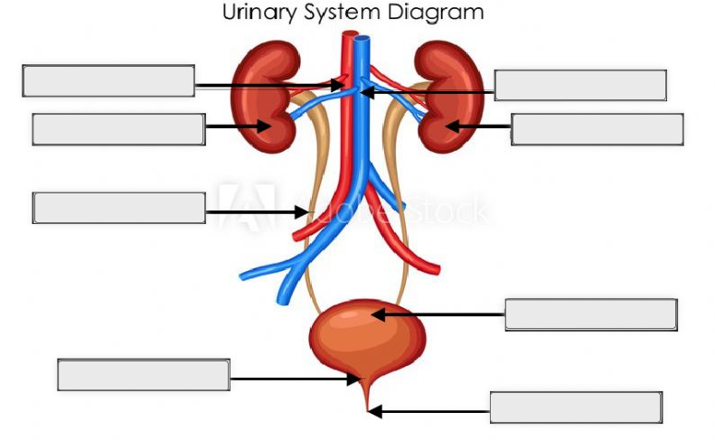
8. Complete the following paragraph:
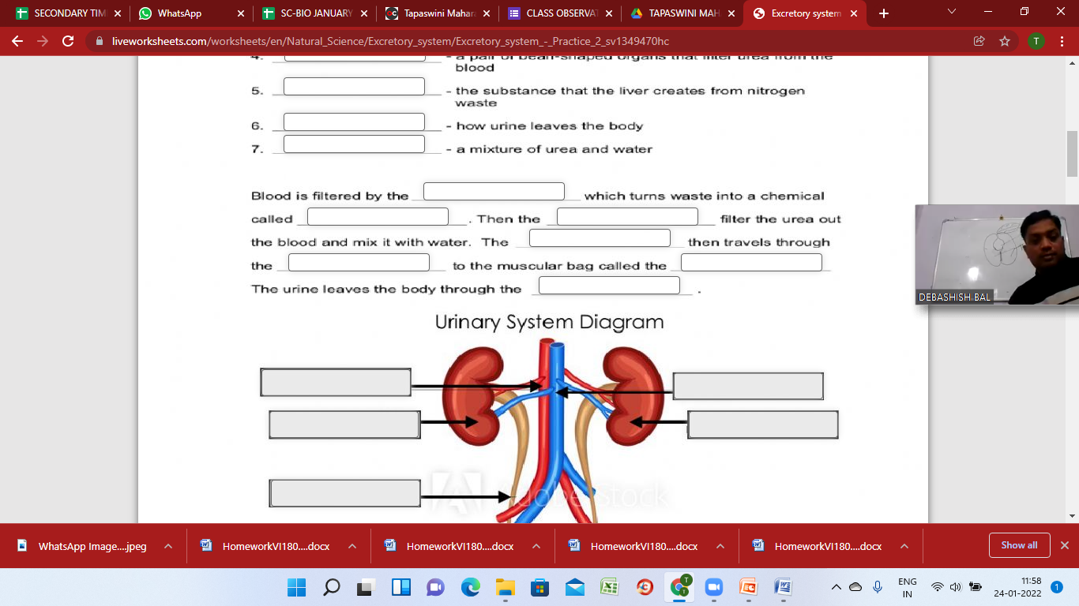
9. Identify the part of Human Urinary System that exhibits the following function:
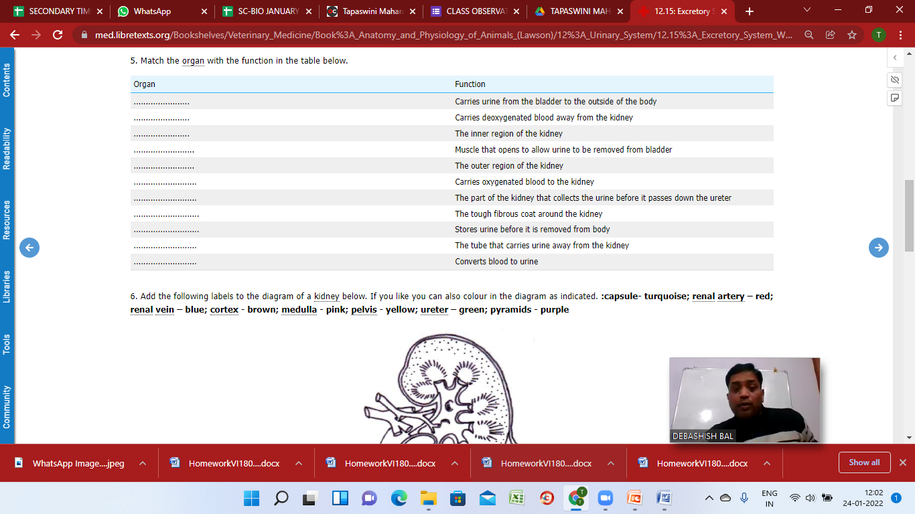
10. Identify and label the following parts of the Nephron and briefly describe their functions:
