
STRUGGLE FOR INDEPENDENCE
CONGRESS MINISTRIES-1937
SUBJECT : HISTORY
CHAPTER NUMBER:14
CHAPTER NAME :STRUGGLE FOR INDEPENDENCE

THE STRUGGLE FOR INDEPENDENCE
CONGRESS MINISTRIES-1937 SESSION-4
The Second World War broke out in September 1939.
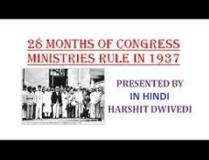
The Congress Leaders were ready to support the British war effort. But in return they wanted that India be granted Independence after the war. The British refused to Concede the demand and the Congress ministers resigned in protest.
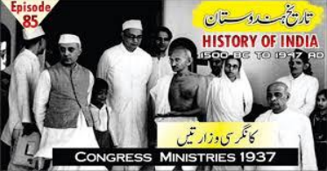
THE STRUGGLE FOR INDEPENDENCE
TWO NATION THEORY
Mohammad Ali Jinnah, the president of the Muslim League, was insistent that it be recognized as the sole representative body of the Muslim Community in India. So he put forward the Two-Nation Theory according to which Hindus and Muslims were not merely separate religious communities but were also culturally and racially different. They were therefore two separate nations.
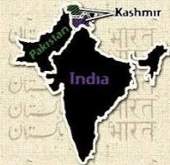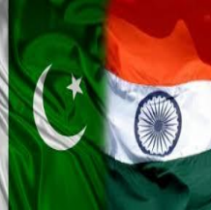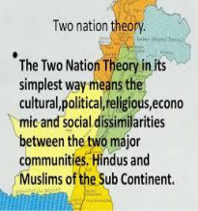
THE STRUGGLE FOR INDEPENDENCE
THE CRIPP’S MISSION
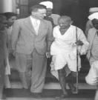
● The Indian Political situation underwent a dramatic change when in December 1941 Japan entered the war on Germany’s side. BY March 1942 the Japanese had reached Burma and an invasion of India seemed imminent. The British govt realized the desperate need for India’s help. In March 1942, it sent a mission to India headed by Sir Stafford Cripps to secure India’s co-operation in the War effort. The Cripps mission failed because the British refused to accept the Congress demand for immediate transfer of power to Indians
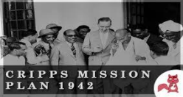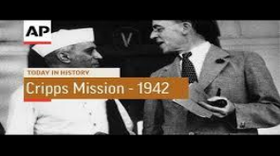
THANKING YOU
ODM EDUCATIONAL GROUP

