
STRUGGLE FOR INDEPENDENCE
THE SWARAJ PARTY-1923
SUBJECT : HISTORY
CHAPTER NUMBER: 14
CHAPTER NAME :STRUGGLE FOR INDEPENDENCE
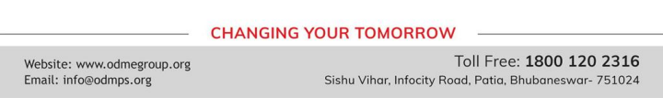
STRUGGLE FOR INDEPENDENCE
THE SWARAJ PARTY session-2
After the withdrawal of the Non-Cooperation Movement, the Congress broke up in to two main groups. In 1923 one group led by C.R Das and Motilal Nehru formed the Swaraj Party. Chittranjan Das and Motilal Nehru argued that the party should fight elections to the councils and enter them in order to influence government policies.So they formed a party called Swaraj Party. They thought they could obstruct the working of the British Government from within. They won a large number of seats in the central Legislative Assembly in 1923.
The other fraction of the Congress wanted to boycott the legislative councils. it was involved in the Constructive Programme proposed by Gandhi. Gandhi’s Constructive Programme included spinning Khadi, Hindu-Muslim Unity, and the removal of Untouchablity. This group included Dr Rajendra Prasad, Dr M.A Ansari and Sardar Vallabhai Patel. Later the two groups merged.
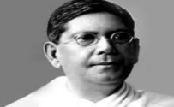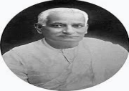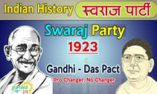
STRUGGLE FOR INDEPENDENCE
THE SIMON COMMISSION
Lord Reading was the viceroy of India from 1921 to1926He believed that the growing national movement could be easily suppressed if further constitutional reforms were carried out. With this end in view the British govt appointed a commission under sir John Simon in 1927.The main purpose of the Simon Commission was to take a decision on self govt for India.
But a single Indian member was included in the Simon Commission. So Indians decided to boycott it. when Simon Commission arrived in India from England in February 1928, it was greeted with demonstrations, black flags and slogans, Simon Go Back.
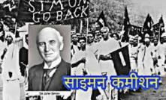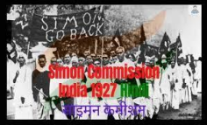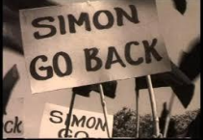
STRUGGLE FOR INDEPENDENCE
THE MOTILAL NEHRU COMMITTEE
● In response to the Simon Commission, the Indian leaders decided to draw up a constitution for India that was acceptable to all. All parties Conference met in 1928 and appointed a committee headed by Motilal Nehru to draft a Constitution.
● In December 1929 the Congress met for its annual session at Lahore with Nehruji as the president. The Congress adopted a resolution that declared Purna Swaraj or complete independence to be its objective. On 31 December 1929, the newly adopted tricolour flag was hoisted.
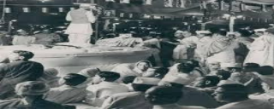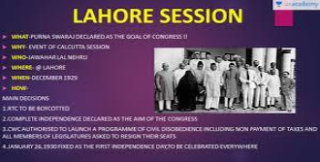
THANKING YOU
ODM EDUCATIONAL GROUP

