
THE STRUGGLE FOR INDEPENDENCE
MAHATMA GANDHI-1869-1948
SUBJECT : HISTORY
CHAPTER NUMBER:-14
CHAPTER NAME :THE STRUGGLE FOR INDEPENDENCE.

THE STRUGGLE FOR INDEPENDENCE
MAHATMA GANDHI-1869-1947 session-1
Mohan Das Karamchand Gandhi was born in Porbandar, Gujarat. After studying law in England, he went to South Africa and practiced law. Appalled by the ill-treatment of coloured people by the ruling white minority of South Africa, Gandhiji moved to fight for their rights. Here he developed the concept of Satyagraha. The word satyagraha indicated the non-violent nature of his struggle against injustice.
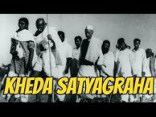
Mahatma Gandhi spent his initial years in India travelling throughout theCountry, understanding the people, their needs and the overall situation. Gandhiji launched local movements in Champaran, Kheda and Ahmedabad in which he received success.
(vii) Gandhiji’s method of fighting was known as Satyagraha which was
based on the principles of- Truth & Non-Violence
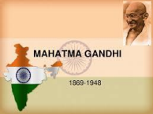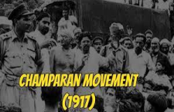
THE STRUGGLE FOR INDEPENDENCE
Rowlatt Act(1919)
In 1919, the government passes the Rowlatt Act and empowered the
provincial government to search any place and arrest any person whom it
Suspected without a warrant.
(ii) Gandhiji launched a Satyagraha against the Rowlatt Act which curbed the fundamental rights such as the freedom of expression and strengthened police powers.
(iii) Mahatma Gandhi and Mohammad Ali Jinnah criticized the act as ‘‘devilish ‘and tyrannical.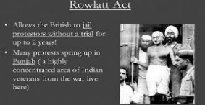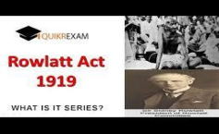
THE STRUGGLE FOR INDEPENDENCE
The Jallianwala bagh massacre
On April 13th 1919, on the day of Baisakhi, people gathered at JallianwalaBagh for celebration and for public meeting.
General Dyer, a British officer entered Jallianwala Bagh locked all the Entries and ordered his troops to start firing at the crowd.
Thousands of people were killed.
The country was shocked by this incident. All national leaders protested strongly against this cruel act.
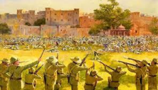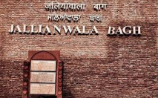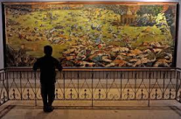
THANKING YOU
ODM EDUCATIONAL GROUP

