
WELCOME TO THE VIRTUAL CLASS

SOCIAL SCIENCE
SUBJECT : HISTORY
CHAPTER NUMBER: 02
CHAPTER NAME : NATIONALISM IN INDIA
PPT: 3 of 6

Rowlatt Act[1919]
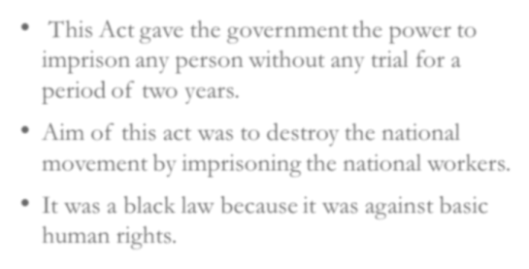


• This Act gave the government the
power to imprison any person without any
trial for a period of two years.
• Aim of this act was to destroy the national
movement by imprisoning the national
workers.
• It was a black law because it was against
basic human rights.


WRITE A SHORT NOTE ON
THE ROWLATT ACT.

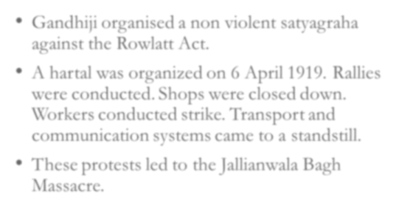
• Gandhiji organised a non violent satyagraha against the Rowlatt Act.
• A hartal was organized on 6 April 1919. Rallies were conducted. Shops were closed down.
Workers conducted strike. Transport and
communication systems came to a standstill.
• These protests led to the Jallianwala Bagh
Massacre.
WHAT CIRCUMSTANCES
TO THE JALLIANWALA BAGH ^{LED} MASSACRE?
• On 13 April 1919, a public meeting was organized at Jallianwala Bagh in Amritsar to protest against the arrests of national
leaders.
• Many villagers who came to attend a fair were also present in the park.
• General Dyer reached the meeting place along with the British troops. He ordered the troops to fire. The firing lasted for nearly 10 minutes.
• More than thousand people were killed and many were
wounded. This incident is called Jallianwala Bagh Massacre.
THANKING YOU
ODM EDUCATIONAL GROUP

