
WELCOME TO THE VIRTUAL CLASS

SOCIAL SCIENCE
SUBJECT : HISTORY
CHAPTER NUMBER: 02
CHAPTER NAME : NATIONALISM IN INDIA
PPT: 2 of 6

FIRST WORLD WAR BROKE
OUT IN 1914
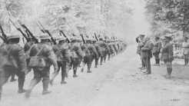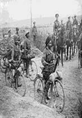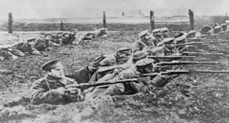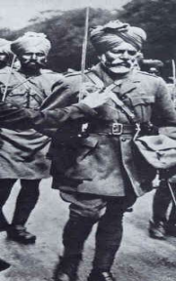
HOW DID THE FIRST WORLD WAR HELP IN THE GROWTH OF
NATIONALISM IN INDIA?
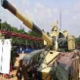Crop failures resulted in
The British imposed war expenditure on India. Income tax was
introduced. Customs duties were raised.
Prices of essential goods doubled during the war period.
Forced recruitment was made in to the British Indian army.
shortage of food materials. Influenza epidemic spread in many parts of India. Millions of people lost their lives.
THANKING YOU
ODM EDUCATIONAL GROUP

