
WELCOME TO THE VIRTUAL CLASS

SOCIAL SCIENCE
SUBJECT : HISTORY
CHAPTER NUMBER: 02
CHAPTER NAME : NATIONALISM IN INDIA
PPT: 1 of 6


NATIONALIS M

NATIONALISM IN
INDIA
NATIONALISM
• Nationalism is the feeling of oneness among the people living in a territory.
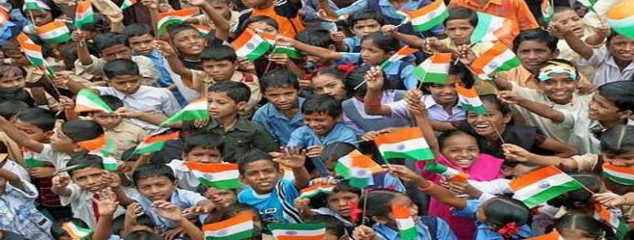
LEARNING OUTCOMES

The Pupil will be able to:-
•Comprehend the topic taught in class VIII.
• Understand the meaning of Nationalism.
•Realize the need and importance of Satyagraha. •Analyze the importance of Truth and Non-Violence.
•Identify the different places where Mahatma Gandhi
started his initial Satyagraha.
WHAT IS THE IDEA OF
SATYAGRAHA?

• Satyagraha literally means holding on to truth or truth force.
• It was a non-violent struggle introduced by Gandhiji in the Indian National Movement.
• It persuades the opponent to understand the truth.
• If the cause was true and if the fight was against injustice then physical force was not necessary to fight the oppressor. • Hunger strike, peaceful demonstrations, strike, hartal and non cooperation with the government are some methods of Satyagraha
GANDHIAN SATYAGRAHA
• Gandhiji came back to India in 1915.He introduced a new powerful method of struggle called
Satyagraha.
FIRST THREE SATYAGRAHA MOVEMENTS ORGANISED BY MAHATMA
GANDHI
•Champaran Movement [1916]: It was a movement of workers in the indigo plantations of the Champaran district of Bihar. It was against the oppressive plantation system.
•Kheda Movement[1917]: Crop failure and plague epidemic made the life of the farmers miserable in the Kheda district of Gujarat.
•Mill Workers Movement: Low wages and poor working conditions forced the mill workers of Ahmadabad to start a movement under Gandhiji’s leadership in 1918.
THANKING YOU
ODM EDUCATIONAL GROUP

