CLASS: VII
SUBJECT:BIOLOGY
LESSON-NERVOUS SYSTEM
Date: 23/11/2021 HOMEWORK

The Human Brain
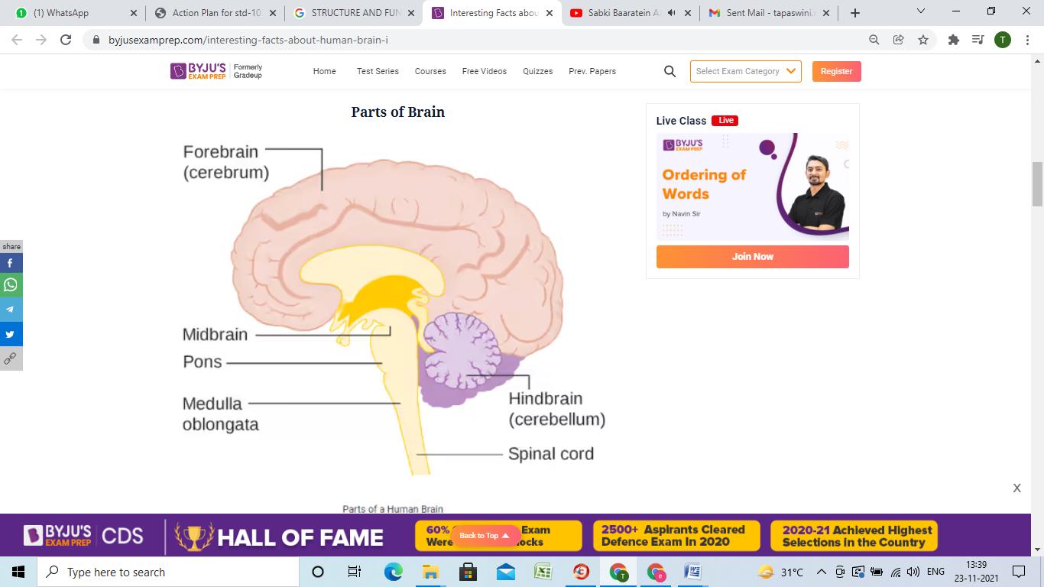
- On average, an adult brain weighs between 1.0 kg – 1.5 kg.
- It is mainly composed of 86-100 billion neurons.
- The brain, along with the spinal cord, constitutes the central nervous system. It is responsible for thoughts, interpretation and origin of control for body movements.
- The brain is enclosed within the skull, which consists of 22 bones, 14 of which form the facial bones and the remaining 8 form the cranial bones. The brain is contained within the cranium and is surrounded by the cerebrospinal fluid.
- The Cerebrospinal Fluid (CSF) is a fluid that circulates within the skull and spinal cord and acts as a buffer for the brain, buoyancy for the brain, cushioning mechanical shocks and dampening minor jolts.
- It also provides basic immunological protection to the brain.

Parts of Human Brain
Following are the major parts of the human brain:

Forebrain – Largest part of the brain
The forebrain parts include: Cerebrum, Hypothalamus and Thalamus
Forebrain Function: Controls the reproductive functions, body temperature, emotions, hunger and sleep, thinking, creativity, reasoning, speech articulation, voluntary functions.
Midbrain: Smallest and central part of the brain
The midbrain consists of: Brain stem
Hindbrain: The lower part of the brain
The hindbrain is composed of Cerebellum, Medulla, Pons
Hindbrain functions: The three regions of the hindbrain coordinate all processes necessary for survival. These induce breathing, heartbeat, sleep, wakefulness and motor learning.

Cerebrum: The cerebrum is further divided into four sections or lobes:
- Frontal lobe: It is associated with parts of speech, planning, reasoning, problem-solving and movements.
- Parietal lobe: Help in movements, the perception of stimuli and orientation.
- Occipital lobe: It is related to visual processing.
- Temporal lobe: This region is related to perception and recognition of memory, auditory stimuli and speech.
The cerebrum is responsible for thinking, intelligence, consciousness and memory. It is also responsible for interpreting touch, hearing and vision.
The brain consists of two types of tissues: Grey matter and White matter.
- Grey matter mainly consists of various types of cells, which make up the bulk of the brain.
- White matter is composed of axons, which connect various grey matter areas of the brain with each other.

Thalamus- The thalamus is responsible for relaying sensory information from the sense organs, transmitting motor information for movement and coordination, formation of new memories and storing past experiences.

Hypothalamus- The hypothalamus is involved in the following functions:
- Receives impulses, Controls the sense of taste and smell.
- Regulates body temperature
- Controls the mood and emotions
- Synthesizes the body’s essential hormones
- Coordinates the messages from the autonomous nervous system
- Controls appetite, peristalsis, the rate of heartbeat, and blood pressure

Cerebellum- It is mainly responsible for coordinating and maintaining the body balance during walking, running, riding, swimming, and precision control of the voluntary movements. The main functions of the cerebellum include:
- It senses equilibrium.
- Transfers information and coordinates eye movement.
- It enables precision control of the voluntary body movements.
- Predicts the future position of the body during a particular movement.
- Coordinates and maintains body balance and posture during walking, running, riding, and swimming.

Medulla Oblongata- The medulla mainly controls the body’s autonomic functions such as heartbeat, breathing, and digestion. Also, it helps us in maintaining our posture and controlling our reflexes.

Pons- The main functions of the pons include:
- Controlling sleep cycles.
- Regulating the magnitude and frequency of the respiration.
- Pons is also involved in sensations, such as the sense of taste, hearing and balance.
Exercise Questions:
1. Name the part of the brain that is responsible for thinking and creativity. [1]
2. What is meant by Meninges? Give its function. [2]
3. Describe the functions of hypothalamus. [2]
4. Name the three parts of the brain and briefly describe their functions. [5]



