SPORTS AND NUTRITION ‘CHAPTER-5’
LECTURE-1
Balance Diet, Nutrition (Macronutrient and Micronutrient)
BALANCED DIET: - A complete food, a diet that contains adequate amounts of all the necessary nutrients required for proper growth & maintenance of the body.
OR
A balanced diet is a diet that contains an adequate quantity of the nutrients that we require in a day. A balanced diet includes fat, protein, carbohydrates, water, fibre, vitamins, and minerals present in the foods that we eat.
FUNCTIONS OF BALANCED DIET:-
- Sufficient energy is given by a balanced diet.
- It helps an individual to grow and develop to an optimum level.
- Proper functioning of organs is done by a balanced diet.
- It helps to repair or replace the worn-out tissue.
- It helps to improve the overall health status.
- A balanced diet improves metabolism.
- It prevents deficiency diseases and maintains body weight thus the overall efficiency of the individual improves.
NUTRITION: - It is the process of obtaining & consuming food or breaking down food & substances taken in by the mouth to use for energy in the body.
NUTRIENTS: - The energic food in our diet consists of various types of essential chemicals for our body termed as nutrients. - E.g. Protein, fat, carbohydrates, vitamins & minerals. 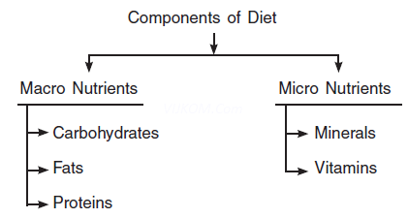
MACRONUTRIENTS: - Macro Nutrient is needed in large quantities they normally include carbohydrates, fat, protein, and water.
MICRONUTRIENTS: - As vitamins and minerals which are required in small quantities to ensure normal metabolism, growth, and physical well-being.
LECTURE-2
PROTEINS: - These are the basic structure of all living cells. Proteins are the main components of muscles, tendons, ligaments, organs, glands, and all living body fluids like enzymes hormones, and blood.
Proteins are needed for the growth & development of the body. It helps to repair or replace the worn-out tissues. It does not provide energy in a normal routine whereas it acts as an energy source only under extreme starvation. Proteins are required for making blood, muscle, Nails, skin, hair, and body parts and repair them and important in some situations like early development maturation, Pregnancy, etc.
CARBOHYDRATES: -
- Simple carbohydrate gives quick energy on the other hand complex carbohydrates release slow energy.
- The types of simple carbohydrates are Glucose, Galactose, Fructose, Maltose, Sucrose, and Lactose. The complex is starch, Glycogen, Dextrin, and Cellulose.
- Simple carbohydrate is sweeter than complex carbohydrates.
- Simple Carbohydrates can be absorbed quickly on the other side complex carbohydrates take time.
- Simple carbohydrates can be dissolved in water but complex carbohydrate is insoluble in water.

FATS: -
- Fats are store in the body and used as emergency sources of energy.
- Fats are important sources of energy for long-duration activities and important for the proper function of glands and other internal organs.
- It helps in the transportation of fat-soluble Vitamins A, D.E.K.
- It helps in blood clotting maintenance of skin & hair. Our diet should consist of 20%–25% of fat higher in take off at the high risk of obesity and many heart diseases.
- Fats maintain body temperature and protect them from the effect of external temperature.
- Fats make the body soft & oily.

WATER: -
Water is a very useful component of our diet because blood plasma comprises 91% of water; water comprises 75% of muscular weight & 70% of body weight. It is important for the secretion of waste produces. It regulates body temperature. Our body loses approximately 2% of our body weight or water per day. We compensate for this loss of water by drinking water and by the intake of food substances. It also functions as a lubricant keeps the skin moist and protects the body from shock. 20% of water intake comes from food and the remaining intake comes from direct drinking water.

NEED OF VITAMINS AND MINERALS: -
- They give the body energy
- They help carry out metabolic reactions
- They insulate the body’s organs
- They draw heat from the body

FUNCTION OF MICRONUTRIENTS: -
MINERALS: -
- Calcium: - It is required for bone and teeth formation, deficiently causes Osteoporosis, Rickets, and retorted growth.
- Iron: - It is required for the formation of Hemoglobin, deficiency of iron leads to Anemia.
- Phosphorus: - It helps to make strong bones and teeth.
- Sodium: - It helps the nervous system for better response, deficiency leads to cramps and tiredness.
- Iodine: - It helps in proper growth and development of the body, deficiency leads to goitre.
- Fluoride: - It helps the formation of teeth and nails.
- Chloride: - It helps the body to fight against infection, proper functions of the nervous system.

LECTURE-3
VITAMINS:
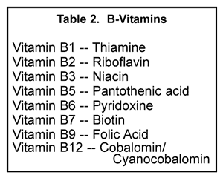

- VITAMIN A - Helps in normal growth and development of eyes and skin.
- VITAMIN D - Important for the formation of strong bones & teeth.
- VITAMIN E - It protects the cell membrane and acts as an antioxidant.
- VITAMIN K - Helps in Blood clotting and heals wounds.
- VITAMIN B - For growth & development.
- VITAMIN B₂ - Helps in the growth of RBC.
- VITAMIN B₃ - Play important role in energy transfer, reactions in the metabolism of glucose, fat & alcohol.
- VITAMIN B₅ - Involved in the oxidation of fatty acids & Carbohydrates.
- VITAMIN B₆ - It helps in the metabolism of amino acids.
- VITAMIN B7 - It plays a key role in the metabolism of lipids, proteins, and carbohydrates.
- VITAMIN B9 - Folic Acids are needed for normal cell division especially during pregnancy and infancy.
- VITAMIN B12 -It is involved in the cellular metabolism of carbohydrates proteins and lipids and helps in the production of RBC in the bone marrow.
ASSIGNMENT:
- What do you mean by macronutrients? Explain in brief about minerals as micro-nutrients in detail.
- What is a balanced diet? Explain the components of the diet.
- What are carbohydrates?
- What is Nutrition?
NUTRITIVE COMPONENTS AND NON-NUTRITIVE COMPONENTS OF A DIET WITH SOURCES: -
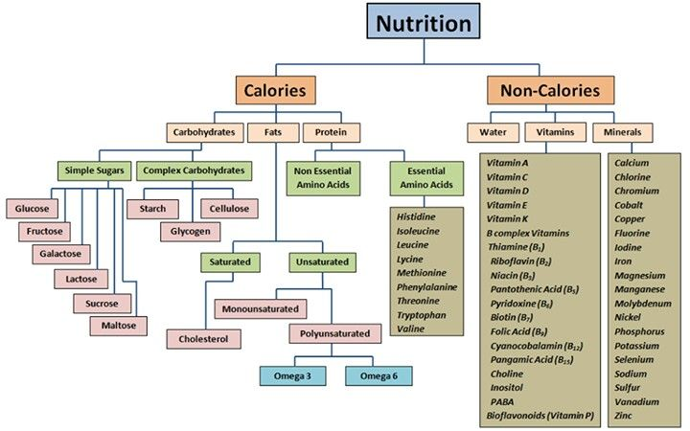SOURCES: -
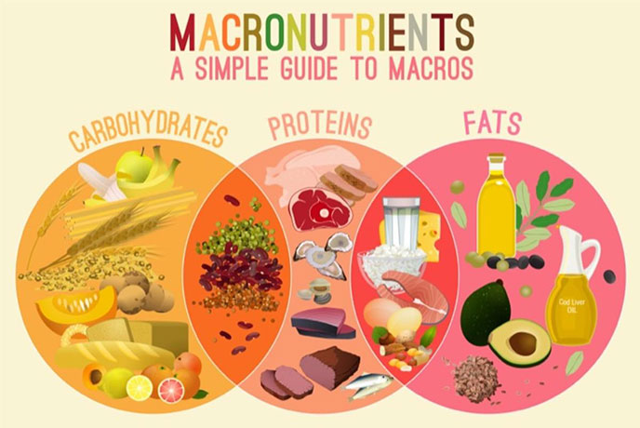

LECTURE-4
PROTEIN: -
(a) Animal Protein: - Protein, which we get from animal products, is called animal protein. Eggs, milk, milk products, meat, and fish
(b) Vegetable Protein: - Protein, which we get from vegetables, is called vegetable protein. Various types of pulses and beans, soya bean, mustard, green peas, nuts, groundnuts, dry fruits, and food grains.
CARBOHYDRATES: -
Generally, carbohydrate is found in rice, maize, jowar, bajra, pulses, gram, dry pea, dates, grapes, potato, banana, gur, sugar, etc.
FATS: -
(a) Animal Sources: Animals are a good source of fats. We get various products from animals such as ghee, butter, cheese, curd, fish oil, milk, meat, and eggs.
(b) Vegetable Sources: We also get fats from various vegetables such as unprocessed starchy vegetables such as sweet potato, whole corn, dry fruits, coconut, soya bean, food grains, mustard oil, cottonseed, etc.
FAT SOLUBLE VITAMIN:

VITAMIN A: Vitamin A is found in Cord liver Oils/animals Liver, yolk, Milk, & Milk products, carrot.

VITAMIN D: Vitamin D is found in milk, fish, and Liver oils Vitamin E is found in Green leafy Vegetables, Pulses, eggs, cereals.

VITAMIN E: Important for growth of many organs in our body, Its deficiency may cause anemia, or low blood count. main sources of green vegetables, kidney,liver, heart,cotton seed,milk,butter

VITAMIN K: Its main sources are tomatoes, Potatoes, Spinach, cabbage, soya bean, fish, cauliflower, wheat, eggs, and meat.

LECTURE-5
TYPES & SOURCES OF VITAMINS: -
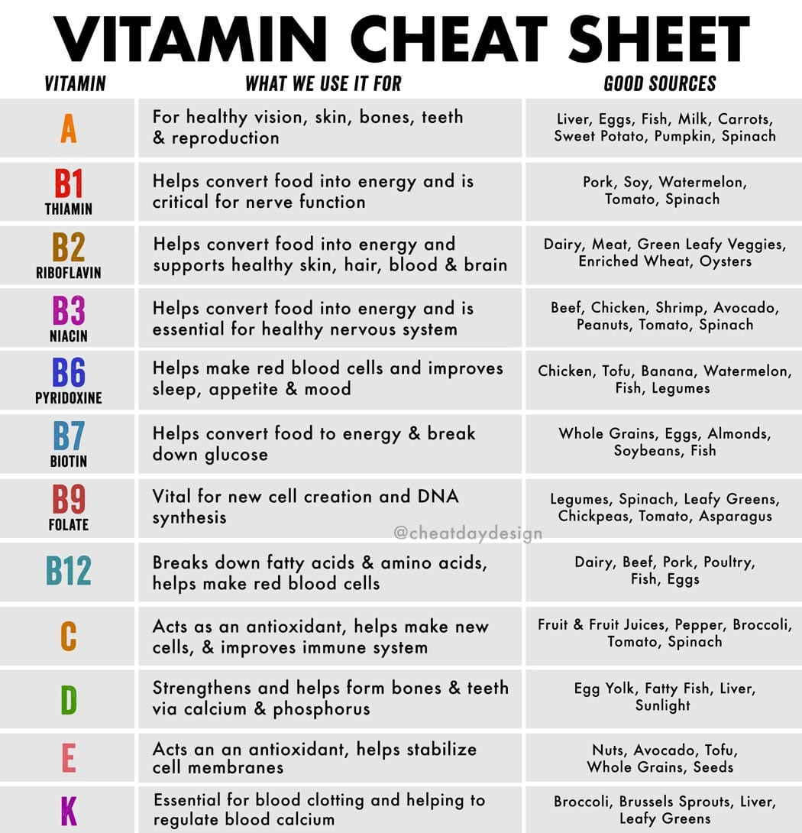

WATER SOLUBLE VITAMINS:
VITAMIN B COMPLEX
B2 -- We can find in eggs, dark green vegetables, legumes, whole, and enriched grain-produced milk.
B3 -- Fish, meat, peanuts, and whole enriched grain produced milk.
B5 -- Pork, meats whole grains, cereals legumes, green leafy vegetables.
B6 -- Cereals, grains, vegetables, milk, cheese, eggs, fish liver, meat, flour.
B12 -- Fish, red meat, milk, cheese, eggs.
VITAMIN C -- Citrus fruits like grape, lemon, oranges, and kiwis, other good sources of vitamin C are mango, papaya, and pineapple.
NON NUTRITIVE COMPONENT OF DIET: -
Non-nutritive component of diet does not provide any calorie or energy but have their importance.
- FIBRE: It is an undigested part of the food. It cannot be digested by the human intestinal part. It increases appetite and smoothers the function of the intestines. It removes constipation. Whole wheat, fresh fruits, root, vegetables, oats, connective tissues of meat, and fish are very good sources of roughage.
- FLAVOUR COMPOUNDS: It addresses the tastes of food. But does not contribute any nutritive value. Like tea in milk or coffee powder in milk gives it colour and taste.
- COLOUR COMPOUND: It makes it attractive to see by the wide reflection of colours made possible through pigments. Natural Pigment is found in fruits and vegetables like red, orange, yellow, green, etc.
- PLANT COMPOUNDS: Some plants contain the non-nutritive element. Ingestion can beneficial or harmful. Many compounds Inhibit cancer.

ASSIGNMENT:
- “Vitamins are essential for our metabolic process”, what happens if we devoid our diet of vitamins?
- Discuss protein as the nutritive components of the diet.
- Discuss mineral as a nutritive component of the diet.
- What do you mean by roughage?

EATING FOR WEIGHT CONTROL - A HEALTHY WEIGHT.
MEANING OF HEALTHY WEIGHT:
A healthy weight is a weight that lowers your risk for health problems; generally, body mass index (BMI) and waist size are good ways to achieve a healthy weight. Methods to calculate BMI = Weight in Kg/ (Height in m)².
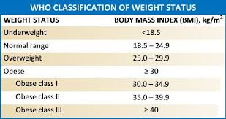
METHODS TO CONTROL HEALTHY BODY WEIGHT:
- Set an Appropriate Goal
- Lay Stress on Health Not on Weight
- Cut Your Calories
- Active Lifestyle
- Bring Out Support
- Yogic Exercises:
- Avoid Fatty Foods
- Avoid Junk and Fast Foods
- Avoid Overeating
- Don’t Eat Smaller Meals Frequently
- Balancing the Intake of Calories and Expenditure of Calories
ASSIGNMENT:
- What do you mean by healthy weight? Discuss the methods to control healthy body weight for a lifetime.
- What is BMI?
- What do you mean by healthy weight?

