Chapter-4 Physical Education and Sports for CWSN (Children with Special Needs–Divyang)
Disability: - Any disadvantage due to which an individual is not able to perform the activities of normal human life is known as disability.

Disorder: Any disruption due to which an individual is not able to perform his daily human activities is known as disorder.
Type of Disabilities
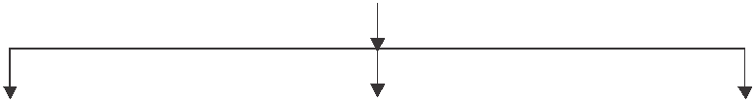

Physical | Cognitive | Intellectual
Disability | Disability | Disability
-Not able of perform | Non able to perform | -Not able to perform
the Normal human | the Normal human life | the normal human
life activities due | mental activities due to | life mental activities and
to the any physical | any mental | adaptative behaviour
Problem or disturbance | Problem or disturbance | skills due to any mental
 |  | Problem or disturbance
Cognitive disability: Cognative disability in children ranges from profound intellectual impairments with minimal functioning to mild impairments in specific operations. Cognitive disability is an inclusive term used to describe impairment in an individual’s mental processes that lead to the acquisition of information and knowledge, and drive how an individual understands and acts in the world.
Types of cognitive disability:
- Memory disorder: an individual who has auditory problems or difficulty in remembering something that he/she heard, said or saw some time ago.
- Hyperactivity: An individual with cognitive disability may not have attention for a long period. He/she finds it difficult to stay at one place. He/she usually loses concentration frequently.
- Dyslexia: An individual with cognitive disability may exhibit dyslexia. It means he/she may have difficulty in writing, reading, speaking, etc.
Intellectual disability: intellectual disability is the onset of both intellectual and adaptive functioning deficits the developmental period which refers to the span of time prior to the age 18. Children with this disorder may evidence delayed developmental milestones, while milder levels may not become identified until school age. Intellectual disability is non-progressive and generally lifelong; however, concurrence with specific genetic disorders may manifest with periods of cognitive deterioration.

Physical disability: Physical disability is any condition that permanently prevents normal body movement and/or control. In the early years, children may have some difficulties in learning to move skilfully. This is not unusual. However, for some children, the muscles and nerves that control body movements may not be properly formed or may become damaged causing a physical disability. Physical disability may either be motor deficiency or a sensory impairment.
- Motor deficiency is related to spinal cord, causing paralysis to some or all the limbs i.e., hands and legs. It may also be related to brain damage, which may occur before birth, during or after birth or after a stroke.
- Sensory impairment is related to an individual’s visual or hearing impairments.
Causes of Disability: There are various causes of disability that are stated below.
- Genetic Causes: Some disabilities are known to be inherited such as spinal muscular atrophy and muscular dystrophy. Abnormalities in genes and genetic inheritance cause intellectual disability in children. Sometimes diseases, illnesses and over exposure to X-rays may cause genetic disorder.

- Poverty. Poverty is one of the major causes of disability. Generally, it is seen that poor persons are the most vulnerable to disability because they live and work in unsafe environment with poor sanitation. They don’t have good living conditions. They usually have little access to education, safe drinking water and proper nutrition.

- Mental Health Problems: Mental health problems such as depression, bipolar disorder, etc., may lead to disability. As a matter of fact, the causes of mental health problems are very difficult to diagnose. They tend to be some of the most misunderstood disabilities.

- Accidents: Nowadays, life is so fast that accidents may occur anywhere, anytime and to anyone. These accidents may happen at workplace, on the roads or in the air. These accidents may lead to disability.

- Infectious Diseases: Infectious diseases may also cause disabilities. If the immunity power of a child is low, he is susceptible to fall sick or contact more serious illnesses. If a child is not immunised well, he becomes vulnerable to infectious diseases like mumps, which can cause hearing impairment or polio, which can cripple the child.

- Disturbance in Endocrine Glands: Disturbance in endocrine glands may also lead to disability. Owing to such disturbance, a child may suffer from various physical and mental deficiency.

- Malnutrition: Malnutrition is another significant cause of disability, especially our country. If a child does not get appropriate nutrition, he may be physically weak Even deficiency of calcium leads to malformation of bones. Deficiency of iodine may diminish the growth of body. Similarly, deficiency of vitamin ‘A’ may cause blindness, in children. Deficiency of vitamin B₁₂ may lead to loss of memory and cause paralysis.

- Poor Approach to Health Care: Many disabilities can be prevented easily, if it is proper access or approach to health care facilities. Sometimes, good health care facilities are not available during difficult labour and birth. It may cause a baby. To be born with a disability such as cerebral palsy. Professionally trained persons could handle such emergencies. They can prevent babies from being born with such disabilities. Proper immunisation can also help in preventing many disabilities. Usually people, who live in remote areas, do not have proper access to health can facilities, and thus, sometimes babies suffer disabilities.

- Nuclear Accidents. Many persons have suffered after being exposed to radiation. It nuclear radiations have also been increase in the number of children born with cognitive disabilities such as Down syndrome.

- Toxic Materials Pesticides Insecticides: Toxic materials like lead and mercury, etc. found in various products, use of insecticides and pesticides, other harmful chemicals may cause disabilities in people and birth defects in babies. As a matter of fact, such toxic materials may cause damage to brain which ultimately leads to disabilities.

- Illnesses: The illnesses like cancer, heart attack, diabetes, etc., cause a number of long-term disabilities. Arthritis, back pain, musculoskeletal disorders, etc., are also significant causes of disability. Some illnesses to pregnant woman may cause physical or learning problems to her baby when born.

- Lack of Education: Lack of education may lead to disability. Generally, labourers are not educated. They fall prey to certain diseases which can be avoided by using scientific methods or by taking precautions. But due to ignorance they do not adopt such precautionary methods. Hence, their chances to get a disability are raised.

- Wars: It is usually seen in wars that the most of the civilians are killed or disabled along with the soldiers. Bomb explosions cause people to become deaf, dumb and lose their limbs. Not only the physical health but mental health of the individuals is also badly affected by nuclear, biological and atomic weapons.

- Medicines and Vaccines: No doubt medicines and vaccines are essential to protect health and prevent disability but there are a number of practitioners in the medical field who are not qualified or registered. They don’t take proper care while dealing with patients. The use of unclean syringes may cause serious diseases like hepatitis or HIV/AIDS. Improperly stored as well as wrong vaccines may cause allergic reactions, poisoning and deafness to child.

- Dangerous Working Environment: If individuals work in factories, mines or in agricultural fields under improper working environment, they may be exposed to dangerous machinery, tools or chemicals and wide variety of health hazards. In such conditions they may get disabilities on the long-run.

Types of disorder:
ADHD (Attention Deficit Hyper activity Disorder):

Attention deficit hyperactivity disorder is a group of behavioural symptoms that include in attentions hyperactivity & impulsiveness.

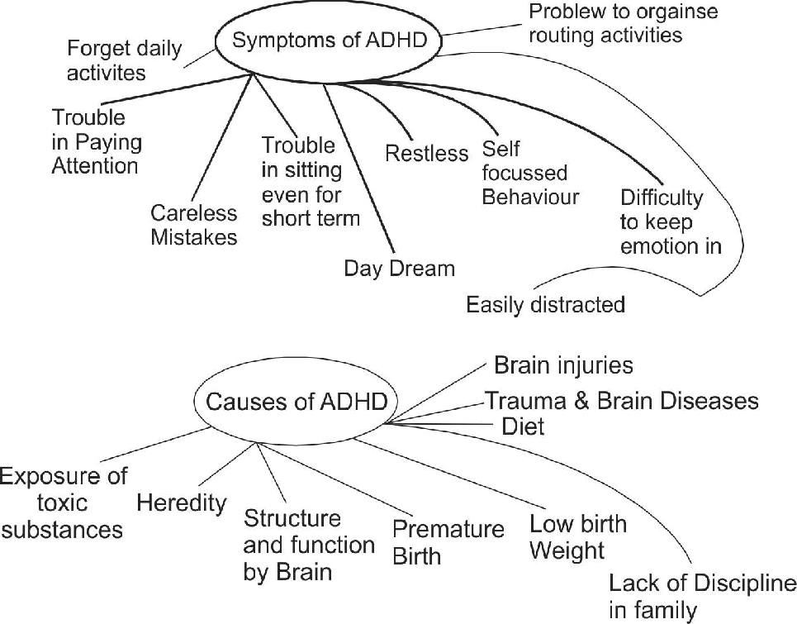

SPD: (Sensory Processing Disorder):

It is a condition is which the brain has difficulty in receiving & responding to information that can as in through the senses o
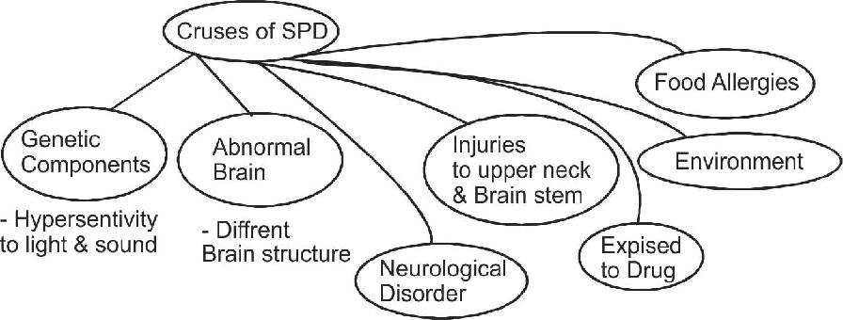

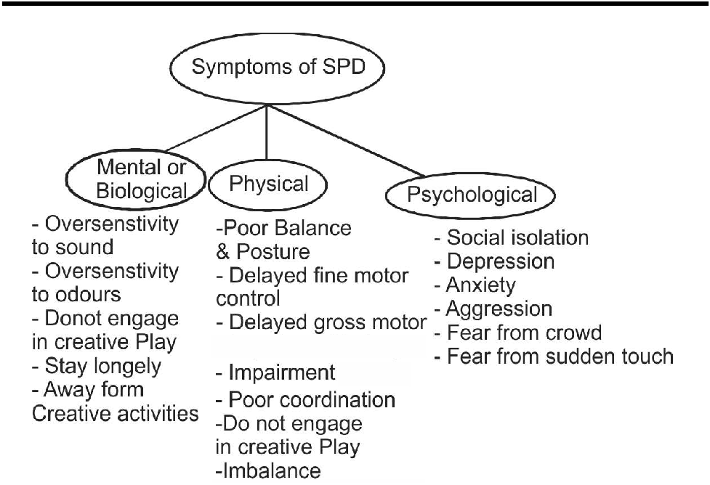

ASD (Autism Spectrum Disorder):

It is a neurological and developmental disorder in which has difficulties with communication, language, social skill and behaviour. Autism Spectrum Disorder (ASD) is a complex neuro-behavioural condition that includes impairment is social interaction and developmental language and communication skills combined with rigid, repetitive behaviours. Children are autism may have repetitive, stereotyped body movements such as rocking, pacing or hand flapping. They may have unusual responses to people, attachments to objects, resistance to change in their routines, or aggressive or self-injurious behaviour. At times they may seem not to notice people, objects, or activities in their surroundings.
Causes of ASD:
- Genetic factors
- Environmental factors
- Brain development
ODD (Oppositional Defiant Disorder):
Children and teens with Oppositional Defiant Disorder (ODD) have behavioural problems, such as attention deficit disorder, learning disabilities, mood disorder (such as depression), and anxiety disorders. Some children with ODD go on to develop a more serious behaviour disorder called conduct disorder. These children exhibit the habit of excessively arguing with adults, especially those with authority. They may actively refuse to complete with requests and rules and deliberately trying to annoy or upset others, or being easily annoyed by others. Blaming other for your mistakes and frequent outbursts of anger and resettlement are common among them.
Causes of ODD:
- Biological or genetic factors
- Physical factors
- Psychological factors
- Social factors
OCD (Obsessive Compulsive Disorder):
Obsessive Compulsive Disorder (OCD) is a potential disabling illness that traps people in endless cycles of repetitive thoughts and behaviours. People with OCD are plagued by recurring and distressing thoughts, fears, or image (obsessions) they cannot control. Such people used to have fear to dirt or contamination by germs or fear of causing harm to another or making mistakes. Fear of being embarrassed or behaving in socially unacceptable manner or fear of thinking evil or sinful thoughts are become part and parcel of their life. Similarly, need for order, symmetry or exactness excessive doubt and the need for constant reassurance hunts them always.
Main obsessions:
- A fear of harm to yourself or loved one
- A fear of contamination by germs
- A forceful or driving need to perform things perfectly or correctly
- Having excessive doubt on any individual
- A fear of being embarrassed
- A fear of getting dirty
- A fear of making mistakes
Main compulsions:
- Repeating things or always moving items to keep them in exact order
- Bathing or washing hands several times
- Checking things over and over again
- Repeating specific words
- Hoarding
- Constant praying
- Persistently counting while doing usual tasks
Causes of OCD: The exact cause of OCD is still unknown but research studies suggest that serotonin is the chemical in the brain that sends messages from one part to another. Insufficiency of serotonin may help in causing OCD. Stress and anxiety do not cause OCD but they may worsen the symptoms of OCD. Genetic and depression may cause OCD but expert opinion is split.
Disability Etiquettes
Etiquettes acceptable behaviour in society with good manners & proper conduct. Disability etiquettes: It is a set of guidelines dealing specifically with person with disabilities to approach.
General disability etiquettes:
- Always put the person first, say person with disability rather than disabled person.
- Always avoid the outdated words like handicapped, retarded, physically challenged or differently-abled.
- In case of introduction it is appropriate to shake hands.
- Leaning or hanging on a person’s wheelchair should always be avoided.
- Always listen carefully as well as attentively when you are having conversation with a person who has difficulty in speaking.

Advantages of physical activities for children with special needs: Physical activities can play a significant as well as positive role in the life of children with special needs. There is a wealth of evidence to support physical activities for children with disabilities. Following are the advantages/benefits of physical activities for children with special needs:
- Physical improvement: involvement in physical activities can help individuals to develop fundamental motor and physical fitness skills. These activities improve the levels of well-being and physical health. It also enhances the hand-eye coordination, flexibility, strength, endurance and even cardiovascular efficiency.
- Mental development: Physical activities are not only good for a child’s body but these are beneficial for their mind too. It also improves general mood and wellness of children with special needs.
- Self-esteem: Physical activities are beneficial for children with special needs because such activities develop a sense of self-esteem and self-confidence.
- Reduce the level of anxiety, stress and depression: Physical activities may help in reducing the level of anxiety, stress and depression of children with disabilities.
- Cognitive benefits: physical activities lead to cognitive skill improvement in children with disabilities. These activities allow them to discover and access strength that cannot be challenged in the classroom setting.
- Better emotional and psychological health: Physical activities are beneficial for children with special needs because such activities improve emotional and psychological health.
Strategies to make physical activities accessible for children with special needs
- Medical Check-up: First of all, it is essential to have a medical check-up of all the children with special needs or with various disabilities. Because without medical check-up, the teachers of physical education cannot come to know about the type of disability the child is facing. Indeed, if we really want to make physical activities accessible for the children with special needs, we need to understand the type of disabilities of the children.

- Physical Activities Must Be Based on Interests of Children: Indeed, physical activities must be based on the interests, aptitudes, abilities, previous experience and limitations of children with special needs. So, the teachers of physical education should have a deep knowledge of limitations, interests and aptitudes of children. After that physical activities can be made accessible for children with special needs more easily.

- Equipment Related to Physical Activities Should Be According to the Needs of children: The equipments/ objects related to physical activities should be according to the needs of children. This equipment should vary in size, shape, colour and weight. This equipment should be according to the capability and level of children. A child with visual impairment should use bright coloured ball. A yarn should be tied to the ball to bring the ball back to children. So, various types of equipment must be provided for children with special needs.

- Specific Environment Should Be Provided: The area of physical activities should be limited as movement capabilities of children with special needs are limited. Specially, in case of children who have autism, they must be provided specific playing area because they may need some time to relax. Light and sound are also vital for making good environment for such children.

- A Variety of Different Instructional Strategies Should Be Used: For performing various types of physical activities, a variety of different instructional strategies such as verbal, visual and peer teaching should be used. It can give children the opportunity to start learning on their own and become more independent. Pictorial books are also vital in terms of instructions regarding physical activities.

- Rules Should Be Modified According to the Needs of Children with Disabilities: In the beginning, rules of the physical activities should be simple but later on these rules can be modified according to the needs of the children. They can be provided extra attempt or time to perform a physical activity. They can also be given additional resting time before doing the next physical activity.

- Children’s Previous Experience Must Be Taken into Consideration: For making physical activities more accessible for children with special needs, the concerned teacher of physical education should have comprehensive understanding and knowledge of children’s previous experience about physical activities.

In conclusion it can be said that the above-mentioned strategies are very significant to make physical activities accessible for children with special needs.

