
Welcome to the Virtual Class
Social Science
SUBJECT : History
CHAPTER NUMBER: 04
CHAPTER NAME : The Age of Industrialization
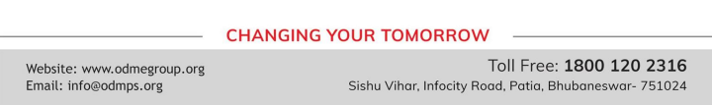
Small-Scale Industries Predominate
• While factory industries grew steadily after the war, large industries formed only a small segment of the economy.
• Handicrafts production actually expanded in the twentieth century. This is true even in the case of the handloom sector.
• While cheap machine-made thread wiped out the spinning industry in the nineteenth century, the weavers survived, despite problems.
• Handicrafts people adopt new technology if that helps them improve production without excessively pushing up costs.
• This increased productivity per worker, speeded up production and reduced labour demand.
• Certain groups of weavers were in a better position than others to survive the competition with mill industries.

Market for Goods
• One way in which new consumers are created is through advertisements.
• When Manchester industrialists began selling cloth in India, they put labels on the cloth bundles. • When buyers saw ‘MADE IN MANCHESTER’ written in bold on the label, they were expected to feel confident about buying the cloth.
• But labels did not only carry words and texts. They also carried images and were very often beautifully illustrated.
• Images of Indian gods and goddesses regularly appeared on these labels. It was as if the association with gods gave divine approval to the goods being sold.
• Like the images of gods, figures of important personages, of Emperors and Nawabs, adorned advertisement and calendars.
• The message very often seemed to say: if you respect the royal figure, then respect this product; when the product was being used by kings, or produced under royal command, its quality could not be questioned.
• When Indian manufacturers advertised the nationalist message was clear and loud. If you care for the nation then buy products that Indians produce. Advertisements became a vehicle of the nationalist message of swadeshi.
THANKING YOU
ODM EDUCATIONAL GROUP

