
Welcome to the Virtual Class
Social Science
SUBJECT : Civics
CHAPTER NUMBER: 04
CHAPTER NAME : Gender Religion and Caste
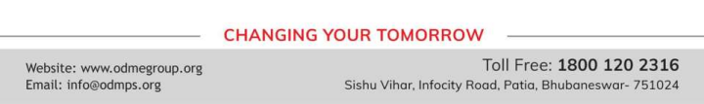
Caste AndPolitics
•Hereditary occupational division sanctioned by rituals.
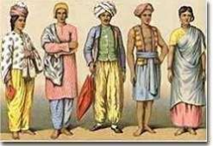
•Members of the same caste group formed similar occupation, married within the caste and did not eat with
members from other caste groups.

Efforts to Check Casteism
•Political leaders and social reformers like Jotiba Phule, Gandhiji, Ambedkar and Periyar Ramaswami Naicker have done a lot to check casteism.
•Socio economic changes have brought in a check. Large scale urbanization.
•Literacy and education. Occupational mobility.
•Weakening of the position of landlords.
•Constitution prohibited caste based discrimination.
Caste in Politics
Q. Why is there a disproportionately large presence of Upper Caste among Urban Middle Class?
A. The disproportionately large presence of 'upper castes' among the urban middle class is an indication that the caste group that had access to education under the old system continue to benefit under the new system as well. This is all because of the casteism in politics that leads the disproportion
Election are all about caste and nothing else
● No parliamentary constituency has a clear majority of one single caste. Every candidate /party must win the confidence of more than one caste and community to win elections.
● No party wins the votes of all voters of a caste/community.
● Many political parties may put up candidates from same caste.
● Ruling party /sitting MP losing election could not have happened if all castes and communities were frozen in political preferences.
Caste can take various forms in Politics
● During the choice of the candidates before an election, parties take care of the composition of electorate and nomination of candidates from different castes so as to muster support to win elections.
● During the formation of the Government, political parties take care that representatives of different castes and tribes find a place in it.
● To make appeals to caste sentiment to muster support.
● Universal adult franchise - one person one vote one value.
Effects of Caste in Politics
● Politics based on caste identity alone is not healthy.
● Diverts attention from poverty, development, and corruption.
● It leads to tension, conflict and violence.
THANKING YOU
ODM EDUCATIONAL GROUP

