
Welcome to the Virtual Class
Social Science
SUBJECT : Civics
CHAPTER NUMBER: 04
CHAPTER NAME : Gender Religion and Caste
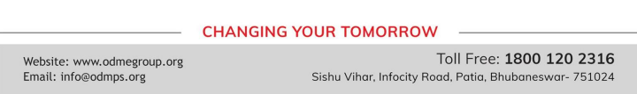
Overview
•In this chapter we apply the ideas of social difference to the practice of democratic system in India. •We look at three kinds of social differencesthat can take the form of social divisions and inequalities.
•These are social differences basedo n :
1. Gender
2. Religion and
3. Caste.

Gender andPolitics
• This is a form of hierarchical social division seen everywhere, but is rarely recognized i n the study of politics.
• The gender divisions tends to be understood as natural and unchangeable.
• Not based on biology but on social expectations and stereotypes
What disadvantages do women face?
● Literacy Rate - 54% for women.76% for men showing disparity.
● Smaller proportion of girls go for higher studies.
● Preferential treatment meted out to boy`s education rather than for girls. ● Proportion of women among highly paid and valued job is small.
● Equal wages Act provides equal wages but discrimin ation con tin u es in sports, cinema, factories and others fields.
● Preference to have sons and abortion of girl child. Sex selective abortions have led to decline in child sex ratio.
● Varioustypes of haras sment, exploitation and violence.
● Urban areas too have become unsafe for women. Proportion of women has been very low in legislature.
● In the government, cabinets are largely all-male even when a woman becomes the Chief Minister or the Prime minister.
THANKING YOU
ODM EDUCATIONAL GROUP

