Chapter- 1
Power Sharing
Study Notes
What is Power Sharing?
[POWER SHARING] | CIVICS| Study Notes
• Power sharing is a technique to share the power at different levels.
• It is an idea inculcated in democracy so that the power is not concentrated at one hand only and that different forms can keep a check on each other.

• India is an example of “holding together” federations, where the power is shared between central government and different constituent states.
Why power sharing is desirable in democracy?
(I) Prudential reasons:
(a) It helps to reduce the possibility of conflict between social groups. Since social conflict often leads to violence and political instability.
(b) It is a good way to ensure the stability of political order.
(c) Imposing the will of majority, community over others may look like an attractive option in the short run, but in the long run it undermines the unity of the nation.
(II) Moral reasons:
(a) Power sharing is the very spirit of democracy. A democratic rule involves sharing power with those affected by its exercise and who have to live with its effect.
(b) People have a right to be consulted on how they are to be governed.
(c) A legitimate government is one where citizens through participation, acquire a stake in the system.
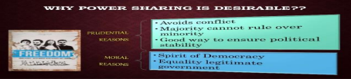ODM Educational Group Page 1
[POWER SHARING] | CIVICS| Study Notes
Khalil’s Dilemma
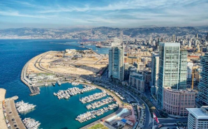
• Khalil lived in the city of Beirut
• Khalil’s father was an orthodox Christian and mother was a Sunni Muslim • People from various communities living in Lebanon came to live in Beirut, its capital • Lebanon’s leader laid down some basic rules for power sharing among different community • As per these rules, the country’s president must being to the Maronite sect of Catholic Christians
• The Prime Minister must be a Sunni Muslim
• The Deputy Prime Minister’s post is fixed for the Orthodox Christians • The position of the speaker is for the Shia Muslim
• Khalil is not happy with the rules laid down by the Lebanese leaders
• He is a popular man with a political ambition
• He does not follow any religion, neither his fathers’ nor his mothers’ • As per Khalil, an election (referendum) should be held
• Everyone should be allowed to participate
• The one with the maximum votes should be elected as the President no matter which community he/she belongs to
• On the other hand, his elders who have seen bloodshed in the civil war, are happy with the present system i.e. position reserved for a particular community only because this system guarantees for peace
Forms of power sharing
1. Power is shared among different organs of the government
ODM Educational Group Page 2
[POWER SHARING] | CIVICS| Study Notes
2. Power is shared among government at different levels
3. Power is shared among different social groups
4. Power is also shared among political parties, pressure groups and movements Power sharing among different organs of government
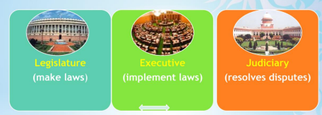
Power is shared among different organs of the government:
1. This is known as horizontal distribution of power
2. This results in a balance of power among various institutions
3. The system of checks and balances ensures that none of the organs can exercise unlimited powers
Power is shared among governments at different levels
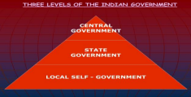
ODM Educational Group Page 3
[POWER SHARING] | CIVICS| Study Notes
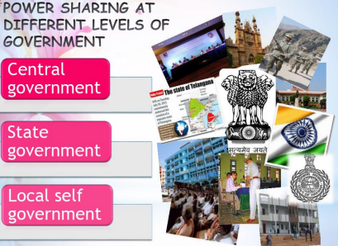
1. This is known as Federal Government
2. It is a general government for the entire country
3. Example: In India, we have Central or the Union Government
Power is shared among different social groups:
1. This is known as ‘Community Government’
2. This type of arrangement is made to give a place in the government, to the diverse social groups who feel ignored by the government
3. This method is used to give fair share in power to minority communities
Power shared among Political Parties, Pressure Groups and Movement Groups. 1. In a democracy, the citizens must have freedom to choose from the various contenders
ODM Educational Group Page 4
[POWER SHARING] | CIVICS| Study Notes
2. This takes the form of competition amongst different parties
3. Such competition ensures that power does not remain in one hand
4. In a democracy, we find interest groups such as traders, businessmen, industrialists, farmers and workers.
The Case Study of Belgium
• Belgium is a federal monarchy in Western Europe.
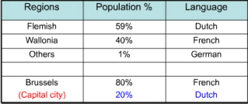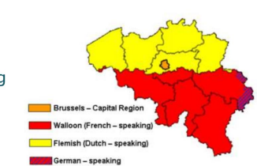
• It is a founding member of the European Union and host the head quarter as well. • It shares its borders with France, Netherlands, Germany and Luxembourg • The ethnic composition of Belgium is very complex.
• Brussels is the capital of Belgium
ODM Educational Group Page 5
[POWER SHARING] | CIVICS| Study Notes
Accommodation in Belgium
• The Belgian leaders recognized the existence of regional differences and cultural diversities • They amended their constitution four times between 1970 and 1993
Elements of Belgian Model
• Constitution prescribes that the number of Dutch and French–speaking ministers shall be equal in the central government
• Some special laws require the support of majority of members from each linguistic group • The state governments are not subordinate to the central government
• Brussels has a separate government in which both the communities have equal representation • The French speaking people accepted equal representation in Brussels because the Dutch speaking community has accepted equal representation in the Central Government. • Apart for the central and state government there is a third kind of government elected by people called as “community government“
• This ‘community government’ is elected by people belonging to one language community – Dutch, French and German-speaking – no matter where they live.
• This government has the power regarding cultural, educational and language-related issues.
Case Study of Sri Lanka
• SriLanka is an island nation
• It is a few kilometers off the southern coast of Tamil Nadu
• It lies to the south eastern tip of the Indian subcontinent
• The Palk Strait and Gulf of Mannar separate Sri Lanka from India
• The Arabian Sea lies to the west, the Bay of Bengal to the northeast ,and the Indian Ocean to • the south
• Colombo is the largest city and the commercial capital of Sri Lanka,
• The administrative capital is Sri Jayawardenepura (Kotte), located about 16 km (about 10 mi) east of Colombo.
Ethnic Composition of Sri Lanka
• Tamil natives of Sri Lanka are called “Sri Lankan Tamils”
• ‘Indian Tamils’ are those whose fore fathers came from India as plantation workers during the colonial period
• Sri Lankan Tamils are concentrated in the north and east of the country. • Most of the Sinhala speaking people are Buddhists, while most of the Tamils are Hindus or Muslims.
• There are about 7 per cent Christians, who are both Tamil and Sinhala
ODM Educational Group Page 6
[POWER SHARING] | CIVICS| Study Notes
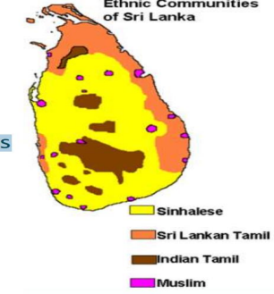
Majoritarianism in Sri Lanka
• Sri Lanka emerged as an independent country in 1948
• The democratically elected government adopted a series of majoritarian measures to adopt a Sinhala supremacy
• In 1956 an act was passed to declare Sinhala as official language
• The government recognized Sinhala applicants for university jobs and governments jobs • By 1980 several political organizations were formed demanding an independent Tamil Eelam in northern and eastern parts of Sri Lanka.
• The distrust between the two communities turned into widespread conflicts. • It soon turned into a civil war as a result thousands of people were forced to leave the country. • This civil war is still going on till 2009.
ODM Educational Group Page 7
[POWER SHARING] | CIVICS| Study Notes
Sri Lankan Civil War Explained
Video link: https://youtu.be/cT6z8irTXHg
****
Note: Topic sequence may vary compared to NCERT Textbook, as it has been rearranged for proper understanding of the content.
ODM Educational Group Page 8

