Chapter- 17
DATA HANDLING
WORKSHEET
Answer the following questions.

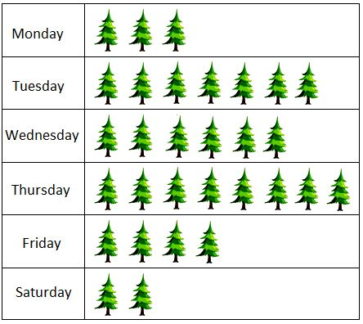
- Different numbers of plants were planted by the students of a school on six days of a week. This is shown in the following pictograph.

- How many plants were planted each day?

- Find the total number of plants planted during the week.

- On which day were the maximum numbers of plants planted?

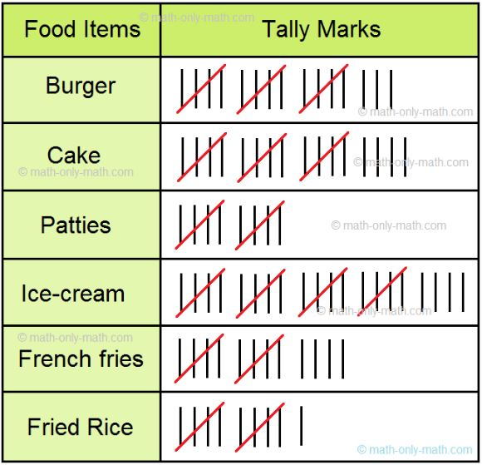
- The tally chart shows the items sold during the weekends. Use the information from the tally chart to answer.er the questions.

- Which item was sold maximum and how many were sold?

- How many French Fries were sold over the weekend?

- Which item was the least selling item?

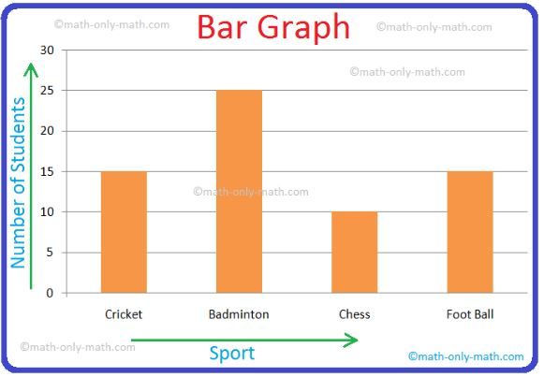
- Look at the bar graph given below and answer the questions.

- Which sport is liked by maximum students?

- Which sport is liked by minimum students?

- Which sport is liked by equal number of students?

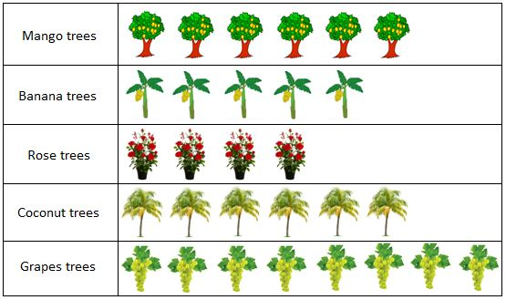
- Look at the bar graph given below and answer the questions.

- Name the tree which is greatest in number in the garden.

- Which tree is least in number in the garden?

- How many trees are there in the garden?

- Look at the bar graph given below and answer the questions.
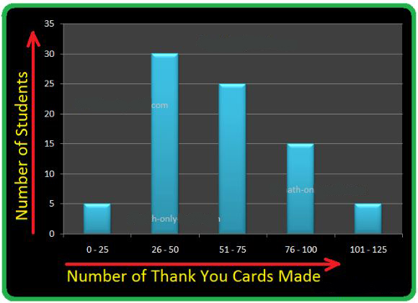

- How many students have made less than 51 cards?

- How many students have made 76 - 100 cards?

- How many students have made more than 75 cards?

---------------X---X---X---------------

