CHAPTER-15
DECIMAL FRACTIONS
STUDY NOTES

The first place after the decimal is got by dividing the number by 10; it is called the tenths place.
The second place after the decimal is got by dividing the number by 100; it is called the hundredths place.
The third place after the decimal is got by dividing the number by 1000; it is called the thousandths place.
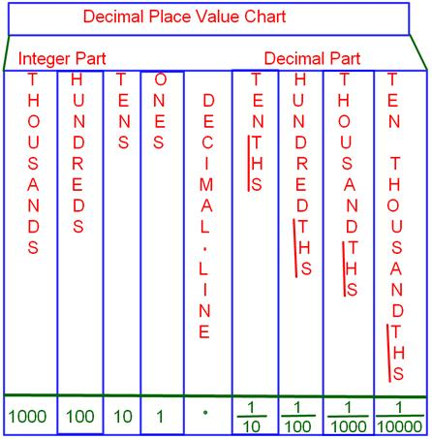
Comparison of decimal numbers: To compare the decimal numbers, we first compare the digits on the left of the decimal point, starting from the leftmost digit.
If all the digits on the left of the decimal point are exactly the same, then we compare the digits on the right of the decimal point starting from the tenths place.
If the digits at the tenths place are also the same, then we compare the digits at the hundredths place and so on.
Addition and subtraction of decimals: To add or subtract decimal numbers, make sure that
the decimal points of the given numbers are placed exactly one below another.
While adding or subtracting two decimal numbers, the number of digits after the decimal point should be equal.
In case they are not equal, the gaps must be filled with zeros after the last digit.

Decimal numbers as a fraction with denominator 10 or 100 or 1000, etc.
We observe that,
2.3 = 23/10 whereas 2.35 = 235/100
Thus, depending upon the position of the decimal point, the decimal number can be converted to a fraction with denominator 10 or 100 or 1000, etc.

Multiplication of a decimal by 10 or 100 or 1000
When we multiply a number by 10 or 100 or 1000, we get a product in which the digits are the same as in the number itself, but the decimal is shifted to the right by one digit (for multiplication by 10), by two digits (for multiplication by 100) and by three digits (for multiplication by 1000).
Division of Decimals
Dividing a decimal number by a whole number:
(i) Divide as in division of numbers ignoring the decimal point.
(ii) Place the decimal point in the quotient in the same position as in dividend.
Note: When the number of digits in the dividend is less and the division is not complete, keep adding zeroes at every step till the division is complete.

Dividing a decimal number by a decimal number:
Move the decimal point in the divisor to the right until it is a whole number.
Move the decimal point in the dividend to the right by the same number of places as the decimal point was moved to make the divisor a whole number.
Then divide the new dividend by the new divisor.

Dividing a decimal number by powers of 10 :
If a decimal is divided by a power of 10, then the decimal point shifts to the left by the number of zeros present in the power of 10.
Example: 98.765÷100=0.98765 Infinity
When the denominator in a fraction is very small (almost tending to 0), then the value of the fraction tends towards infinity.
E.g: 999999/0.000001 = 999999000001 ≈ a very large number, which is considered to be ∞

