CHAPTER -14
FRACTIONS
Fractions tell about “a part of a whole”.
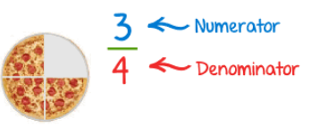
Here the pizza is divided into 4 equal parts and there are 3 parts left with us.
We will write it in a fraction as 3/4, in which 3 is numerator which tells the number of parts we have and 4 is denominator which tells the total parts in a whole.

The General form of a Fraction
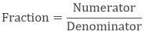
Where, denominator ≠ 0
If numerator = denominator then the fraction becomes a whole i.e. 1. This is called unity of fraction.

Types of Fraction
Type of Fraction | Meaning | Example
Proper fraction | When numerator is less than the denominator. It shows the part of a whole. | 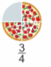
Improper fraction | When numerator is more than the denominator. It represents the mixture of whole and a proper fraction. | 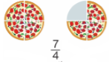
Mixed Fraction | The improper fraction can be written in the mixed form as it is the mixture of whole number and a fraction. | 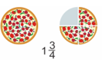
Like Fraction | The fractions with the same denominator are like fractions. | 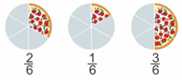
Unlike Fraction | The fractions with different denominators are unlike fractions. | 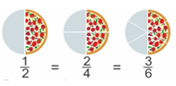
Equivalent Fraction | The fractions proportional to each other are called equivalent fractions. It represents the same amount with different fractions. | 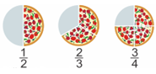

Converting a Mixed Fraction into an Improper Fraction
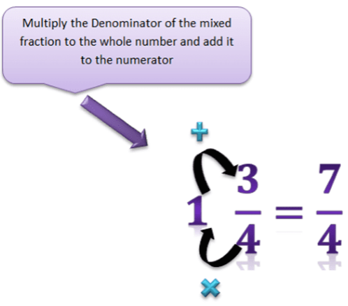

Converting an Improper Fraction into a Mixed Fraction
Divide the Numerator by the denominators that the quotient will be the whole number and remainder will be the numerator, while denominator will remain the same.
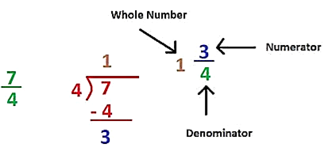
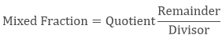
How to find the equivalent fractions?
To find the equivalent fraction of proper and improper fraction, we have the multiply both the numerator and denominator with the same number.
Example
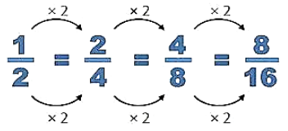

Reciprocal of a Fraction
If we have two non-zero numbers whose product is one then these numbers must be the reciprocals of each other.
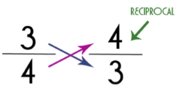
To find the reciprocal of any fraction, we just need to flip the numerator with the denominator.

Multiplication of Fractions
1. How to multiply a fraction with a whole number?
a. If we have to multiply the proper or improper fraction with the whole number then we simply multiply the numerator with that whole number and the denominator will remain the same.
Example
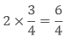
b. If we have to multiply the mixed fraction with the whole number then first convert it in the form of improper fraction then multiply as above.
Example
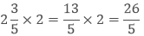
c. Fraction as an operator “of”.
If it is written that find the 1/2 of 24 then what does ‘of’ means here?
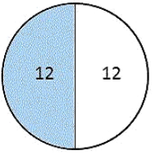
Here ‘of’ represents the multiplication.
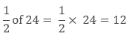
2. How to multiply a fraction with another fraction?
If we have to multiply the proper or improper fraction with another fraction then we simply multiply the numerator of both the fractions and the denominator of both the fractions separately and write them as the new fraction.
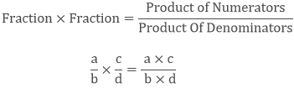
Example
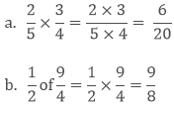
Value of the products of the fractions
Generally when we multiply two numbers then we got the result which is greater than the numbers.
5 × 6 = 30, where, 30 > 5 and 30 > 6
But in case of a fraction, it is not always like that.
a. The product of two proper fractions
If we multiply two proper fractions then their product will be less than the given fractions.
Example
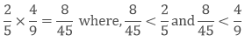
b. The product of two improper fractions
If we multiply two improper fractions then their product will be greater than the given fractions.
Example
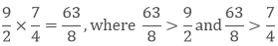
c. The product of one proper and one improper fraction
If we multiply proper fraction with the improper fraction then the product will be less than the improper fraction and greater than the proper fraction.
Example
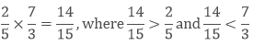

Division of Fractions
1. How to divide a whole number by a Fraction?
a. If we have to divide the whole number with the proper or improper fraction then we will multiply that whole number with the reciprocal of the given fraction.
Example
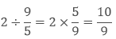
b. If we have to divide the whole number with the mixed fraction then we will convert it into improper fraction then multiply it’s reciprocal with the whole number.
Example
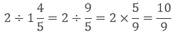
2. How to divide a Fraction with a whole number?
To divide the fraction with a whole number, we have to take the reciprocal of the whole number then divide it with the whole number as usual
Example
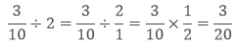
3. How to divide a fraction with another Fraction?
To divide a fraction with another fraction, we have to multiply the first fraction with the reciprocal of the second fraction.
