CLASS: VII
SUBJECT:BIOLOGY
LESSON- EXCRETION IN HUMANS

Human Excretory System
The diagram below represents the different parts of the human excretory system.
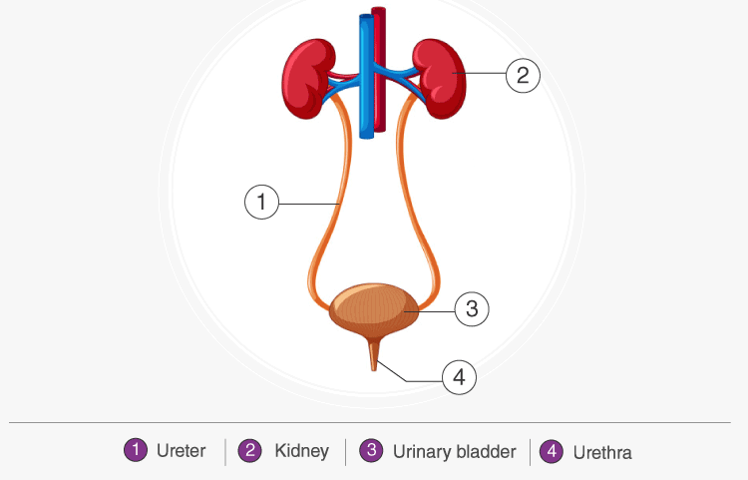

The human excretory system organs include:
- A pair of kidneys
- A pair of ureters
- A urinary bladder
- A urethra

Kidneys

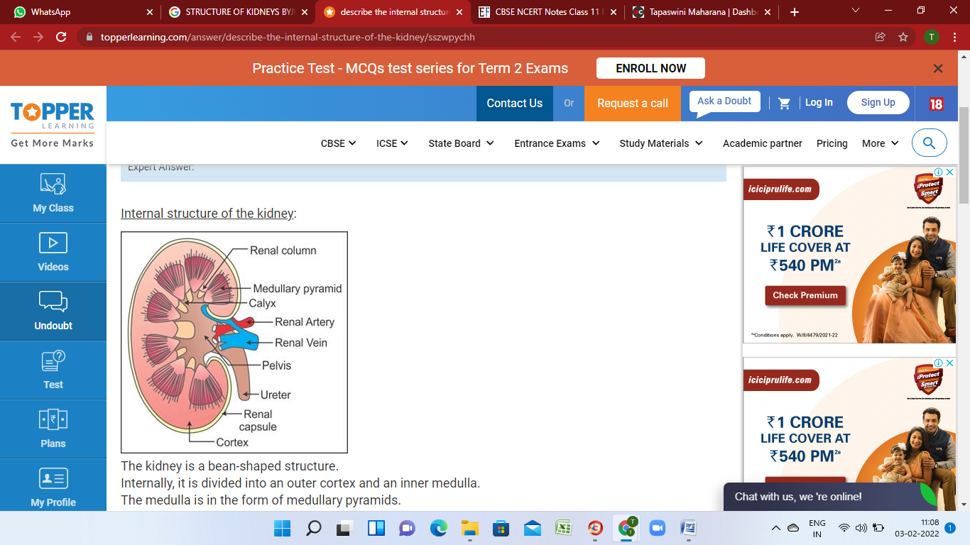
Kidneys are bean-shaped structures located on either side of the backbone and are protected by the ribs and muscles of the back. Each human adult kidney has a length of 10-12 cm, a width of 5-7 cm and weighs around 120-170g.
The kidneys have an inner concave structure. The blood vessels, ureter and nerves enter the kidneys through the hilum, which is a notch at the inner concave surface of the kidney. The renal pelvis, a large funnel-shaped space is present inner to the hilum, is has many projections known as calyces.

Structure of Kidney
The structure of the kidney is explained below:

Capsule
The outer layer is called the capsule. Inside the kidney, there are two zones- the outer zone is the cortex and the inner zone is the medulla. The cortex extends in between the medullary pyramids as renal columns called columns of Bertin.

Nephrons
Nephrons are the functional units of the kidney. Each nephron has two parts- glomerulus and renal tubule.
Glomerulus consists of a bunch of capillaries formed by afferent arterioles. Blood from glomerulus is carried away by efferent arterioles.
The renal tubule starts with a cup-like structure called Bowman’s capsule and this encloses the glomerulus. The malpighian body consists of glomerulus and Bowman’s capsule. The highly coiled structure in the tubule next to the Bowman’s capsule is the proximal convoluted tubule.

Henle’s loop
The next part of the tubule is Henle’s loop which has an ascending and a descending limb. The ascending loop continues as a distal convoluted tubule. The distal convoluted tubules of many nephrons open into the collecting duct.
The cortical region of the kidney comprises of malpighian corpuscle, proximal convoluted tubule and distal convoluted tubule and the medullary region contains a loop of Henle.
There are two types of nephrons – cortical and juxtamedullary. In the case of cortical, the loop of Henle is very short and extends only a little into the medulla. In juxtamedullary, the loop of Henle is very long and runs deep into the medulla.

Ureter
A pair of thin muscular tubes called the ureter comes out of each kidney extending from the renal pelvis. It carries urine from the kidney to the urinary bladder.

Urinary Bladder
It is a muscular sac-like structure, which stores urine. The urinary bladder is emptied by the process of micturition, i.e. the act of urination.

Urethra
This tube arises from the urinary bladder and helps to expel urine out of the body. In males, it acts as the common route for sperms and urine. Its opening is guarded by sphincter muscles.

Excretion in Humans
Excretion is the process where all the metabolic wastes are removed from the body. Excretion in humans is carried through different body parts and internal organs in a series of processes.
Diffusion is the most common process of excretion in lower organisms. A human body is an exceptional machine, where different life-processes (respiration, circulation, digestion, etc.) take place simultaneously. As a result, many waste products produced in our body are in various forms that include carbon dioxide, water, and nitrogenous products like urea, ammonia, and uric acid.
In addition to these, the chemicals and other toxic compounds from medications and hormonal products are also produced. Simple diffusion is not sufficient to eliminate these wastes from our body. We need more complex and specific processes in order to eliminate waste products.
Blood contains both useful and harmful substances. Hence, we have kidneys which separate useful substances by reabsorption and toxic substances by producing urine.
Kidney has a structural filtration unit called nephron where the blood is filtered. Each kidney contains a million nephrons.
Capillaries of kidneys filter the blood and the essential substances like glucose, amino acids, salts, and the required amount of water get reabsorbed and the blood goes into circulation.
Excess water and nitrogenous waste in humans are converted to urine. Urine thus produced is passed to the urinary bladder via the ureters. The urinary bladder is under the control of the Central Nervous System. The brain signals the urinary bladder to contract and through the urinary opening called the urethra, we excrete the urine.
A nephron is the basic structural and functional unit of the kidney. They are the microscopic structure composed of a renal corpuscle and a renal tubule. The word nephron is derived from the Greek word – nephros, meaning kidney. There are about millions of nephrons in each human kidney.

Structure of Nephron
The mammalian nephron is a long tube-like structure, its length varying from 35–55 mm long. At one end, the tube is closed, folded and expanded, into a double-walled, a cuplike structure called the Bowman’s capsule or renal corpuscular capsule, which encloses a cluster of microscopic blood vessels called the glomerulus. This capsule and glomerulus together constitute the renal corpuscle.
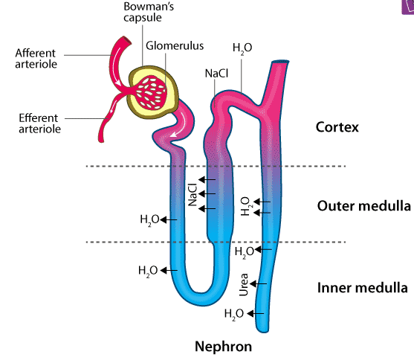
The structure of nephron comprises two major portions:
- Renal Tubule
- Renal Corpuscle

Renal Tubule
The renal tubule is a long and convoluted structure that emerges from the glomerulus and can be divided into three parts based on function.
- The first part is called the proximal convoluted tubule (PCT) due to its proximity to the glomerulus; it stays in the renal cortex.
- The second part is called the loop of Henle, or nephritic loop because it forms a loop (with descending and ascending limbs) that goes through the renal medulla.
- The third part of the renal tubule is called the distal convoluted tubule (DCT) and this part is also restricted to the renal cortex.
The capillaries of the glomerulus are enclosed by a cup-like structure called Bowman’s capsule. This structure extends to form highly coiled tubules called PCT. PCT continues to form the loop of Henle which ascends to DCT, which in turn opens into the collecting duct.
The major function of tubules is reabsorption and the process can either be through active transport or passive transport. In addition, secretions by tubules help in the urine formation without affecting the electrolyte balance of the body.
- Proximal Convoluted Tubule (PCT)
The blood brought by the renal artery is filtered by the glomerulus and then passed to the PCT. Maximum reabsorption takes place in PCT of the nephron.PCT is the region of renal tubule where reabsorption of essential substances like glucose, proteins, amino acids, a major portion of electrolytes and water takes place. The surface area for reabsorption is facilitated by the lining of the simple cuboidal epithelium in them. Reabsorption takes place at the expense of energy, i.e., the process is active.PCT selectively secretes ions such as hydrogen, ammonia, and potassium into the filtrate and absorbs HCO₃–from it. Thus, PCT maintains the electrolyte and acid-base balance of the body fluids.
- Henle’s Loop
Henle’s loop has a descending and an ascending limb. Being parts of the same loop, both the descending and ascending limbs show different permeability. The descending limb is permeable to water but impermeable to an electrolyte, while the ascending limb is permeable to electrolytes but impermeable to water. Since the electrolytes get reabsorbed at the ascending loop of Henle, the filtrate gets diluted as it moves towards the ascending limb. But reabsorption is limited in this segment.
- Distal Convoluted Tubule (DCT)
The DCT, which is the last part of the nephron, connects and empties its contents into collecting ducts that line the medullary pyramids. The collecting ducts amass contents from multiple nephrons and fuse together as they enter the papillae of the renal medulla.
Similar to PCT, DCT also secretes ions such as hydrogen, potassium, and NH₃ into the filtrate while reabsorbing the HCO₃–from the filtrate. Conditional reabsorption of sodium ions and water takes place in DCT. Thus, it maintains the pH and sodium-potassium level in the blood cells.
Collecting Duct
Collecting duct is a long, straight tube where H+ and K+ ions are secreted to maintain the electrolyte balance of the blood. This is also the region where the maximum reabsorption of water takes place to produce concentrated urine.

Mechanism of Excretion in Humans
The process of excretion in humans takes place in the following steps:

Urine Formation
The urine is formed in the nephrons and involves the following steps:
- Glomerular Filtration
- Tubular Reabsorption
- Secretion

Glomerular Filtration
It is the primary step in urine formation. In this process, the excess fluid and waste products from the kidney are filtered out of the blood into the urine collection tubules of the kidney and eliminated out of the body.
The amount of filtrate produced by the kidneys every minute is known as Glomerular Filtration Rate (GFR).

Tubular Reabsorption
It is the absorption of ions and molecules such as sodium ions, glucose, amino acids, water etc. Water involves passive absorption, while glucose and sodium ions are absorbed by an active process.

Secretion
Potassium ions, hydrogen ions, and ammonia are secreted out to maintain the equilibrium between the body fluids.
The functions of the various tubules involved in the process are:
- Glomerulus- filters the blood
- Proximal Convoluted Tubules (PCT)- reabsorb water, ions and nutrients. They remove toxins and help in maintaining the ionic balance and pH of the body fluids by secretion of potassium, hydrogen and ammonia to filtrate and reabsorbing bicarbonate ions from the filtrate.
- Descending Loop of Henle- is permeable to water and the filtrate gets concentrated as it is impermeable to electrolytes.
- Ascending Loop of Henle- it is impermeable to water and permeable to electrolytes. The filtrate gets diluted due to the movement of electrolytes from the filtrate to the medullary fluid.
- Distal Convoluted Tubule (DCT)- allows reabsorption of water and sodium ions. It also helps in maintaining pH and ionic balance by secretion and reabsorption of ions like PCT.
- Collecting Duct- a large amount of water is reabsorbed from the filtrate by the collecting duct.

Micturition
The urinary bladder is stretched and gets filled with urine formed in the nephrons. The receptors present on the walls of the urinary bladder send signals to the Central Nervous System, thereby, allowing the relaxation of sphincter muscles to release urine. This is known as micturition.

Dialysis
Under certain circumstances such as poor blood flow to the kidneys, infections, injuries, etc. the kidneys fail to perform their functions. In such situations, artificial kidneys are used for blood filtration and this process is called dialysis.
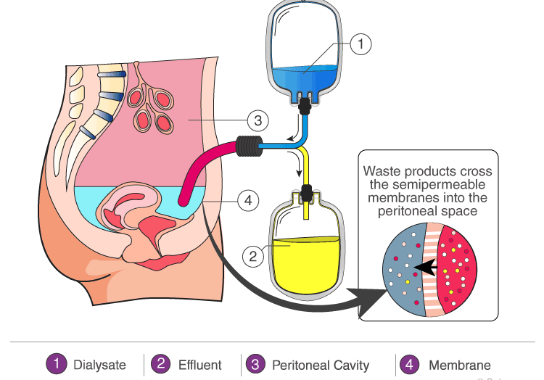
Other than the urinary system, skin, lungs, and even eyes helps in excreting waste products in different forms. Sweating is a mode of excretion where water, urea, and other salts are excreted through the skin. Lungs help us to exhale gaseous wastes such as carbon dioxide, nitrogen, etc.

Key Points On Human Excretory System
- Human excretory system includes organs that facilitate the removal of nitrogenous wastes from the body.
- The main excretory organs include kidney, ureter, urinary bladder and urethra.
- Kidneys filter the blood and urine is the filtrate obtained.
- Urine passes to the urinary bladder via ureter and is expelled out of the body. This is known as micturition.
- Kidneys also regulate the osmotic pressure of a mammal’s blood through excessive purification and filtration. This is known as osmoregulation.



