
Chapter-8
ELECTRICITY
STUDY NOTES

of energy which produces a sensation of hearing in our ears.
Propagation of Sound: Sound is produced by vibrating objects.
Medium: The matter or substance through which sound is transmitted is called a medium. It can be solid, liquid or gas. Air is the most common medium for sound propagation.
Wave: A wave is a disturbance that moves through a medium when the particles of the medium set neighboring particles into motion. They in turn produce similar motion in others. The particles of the medium do not move forward themselves, but the disturbance is carried forward. This is what happens during propagation of sound in a medium; hence sound can be visualized as a wave. Sound waves are characterized by the motion of particles in the medium and are called mechanical waves.
When a vibrating object moves forward, it pushes and compresses the air in front of it creating a region of high pressure. This region is called a compression (C), as shown in following figure. This compression starts to move away from the vibrating object. When the vibrating object moves backwards, it creates a region of low pressure called rarefaction (R).
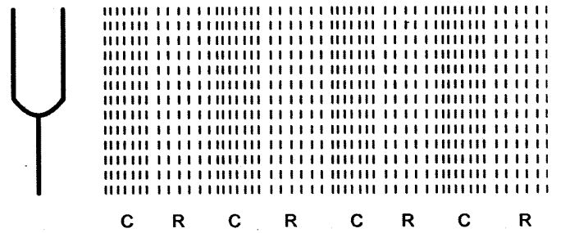
As the object moves back and forth rapidly, a series of compressions and rarefactions is created in the air. These make the sound wave that propagates through the medium. Compression is the region of high pressure and rarefaction is the region of low pressure.
Experiment to show Sound needs a medium:
Activity:
- Take and electric bell and airtight jar.
- Fit the bell inside the jar and attach to battery.
- With air still in jar ring the bell.
- Now take out air by vaccumization.
- Ring the bell again.
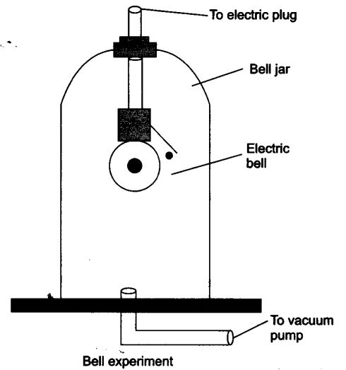
Observation: Sound of bell can be heard when air is inside the jar. When air is taken out then sound cannot be heard.
Conclusion: This shows that presence of medium is necessary for propagation of sound waves.

Properties of Sound Waves:
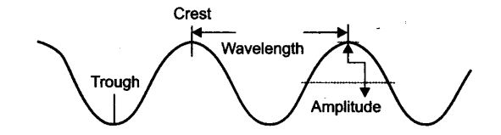

Wavelength
The distance between two successive crests or troughs (or) successive compressions and rarefactions is called as wavelength (λ). The SI unit of wavelength is metre (m).

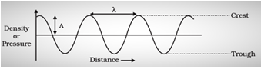
Frequency: Number of oscillations of sound waves is called its frequency. The number of peak and troughs per unit of time will give frequency. It is represented by v (nu) and its SI unit is Hertz (Hz).
The number of compressions or rarefactions per unit time is called frequency (𝛎).
The SI unit of frequency is Hertz. The SI unit is Hertz (s−1)
v=1/T
Speed (v), wavelength (λ) and frequency (𝛎) are related as v=λ𝛎
Time Period: The time taken to complete one oscillation is called its time period. Its unit is second and is represented by T.
Relation of frequency and time period:
v = 1/T
Amplitude: The magnitude of the maximum disturbance in the medium on either side of the mean value is called the amplitude of the wave. It is usually represented by the letter A. Its unit is meter.

Pitch
The number of compressions or rarefactions per unit time. Directly proportional to frequency.
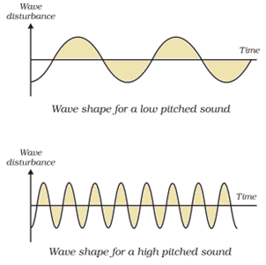
Softness or Loudness of Sound: If the amplitude is smaller, then the sound will be softer and if it is larger, then sound will be louder. Higher amplitude helps the sound wave is travelling faster.

Volume
Volume or loudness of a sound depends on the amplitude. The force with which an object is made to vibrate gives the loudness.

Higher force → higher amplitude → louder sound
The amount of sound energy flowing per unit time through a unit area is called the intensity of sound.
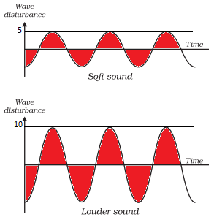
Speed of sound: It is the distance which compression or a rarefaction travels per unit of time.
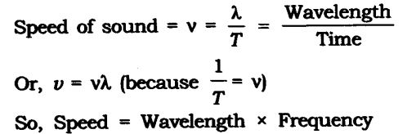

So, Speed = Wavelength Frequency
The speed of the sound remains almost the same for all frequencies in a given medium under the same physical condition.
Speed of Sound in Different Media at 25° C.

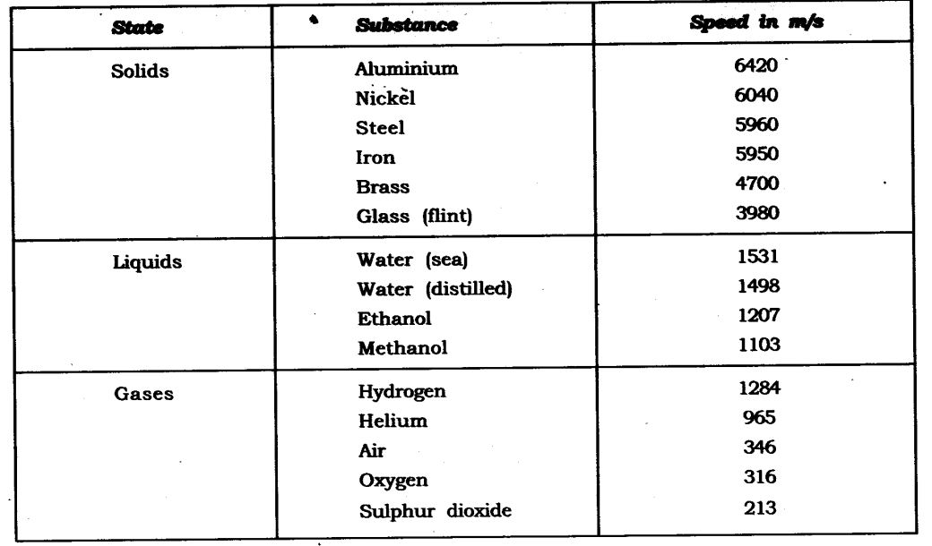

Note and Tone
A sound of a single frequency is called a tone. A sound produced with a mixture of several frequencies is called a note.

Quality of sound
The richness or timber of sound is called the quality. Sound with the same pitch and loudness can be distinguished based on the quality. Music is pleasant to the ears while noise is not. But they both can have the same loudness and pitch.

Reflection of Sound: Sound reflects off a surface in the same way as light reflects and follows same rules of reflection. The incident sound and the reflected sound make equal angles with the normal and all three are in the same plane.
Echo: In bigger monuments and in large empty halls you can hear reflections of your sound after you speak something. This effect is known as echo. The sensation of sound persists in our brain for 0.1 seconds, so to hear echo the time difference between original sound and reflected sound should be more than that.
As you know speed of sound in air is = 344 m/s And 344 x 0.1 = 34.4 metre
So, the minimum distance required to hear an echo from a reflecting wall or surface should be half of 34.4, means it should be 17.2 metres.
Reverberation: Repeated reflections of sound results in persistence of sound and is called reverberation.
Use of Reverberation of Sound: Following instruments use this property of sound:
- Megaphones, Shehanais, Trumpets
- Stethoscope
- Curved dome of concert halls

Sonar and Radar
SONAR – Sound Navigation And Ranging.
It is a technique that uses sound or ultrasonic waves to measure distance. The human range of hearing is 20Hz- 20 kHz.
What are Ultrasonic sounds?
Ultrasonic sounds are high-frequency sound having a frequency greater than 20kHz (inaudible range).
Applications of Ultrasound
(i) Scanning images of human organs
(ii) Detecting cracks in metal blocks
(iii) Cleaning parts that are hard to reach
(iv) Navigating, communicating or detecting objects on or under the surface of the water (SONAR).
Sonar consists of a transmitter and detector mounted on a boat or ship. The transmitter sends ultrasonic sound waves to the seabed which gets reflected back and picked up by the detector. Knowing the speed of sound in water, distance can be measured using: 2d=v×t. This method is called echo-location or echo ranging.

Doppler’s effect
If either the source of sound or observer is moving, then there will be a change in frequency and wavelength for the observer. The frequency will be higher when the observer moves towards the source and it decreases when the observer moves away from the source.
Example: If one is standing on a street corner and an ambulance approaches with its siren blaring, the sound of the siren steadily gains in pitch as it comes closer and then, as it passes, the pitch suddenly lowers.

Range of Hearing in humans:
From 20 Hz to 20000 Hz
Sounds below 20 Hz are called infrasonic.
Sounds above 20000 Hz are called ultrasonic.

Human Ear
The ear is a sensitive organ of the human body. It is mainly involved with detecting, transmitting and transducing sound and maintaining a sense of balance is another important function of the human ear. Human ear includes:
- The outer ear or the visible part of the ear is called the pinna.
- Pinna collects sound from the surroundings.
- Sound passes through a tube called an auditory canal.
- Eardrum (tympanic membrane) vibrates in response to incident sound waves.
- Vibrations are amplified and transmitted further by three bones hammer, anvil and stirrup in the middle ear to the inner ear.
- In the inner ear, cochlea converts pressure signals into electrical signals.
- Electrical signals are transmitted by the auditory nerve to the brain for interpretation.
