
SUBJECT : SOCIAL SCIENCE
CHAPTER NUMBER: 3
CHAPTER NAME : THE UNION LEGISLATURE- THE PARLIAMENT
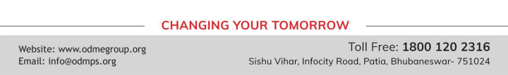
▪
▪
▪

THANKING YOU
ODM EDUCATIONAL GROUP

