
The Union Legislature
- the Parliament
SUBJECT : SOCIAL SCIENCE
CHAPTER NUMBER: 3
CHAPTER NAME : THE UNION LEGISLATURE- THE PARLIAMENT

Session-II
Rajya Sabha
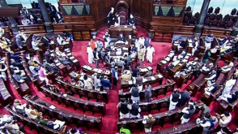
The Rajya Sabha consists of 250 members,
Its members are elected indirectly by the
members of the State Assemblies and two
Union Territories (Delhi and Pondicherry)
12 members are nominated by the
president of India from among
distinguished personalities in the country
Rajya Sabha is a permanent house because it is not subject to dissolution. Members of the Rajya like authors, journalists jurists, and
Sabha are elected for six years and one-third members retire after every two years
scientists.

THANKING YOU
ODM EDUCATIONAL GROUP

