
The Union Legislature
- the Parliament
SUBJECT : SOCIAL SCIENCE
CHAPTER NUMBER: 3
CHAPTER NAME : THE UNION LEGISLATURE- THE PARLIAMENT
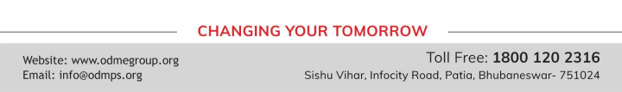
Session-I
Introduction
As we all know that India is a Federal, Republic Democratic Country. As it is having Federal Structure there are three levels of Government. Centre Government, State Government, Local Government.
Parliament
The body that governs India at the centre, India’s Union Legislature is known as the Parliament. It is the Lawmaking body of India. It consists of two houses
The Lok Sabha and The Rajya Sabha

Session-I
Lok Sabha
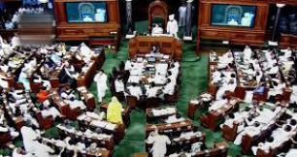
It is also known as House of People. Because its members
are directly elected by the people.
The maximum strength of the Lok Sabha is 552. Between
1952 and 2020, 2 additional members of
the Anglo-Indian community were also nominated by the
President of India on the advice of Government of India,
which was abolished in January 2020 by the 104th
Constitutional Amendment Act, 2019. A total of 131 seats (24.03%) are reserved for
representatives of Scheduled Castes (84) and Scheduled Tribes (47).
Election- It will be conducted every after 5 years. For the purpose of elections the country is divided in to several

Constituencies. During the elections the party which gets an absolute majority (more than half the seats in Parliament), is invited by the president to form the Government. .
Session-I
❖Qualifications- should be an Indian Citizen above the age of 25 years, should not be bankrupt or mentally unstable, and should not hold any salaried Govt job.
❖There are three sessions of Lok-Sabha – The Budget Session , The Monsoon Session , The Winter Session Speaker- The presiding officer of Lok Sabha. He usually belongs to ruling party.
❖The important powers of Speaker –
•Presides the Lok Sabha
•Maintains Discipline
•Certifies Money Bill
•May cast his vote to resolve the deadlock, if there is tie after voting.
•Allows the members to ask questions
THANKING YOU
ODM EDUCATIONAL GROUP

