Chapter-4
AND THEN, THE FIRST CITIES
STUDY NOTES

LEARNING GOALS:
- Indus Valley Civilisation
- Harappa
- City Planning
- Life of people
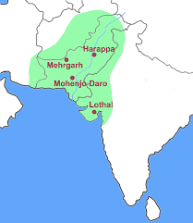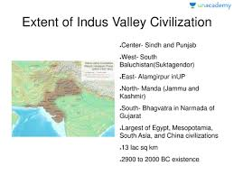

INDUS VALLEY CIVILIZATION
The Indus Valley Civilization prospered around 4700 years ago. The cities of that period flourished mainly in the valley of the river Indus. Hence, it was called the Indus Valley Civilization. Harappa was the first site of this civilization to be discovered. Hence, this is also called the Harappan Civilization.

Harappa is in modern day Pakistan. This site was accidentally Harappa discovered. The East India Company was doing the construction of railway lines in 1856. Initially, the construction workers thought the ruins to be of some ordinary old city. The bricks from the site were used for the construction. It was about 80 years ago that archaeologists could realize that it was an ancient city.
Mohenjo–Daro, Kalibangan, Lothal and Dholavira are some other important sites of the Indus Valley Civilization. About 150 sites of this civilization have been discovered till date.
Most of the sites of this civilization are in modern day Pakistan. Some of the sites are in India, e.g. Kalibangan (Northern Rajasthan), Banavali (Haryana), Dholavira (Gujarat) and Lothal (Gujarat). After excavations from different sites, it has become clear that this civilization was spread over major parts of western India and Pakistan and some parts of Afghanistan.
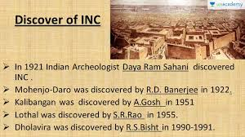

TOWN PLANNING:
- These cities show immaculate town planning.
- The city of Harappa was divided into two parts, i.e., western and eastern parts.
The western part of the city was smaller but higher. The higher part was called the citadel. The citadel contained some special structures.
- The eastern part of the city was larger but lower. The lower part was called the lower city.
- A huge tank has been found within the citadel. This has been named as the Great Bath by archaeologists. This was made from baked bricks. Its walls and floors were sealed by naturally occurring tar. There were steps on all sides so that people could easily go down the tank. Rooms were built around it. The historians guess that this was used by the ruling classes; for ritual bath.
- Rich people lived in the upper part of the city.
- Workers lived in the lower part of the city.

USE OF BAKED BRICKS:
Houses and other structures were made of baked bricks. Bricks were of uniform size. This means that the people of Harappa had developed good workmanship. Bricks were joined in interlocking pattern. This gave more strength to the building.

ROADS AND DRAINAGE:
Roads were paved with bricks. The road intersected at right angles. The drainage system was properly planned. Drain from each house was connected to the drains in the streets. Drains were covered with stone slabs. Inspection holes were made at frequent intervals on the drain.

PLANNED HOUSES:
The walls of the houses were strong and thick. Some of the houses were two storey high. This shows the well-developed architecture in those days. A house normally had a kitchen, a bathroom and a large courtyard. Wells were also present in most of the houses; to ensure continuous supply of water.

GRANARIES:
In the cities of the Indus Valley Civilization; a large granary has been found. Charred grains have been found in these granaries. This shows that food grain production was surplus during this period. Historians also guess that taxes were collected in the form of grains. Grains collected as tax were stored in such large granaries.

ART AND CRAFT:
- Clay, copper and bronze was used for making pots. Tools, weapons and seals were made from copper and bronze. Seals were also made from clay. Some large pots have also been found. They were probably used for storing grains.
- Jewelries were made of gold, beads, wood and clay. Precious stones; like cannelian, jasper, crystal, etc. were used to make beads.
- Clay and wood were used for making toys. A cart-shaped toy has been found in very good condition. This shows that animal-driven carts were used at that time.
- Ornate carvings can be seen on toys, pots and jewelry. This speaks about the fine craftsmanship of people of the Indus Valley Civilization.
- Some spindles have also been found. They were used for making threads. People knew how to make cotton thread.
- 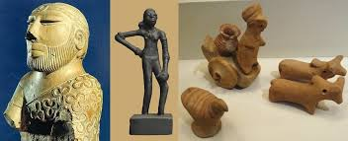

TRADE:
- Trade was the main occupation of people of Harappa. Copper came from Rajasthan and from Oman. Some of the seals from Harappa have been found in Mesopotamia. This shows that trade link existed between Harappa and Mesopotamia.
- A dockyard has been discovered in Lothal in Gujarat. This shows that trade through sea route existed at that time. Different types of seals show that proper systems of business transactions were followed.
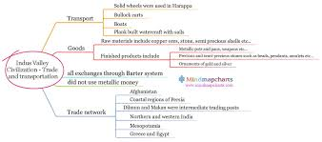
FARMING
- Remains of charred grains have been found. This shows that wheat, barley, pulses, pea, rice, sesame, linseed and mustard were grown in the villages of the Harappa Civilization.
- A toy model of plough has been found from the ruins. This shows that plough was used for tilling the land. Presence of large granaries and huge utensils shows that there was surplus food production at that time.
- Bones of many domesticated animals have been found from the excavation site. This shows that people of Harappa domesticated cattle, sheep, goat, buffalo and pig.
- Seals from the Harappa site show scripts on them. This shows that people of the city knew how to write. Historians are yet to decipher the script of the Indus Valley Civilization.
RELIGION
People worshipped gods and goddesses. Many statues have been found. A male figure; surrounded by animals; has brought special attention of the archaeologists. This figure is similar to the Hindu god Lord Shiva. We know that Lord Shiva is also known as Pashupatinath.
END OF THE CIVILISATION
Historians have not yet identified the proper cause of the decline of the Indus Valley Civilization. Some guesses have been made which are as follows:
- There is a possibility that the rivers dried up. It forced people to move to some other places.
- There were too many brick kilns and furnaces. It may have damaged the environment. This would have led to deforestation. Lack of green cover may have forced people to move to some other places.
- Overgrazing by cattle and sheep may also have resulted in loss of forests. This would have led to desertification, i.e., formation of desert.
- There is also a possibility of large-scale epidemic or natural calamity. It could have wiped off a major portion of the population.

**************************************************

