[TRANSPORTATION IN PLANTS.]
| BIOLOGY | STUDY NOTES-1

Chapter-1
Transportation in plants.
Sub-Transportation, conducting tissues- xylem( tracheid's, vessels ,wood parenchyma, wood fibre). Phloem (sieve tube, companion cells ,phloem parenchyma, phloem ,phloem fibre).

INTRODUCTION


“Transportation is the process that involves the movement of water and necessary nutrients to all parts of the plant for its survival.

“Transportation is a vital process in plants.

Trees transport all the nutrients and water it needs for survival from its roots to the tips of the leaves.

Plants have tissues to transport water, nutrients and minerals. Xylem transports water and mineral salts from the roots up to other parts of the plant, while phloem transports sucrose and amino acids between the leaves and other parts of the plant.

The vascular tissue for the transport of water and nutrients in the plant is called the xylem.
The food has to be transported to all parts of the plant. This is done by the vascular tissue called the phloem.

Thus, xylem and phloem transport substances in plants.
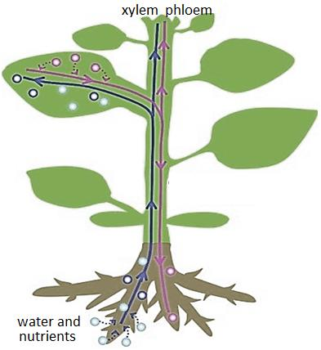
- In rooted plants, transport of water and minerals is essentially unidirectional, from roots to the stems, whereas organic and mineral nutrients however, undergo multidirectional transport.

xylem
Xylem originates from the Greek word “xylon” that means wood.
Carl Nägeli coined the word xylem.
Xylem is a type of vascular tissue present in plants, which primarily transports water and nutrients from roots to stem and leaves.
On the basis of origin, there are two types of xylem cells:
Xylem is composed of four different kinds of elements:
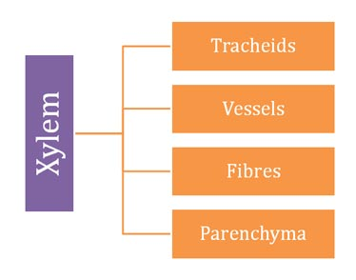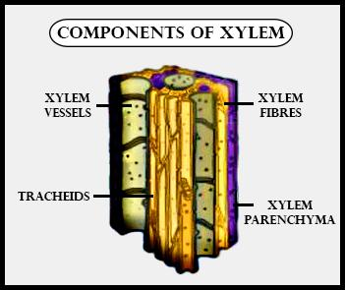
- Tracheids: Dead, tube-like cells with a tapering end. They are present mostly in gymnosperm and lower angiosperm. They have a thick lignified wall and lack protoplasm. Their main function is water and mineral transportation.
- Vessels: They are present in angiosperms. These are a long cylindrical structure having tube-like appearance. The walls are lignified and have a large central cavity. They are also dead and lack protoplasm. They have many cells called vessel members which are interconnected through a perforation in common walls. Mostly involved in the conduction of water, minerals and give mechanical strength to the plant.
- Xylem Fibre: Dead cell with lignified walls and a central lumen. Involved in water transportation and providing mechanical support.
- Xylem Parenchyma: Only living cells of xylem and store starch and fat. They assist in the short distance transportation of water.

What is the main function of xylem?
- The main function of the xylem is water transport from roots to the other parts of the plant.
- Xylem also provides mechanical strength.
- Tracheids and vessels are the main elements for conducting water.
- Xylem fibres provide mechanical support and
- xylem parenchyma stores food materials and tannins and also conducts water radially.

Phloem-

Phloem is a living tissue in vascular plants which conducts the soluble organic compounds synthesized during photosynthesis downwards from the leaves.
phloem is composed of four different kinds of elements:
- Companion cells – it appears to check the activity of the adjacent sieve element and participates in loading and unloading of the sugar into the sieve element
- Sieve tubes – these elongated living cells, conveys carbohydrates, chiefly sucrose from leaves to roots and fruits
- Phloem fibres – they are commercially useful as they possess great pliability and tensile strength
- Phloem parenchyma – also known as transfer cells, they are found near the finest branches, ends of sieve tubes in leaf veinlets, functional here in conveying food
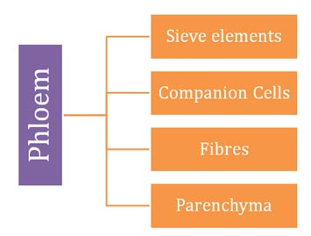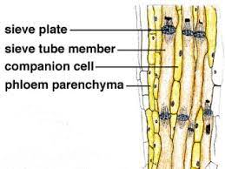

Differences between xylem and phloem
Xylem tissue | Phloem tissue
Movement of water from roots to all parts of plant | Movement of starch from leaf to all parts of plant
Upward direction | Bi-directional
Transpiration, root pressure, capillary action | Translocation
No energy required | Energy required

[TRANSPORTATION IN PLANTS.]
| BIOLOGY | STUDY NOTES-2

Chapter-1
Transportation in plants.
Sub-Water absorption by the roots, Root system of a plant, root hair, semi-permeable membrane, speciality of root hairs.
Water absorption by the roots.

water is very crucial for plants for different metabolic activities.
One of the most significant functions of the roots is to absorb water and minerals from the soil.
Terrestrial plants obtain their water supply from the soil
The root system of plants consists of main root, which gives out lateral roots
The lateral roots bear a large number of fine outgrowths called root hairs.
Root hair-
The root hair contains a cell wall made of an outer layer of pectin and an inner layer of cellulose. Functions of Root Hair:
- Increase the surface area of absorption of the root.
- Allows the entry of water due to imbibition and passive diffusion.
- The cell membrane is selectively permeable in nature and restricts the movement of molecules into and from the root hair.
Specialty of root hairs.
Ability of roots to absorb water depends on three factors:
- Large surface area,
- Root hairs with cell sap at higher concentration than soil water.
- Thin-walled root hairs.
What is a semi-permeable membrane?
A membrane which allows the entry of some substances but does not allow other substances to move across is called semi-permeable. Example: root hairs.

[TRANSPORTATION IN PLANTS.]
| BIOLOGY | STUDY NOTES-3

Chapter-1
Transportation in plants.
Sub-Movement of water and minerals, Active transport, passive transport,osmosis,diffusion, ascent of sap, root pressure.
osmosis
Osmosis is the movement of molecules from a region of higher concentration to a region of lower concentration across a semi-permeable membrane until an equilibrium is reached.
The plant cell wall is freely permeable to substances in solution and water. Osmosis is of two types:
- Endosmosis: This is the movement of water molecules enters into the cell when the cell is placed in a hypotonic solution.
- Exosmosis: This is the movement of water molecules out of the cell when the cell is placed in a hypertonic solution.
Plasmolysis
Plasmolysis is the process in which plant cell loses water when placed in a hypertonic solution. It depends upon three types of solutions:
- Isotonic: This refers to two solutions with the same osmotic pressure across the semi-permeable membrane.
- Hypotonic: This is the solution which has a lower osmotic pressure than another solution.
- Hypertonic: This is the solution with higher osmotic pressure than another solution.
The cells when placed in a hypotonic solution swell or get deplasmolysed. Whereas, the cells when placed in a hypertonic solution shrink or get plasmolysed.
Diffusion
- The movement of molecules from regions of higher concentration to regions of lower concentration is called diffusion.
- Movement by diffusion is passive.
- Diffusion rates are affected by the gradient of concentration, the permeability of the membrane separating them, temperature, and pressure.
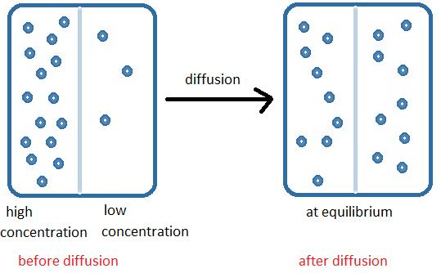
Active transport
- The movement of molecules against a concentration gradient, from the region of lower concentration to the region of higher concentration, with the help of ATP is called active transport.
- Active transport is an up-hill transport.

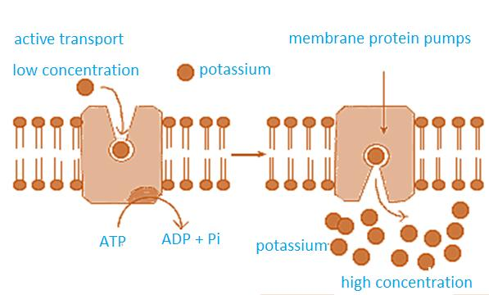

Ascent of sap:
Water enters a root hair → the cell content becomes dilute → cell next to the root hair cell will be more concentrated → Water enters by osmosis into this cell → Water, along with dissolved nutrients moves along from cell to cell and goes into the xylem.
Thus root pressure is the force which pushes water into the xylem. This is also called ascent of sap.
Root pressure: Root pressure refers to the osmotic pressure within the cells of a root system that causes sap to rise through a plant stem to the leaves.

[TRANSPORTATION IN PLANTS.]
| BIOLOGY | STUDY NOTES-4

Chapter-1
Transportation in plants.
Sub-Transpiration, transpirational pull, capillary force,cohesion and adhesion.factors affecting the rate of transpiration, importance of transpiration in plants, Micronutrients,Macronutrients
Capillary action:
Capillary action is the movement of liquid through a narrow space like oil rising through the wick of a lamp. Since xylem cells are long and thin, water moves up by capillary action.

Transpiration
All leaves have small pores called stomata on the epidermis. Water is lost by evaporation from these stomata as water vapour by a process called transpiration. This creates a pull on the xylem cells and water rushes to fill the space left by evaporating water molecules. This forces the water to move up due to suctional pull or suction pressure.
Root pressure, sectional pull and cohesive forces all act together to transport water and minerals. No process is singly sufficient to provide water to tall trees.
Factors affecting the rate of transpiration.
- Sunlight
- Temperature
- Wind
- Humidity
Importance of transpiration in plants
- Cools the surface of the leaves.
- Helps in growth and development.
- It controls the temperature of the plants.
- Allows the movement of minerals from the soil to different parts of the plant.

Uses of water in the plant- The various functions of water in plants include:

- maintaining cell turgidity for structure and growth;

- transporting nutrients and organic compounds throughout the plant; comprising much of the living protoplasm in the cells;

- serving as a raw material for various chemical processes, including photosynthesis

Importance of minerals
Micronutrients-1- Nitrogen- major constituent of all protein.
Deficiency- Yellowing of leaves, wrinkling of cereal grains.
2-phosphorous- constituent of cell membrane and certain proteins.
Deficiency- purple and red spots on leaves, delay in seed germination.
3- potassium- more abundant in growing tissues, opening and closing of stomata.
Deficiency- poor growth with reduced rate o transpiration.
Macronutrients-1- iron- constituent of some proteins.
Deficiency- yellowing of leaves.
2-manganese- constituent of some enzymes
Deficiency -yellowing of leaves with grey spots.
3- zinc- constituent of plant hormones, activates enzymes.
Deficiency- deshaped leaves, yellowing of leaves, stunted plant growth.

