[THE CIRCULATORY SYSTEM]
| BIOLOGY | STUDY NOTES-1

Chapter-6
THE CIRCULATORY SYSTEM
Sub- Blood, Tissue fluid, Lymph, Blood and Lymph circulation.

HUMAN CIRCULATORY SYSTEM

- The circulatory system is made up of blood vessels that carry blood away from and towards the heart.
- Arteries carry blood away from the heart and veins carry blood back to the heart.
- The circulatory system carries oxygen, nutrients, and hormones to cells, and removes waste products, like carbon dioxide.

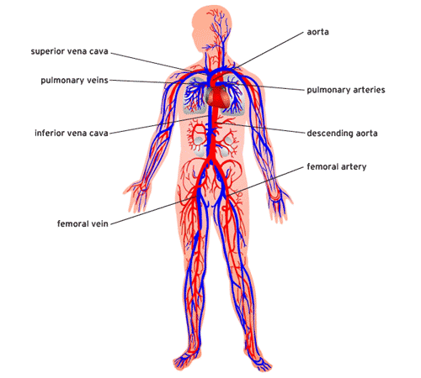
FLUIDS IN OUR BODY
There are three principal fluids in our body:
- Blood
- Tissue fluid
- Lymph
Blood

- Blood is a body fluid in humans and other animals that delivers necessary substances such as nutrients and oxygen to the cells and transports metabolic waste products away from those same cells.
- In vertebrates, it is composed of blood cells suspended in blood plasma.

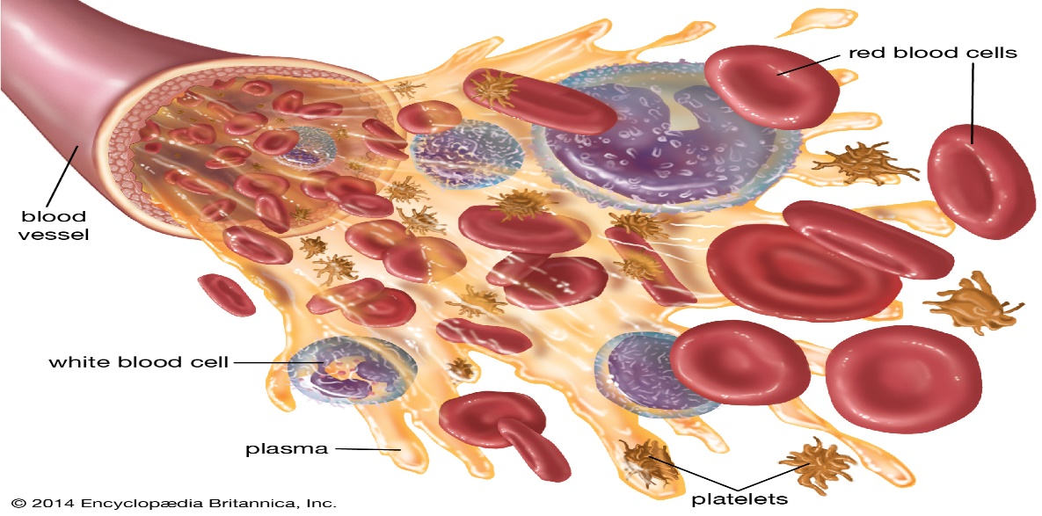

Tissue fluid

- Fluid found in the spaces around cells.
- It comes from substances that leak out of blood capillaries (the smallest type of blood vessel).
- It helps bring oxygen and nutrients to cells and to remove waste products from them. As new tissue fluid is made, it replaces older fluid, which drains towards lymph vessels.
- When it enters the lymph vessels, it is called lymph. Also called interstitial fluid.

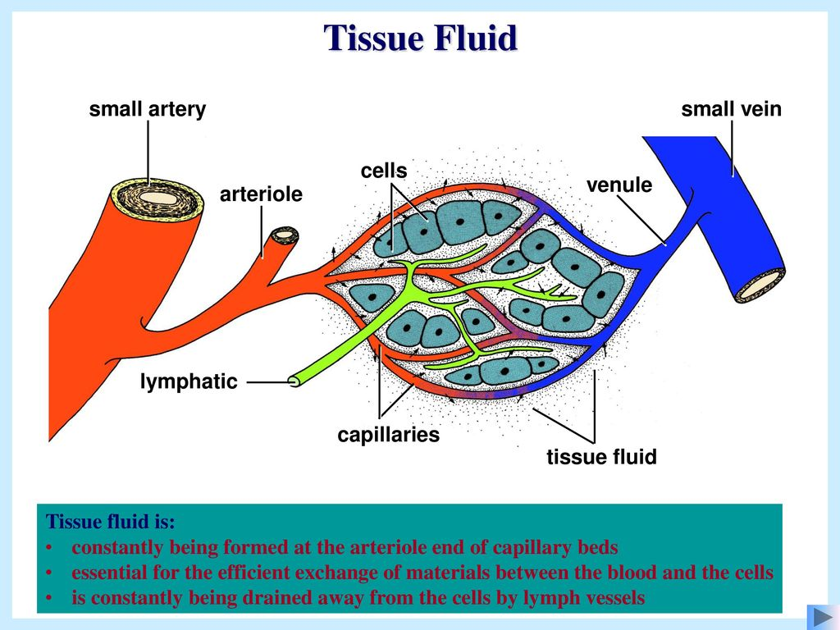

lymph

- Lymph is a clear-to-white fluid made of: White blood cells, especially lymphocytes, the cells that attack bacteria in the blood.
- Fluid from the intestines called chyle, which contains proteins and fats.

Vascular system

- A specialized network of vessels for the circulation of fluids throughout the body tissues of an animal.
- All animals, apart from simple invertebrate groups, possess a blood vascular system, which enables the passage of respiratory gases, nutrients, excretory products, and other metabolites into and out of the cells.

What is the vascular system?
- Arteries. Blood vessels that carry oxygenated blood away from the heart to the body.
- Veins. Blood vessels that carry blood from the body back into the heart.
- Capillaries. Tiny blood vessels between arteries and veins that distribute oxygen-rich blood to the body.
Almost all multicellular organisms need a circulatory system to transport oxygen and nutrients through the body. Evolution has led to the existence of two types of circulatory systems namely:
- Open circulatory system: primarily found in invertebrates. Here, the blood flows freely through cavities since there are no vessels to conduct the blood.
- Closed circulatory system: is found in vertebrates and a few invertebrates like earthworms. This system has vessels that conduct blood throughout the body.
Blood and lymph circulation

- Together, the blood, heart, and blood vessels form the circulatory system.
- The lymphatic system (lymph, lymph nodes and lymph vessels) supports the circulatory system by draining excess fluids and proteins from tissues back into the bloodstream, thereby preventing tissue swelling.

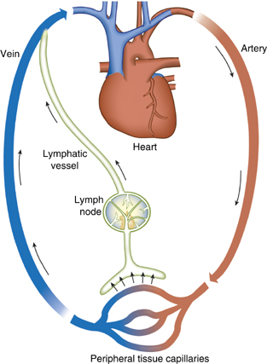

[THE CIRCULATORY SYSTEM]
| BIOLOGY | STUDY NOTES-2

Chapter-6
THE CIRCULATORY SYSTEM
Sub- Human heart, Internal structure of the Human heart, pacemaker.
Human Heart
- The human heart is one of the most important organs responsible for sustaining life.
- It is a muscular organ with four chambers.
- The size of the heart is the size of about a clenched fist.
- The human heart functions throughout a person’s lifespan and is one of the most robust and hardest working muscles in the human body.
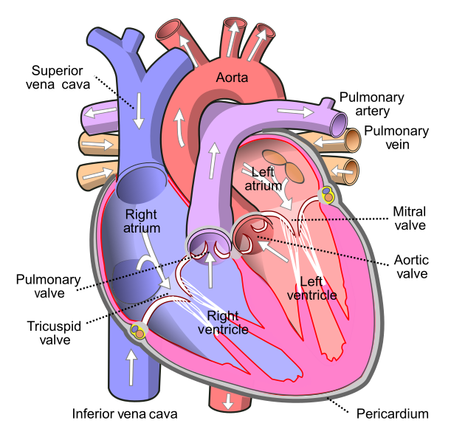

Position of Heart in Human Body
- The human heart is located between the lungs in the thoracic cavity, slightly towards the left of the sternum (breastbone). It is derived from the embryonic mesodermal germ layer.

Structure of the Human Heart
- The human heart is situated to the left of the chest and is enclosed within a fluid-filled cavity described as the pericardial cavity.
- The walls and lining of the pericardial cavity are made up of a membrane known as the pericardium.
- The human heart is about the size of a human fist and is divided into four chambers, namely two ventricles and two atria.
- The ventricles are the chambers that pump blood and atrium are the chambers that receive blood. Among which both right atrium and ventricle make up the “right heart,” and the left atrium and ventricle make up the “left heart.” The structure of the heart also houses the biggest artery in the body – the aorta.

- The right and the left region of the heart are separated by a wall of muscle called the septum.

- The right ventricle pumps the blood to the lungs for re-oxygenation through the pulmonary arteries. The right semilunar valves close and prevent the blood from flowing back into the heart. Then, the oxygenated blood is received by the left atrium from the lungs via the pulmonary veinsChambers of the Heart
- Vertebrate hearts can be classified based on the number of chambers present.
- For instance, most fish have two chambers, reptiles and amphibians have three chambers. Avian and mammalian hearts consist of four chambers.
- Humans are mammals; hence, we have four chambers, namely:
- Left atrium
- Right atrium
- Left ventricle
- Right ventricle
Atria are thin, less muscular walls and smaller than ventricles. These are the blood-receiving chambers that are fed by the large veins.
Ventricles are larger and more muscular chambers responsible for pumping and pushing blood out to the circulation. These are connected to larger arteries that deliver blood for circulation.

Valves
- Valves are flaps of fibrous tissues located in the cardiac chambers between the veins. They ensure that the blood flows in a single direction (unidirectional). Flaps also prevent the blood from flowing backwards. Based on their function, valves are of two types:
- Atrioventricular valves are between ventricles and atria. The valve between the right ventricle and right atrium is the tricuspid valve, and the one which is found between the left ventricle and left atrium is known as the mitral valve.
- Semilunar valves are located between the left ventricle and aorta. It is also found between the pulmonary artery and right ventricle.
Pacemaker

- A pacemaker is a device that sends small electrical impulses to the heart muscle to maintain a suitable heart rate or to stimulate the lower chambers of the heart (ventricles).
- A pacemaker may also be used to treat fainting spells (syncope), congestive heart failure and hypertrophic cardiomyopathy.

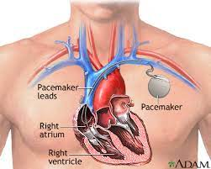

[THE CIRCULATORY SYSTEM]
| BIOLOGY | STUDY NOTES-3

Chapter-6
THE CIRCULATORY SYSTEM
Sub- Blood vessels, Vena cava, Difference between arteries and veins
Blood Vessels
- The external structure of the heart has many blood vessels that form a network, with other major vessels emerging from within the structure.
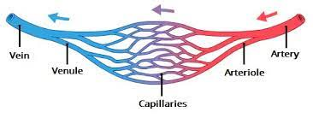
- The blood vessels typically comprise the following:
- Arteries are muscular-walled tubes mainly involved in supplying oxygenated blood away from the heart to all other parts of the body. Aorta is the largest of the arteries and it branches off into various smaller arteries throughout the body.
- Veins supply deoxygenated blood to the heart via inferior and superior vena cava, and it eventually drains into the right atrium. 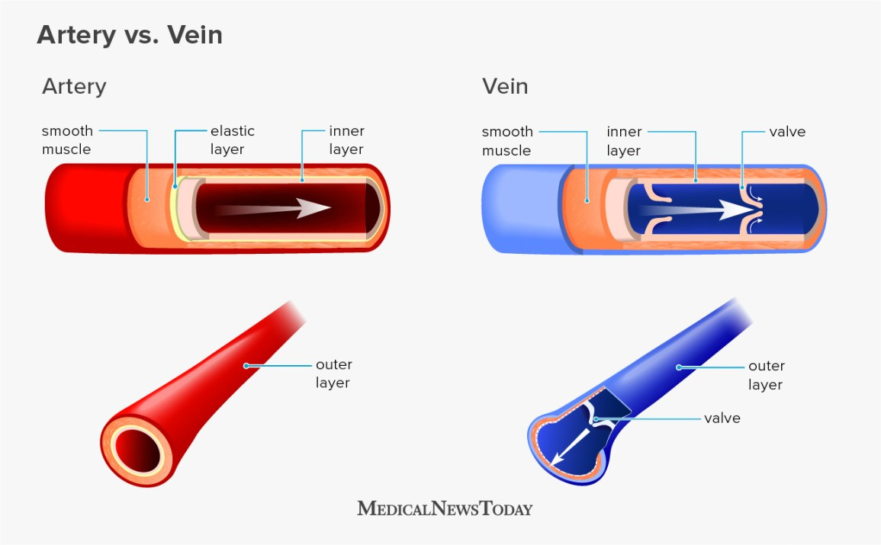
- Capillaries are tiny, tube-like vessels which form a network between the arteries to veins.

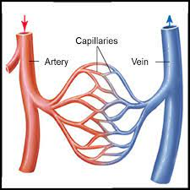

Blood vessels of the heart

- The major blood vessels connected to your heart are
- the aorta,
- the superior vena cava,
- the inferior vena cava,
- the pulmonary artery (which takes oxygen-poor blood from the heart to the lungs where it is oxygenated),
- the pulmonary veins (which bring oxygen-rich blood from the lungs to the heart),
- the coronary. artery and
- the coronary vein

Difference between arteries and veins

Parameter | Arteries | Veins
Transport direction | Carries blood away from the heart | Carries blood towards the heart
Type of blood | Carries oxygenated blood | Carries deoxygenated blood
Location | Its location is deep within the body | Its location is close to the skin
Colour | Their colour is red due to the oxygenated blood | Their blood is blue due to the deoxygenated blood
Pulmonary vessel | The pulmonary artery carries blood that is deoxygenated | The pulmonary vein carries blood that is certainly oxygenated
Resistance/capacitance | They are resistance blood vessels | They are capacitance blood vessels
Lumen | The lumen in arteries is narrow | The lumen in veins is wide
Pressure intensity | The pressure of blood flowing is high | The pressure of blood flowing is low
Rate of blood flow | The rate of blood flow is rapid and quick | The rate of blood flow is slow and steady

[THE CIRCULATORY SYSTEM]
| BIOLOGY | STUDY NOTES-4

Chapter-6
THE CIRCULATORY SYSTEM
Sub- Blood circulation, Double circulation

How Does Blood Flow Through the Heart?
The right and left sides of the heart work together. The pattern described below is repeated over and over, causing blood to flow continuously to the heart, lungs, and body.
Right side
- Blood enters the heart through two large veins, the inferior and superior vena cava, emptying oxygen-poor blood from the body into the right atrium.
- As the atrium contracts, blood flows from your right atrium into your right ventricle through the open tricuspid valve.
- When the ventricle is full, the tricuspid valve shuts. This prevents blood from flowing backward into the atria while the ventricle contracts.
- As the ventricle contracts, blood leaves the heart through the pulmonic valve, into the pulmonary artery and to the lungs where it is oxygenated.
Left side
- The pulmonary vein empties oxygen-rich blood from the lungs into the left atrium.
- As the atrium contracts, blood flows from your left atrium into your left ventricle through the open mitral valve.
- When the ventricle is full, the mitral valve shuts. This prevents blood from flowing backward into the atrium while the ventricle contracts.
- As the ventricle contracts, blood leaves the heart through the aortic valve, into the aorta and to the body.
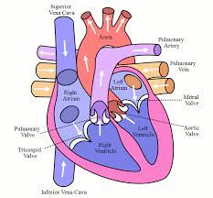

Double circulation

In double circulation, there are two pathways in which the blood flows. They are:
- Systemic circulation
Systemic circulation carries oxygenated blood from the left ventricles to the tissue capillaries.
- The oxygen-rich blood is transferred to the aorta for circulating into various parts of the body.
- Later, the veins and venules collect the deoxygenated blood – which is rich in carbon dioxide from various parts of the body.
- The deoxygenated blood is pumped back into the superior vena cava and then to the right atrium.
- Once, after receiving the deoxygenated blood, the right atrium carries blood to the right ventricle for pulmonary circulation.
- Pulmonary circulation
In the pulmonary circulation, the blood circulation starts from the right atrium to the left atrium. In this pathway:
- The pulmonary artery collects the blood from the right ventricle and carries to lungs for oxygenation.
- Once, after the purification process, the oxygenated blood is pumped back to the left atrium through the pulmonary vein which is carried to the left ventricles.
- The left ventricles pump the oxygenated blood to the aorta for systemic circulation.

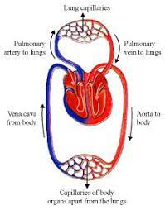

[THE CIRCULATORY SYSTEM]
| BIOLOGY | STUDY NOTES-5

Chapter-6
THE CIRCULATORY SYSTEM
Sub- Lymphatic system, composition of lymph, functions of Lymph.

Tissue fluid
- Fluid found in the spaces around cells. It comes from substances that leak out of blood capillaries (the smallest type of blood vessel).
- It helps bring oxygen and nutrients to cells and to remove waste products from them. As new tissue fluid is made, it replaces older fluid, which drains towards lymph vessels.

Lymph and lymphatic system

- The lymphatic system is a network of tissues, vessels and organs that work together to move a colorless, watery fluid called lymph back into your circulatory system (your bloodstream).
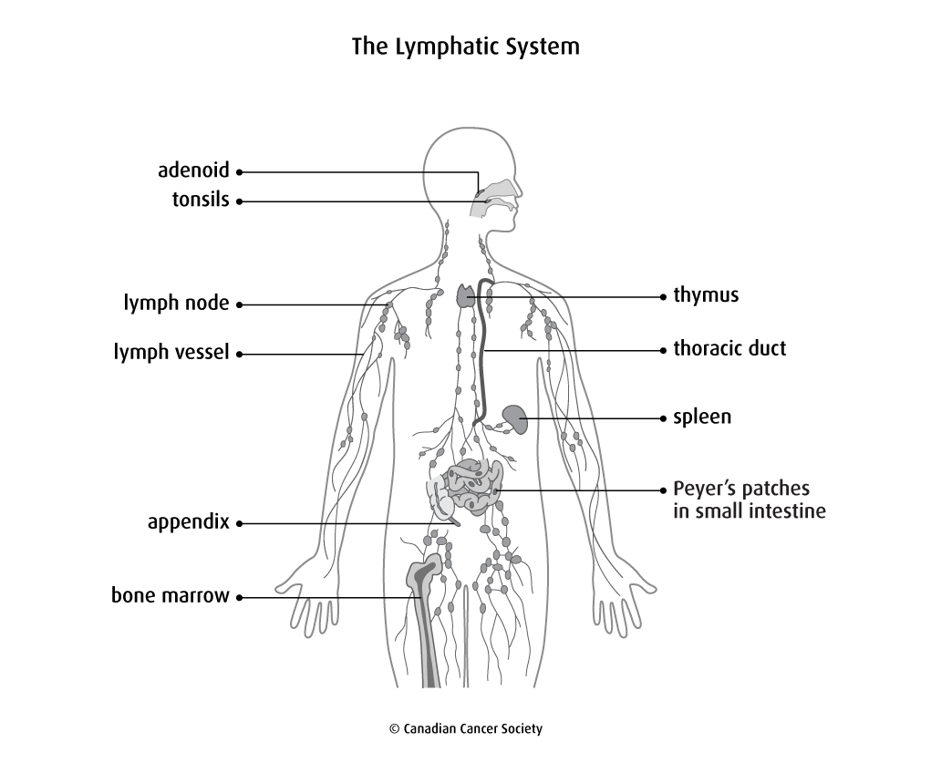

Composition of lymph
- Lymph contains a variety of substances, including proteins, salts, glucose, fats, water, and white blood cells.
- Unlike your blood, lymph does not normally contain any red blood cells.
- The composition of lymph varies a great deal, depending on where in your body it originated.

Functions of lymph
- Nutritive
- Drainage
- Absorption
- defense

Differences between lymph and blood

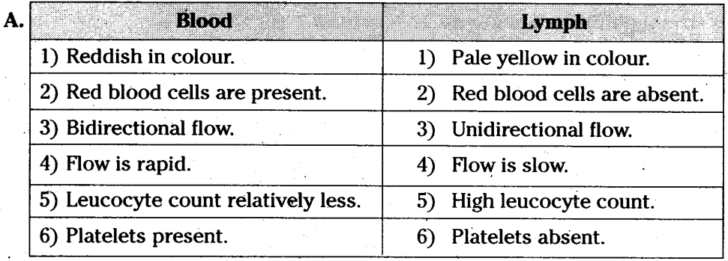

[THE CIRCULATORY SYSTEM]
| BIOLOGY | STUDY NOTES-6

Chapter-4
THE CIRCULATORY SYSTEM
Sub- Blood groups, Matching of blood groups. Palpitations, Hypertension, Heart attack, Cardiac arrest, keeping the heart Healthy

Blood groups
- A blood type is a classification of blood, based on the presence and absence of antibodies and inherited antigenic substances on the surface of red blood cells. These antigens may be proteins, carbohydrates, glycoproteins, or glycolipids, depending on the blood group system.
- There are 4 main blood groups (types of blood) – A, B, AB and O. Your blood group is determined by the genes you inherit from your parents.

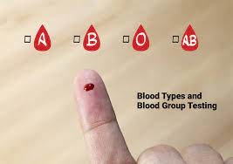

Matching of blood group

- Donors with blood type A... can donate to recipients with blood types A and AB
- Donors with blood type B... can donate to recipients with blood types B and AB
- Donors with blood type AB... can donate to recipients with blood type AB only
- Donors with blood type O... can donate to recipients with blood types A, B, AB and O (O is the universal donor: donors with O blood are compatible with any other blood type)
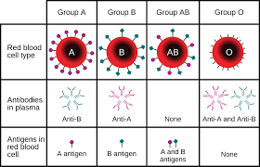
- Recipients with blood type O... can receive a kidney from blood type O only
- Recipients with blood type A... can receive a kidney from blood types A and O
- Recipients with blood type B... can receive a kidney from blood types B and O
- Recipients with blood type AB... can receive a kidney from blood types A, B, AB and O (AB is the universal recipient: recipients with AB blood are compatible with any other blood type)
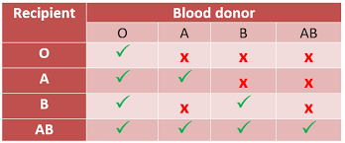

Blood donation and blood bank

- Also known as Giving Blood, Donating Blood, Blood Drive, Apheresis. Volunteer blood donation is a safe and simple procedure that involves a donor giving one of the following blood products: whole blood, red blood cells, plasma, or platelets.
- A blood bank is a center where blood gathered as a result of blood donation is stored and preserved for later use in blood transfusion

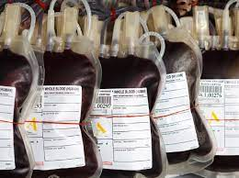

Heart related conditions

- Palpitations
- Hypertension
- Heart attack
- Cardiac arrest

Palpitations
Heart palpitations are heartbeats that suddenly become more noticeable. Your heart may feel like it's pounding, fluttering or beating irregularly, often for just a few seconds or minutes. You may also feel these sensations in your throat or neck.

Hypertension
High blood pressure (hypertension) is a common condition in which the long-term force of the blood against your artery walls is high enough that it may eventually cause health problems, such as heart disease.

Heart attack
A heart attack is when blood flow to the heart is blocked. It's a circulation problem. With sudden cardiac arrest (SCA), the heart malfunctions and suddenly stops beating unexpectedly. Sudden cardiac arrest is an electrical problem. A heart attack can cause a cardiac arrest.

Cardiac arrest

Cardiac arrest is a sudden loss of blood flow resulting from the failure of the heart to pump effectively. Signs include loss of consciousness and abnormal or absent breathing. Some individuals may experience chest pain, shortness of breath, or nausea immediately before entering cardiac arrest.

Difference between a cardiac arrest and a heart attack

Heart Attack | Cardiac Arrest
Heart attacks usually occur due to the blockage of a coronary artery in the heart. | Cardiac Arrests usually occur when the heart stops beating due to certain reasons.
The primary cause for getting heart attacks is due to the blood clots that occur in the arteries. | Cardiac arrests cause the stopping of the heart, leading to heart failure primarily due to Ventricular fibrillation.
Heart attacks may be caused due to a variety of different factors including drowning, shock, hypothermia etc. | Cardiac arrests, on the other hand, can also occur due to heart attacks.
Symptoms of a heart attack are chest pain, shortness of breath, wheezing and coughing. | Symptoms of a cardiac arrest are unconsciousness, shortness of breath and no pulse
Heart attack victims are usually smokers and people with unhealthy diets. | Cardiac arrest victims may also be overweight people and those without regular exercise.

Keeping the heart healthy

