
CHAPTER- IV

The Union Executive

STUDY NOTES

Introduction

In parliamentary democracy there are three branches of government. They are legislature, executive, and judiciary.

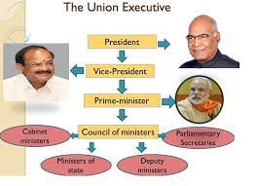

The executive is a part of the government which executes or puts in to action the laws passed by the legislature.
The union executive consists of the
- President
- Vice president
- Prime minister
- Council of Ministers.
The Council of Ministers consists of the
- Cabinet ministers
- Ministers of state
- Deputy ministers

PRESIDENT

In a parliamentary form of government there is a nominal head of the state. This nominal head of the state may be a hereditary monarch as in the case of UK or an elected president as in the case of India. Being a parliamentary form of government, India has a separate head of the state and separate head of the government. The head of the State holds the highest office and it is the president of India. The head of the government is the prime minister. The position of the president is however mainly that of a figurehead. He or she is bound by the Constitution to follow the advice of the prime minister.

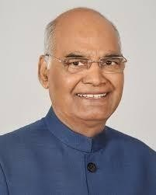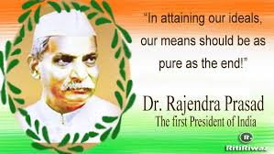

Qualifications

The qualifications necessary to become the president of India are
- Should be an Indian citizen and above the age of 35 years
- Should not be bankrupt or mentally unstable Should not hold any salaried government job

- How is the president elected?
The election of the president of India is done through an electoral college consisting of members of both the houses of parliament, and the legislative assemblies and legislative councils of all states and union territories.

Term of Office.

The term of office is five years.

The president may resign from the office by sending a letter to the vice president who then would forward the letter to the Lok Sabha’s speaker.

If the president loses the trust of Parliament, he can be removed from the office through a special process known as impeachment.

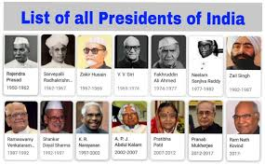

Powers of the President

Executive power of the President

- The president invites the leader of the majority party to form the Govt and also appoints the Council of Ministers on the advice of the prime minister

- He appoints the governors of the state, the attorney- general, the auditor- general, the chief election Commissioner, ambassadors of India to other countries, judges and chief justice of the high court and Supreme Court

- The president is the supreme Commander of the armed force

- The president, a head of the state, can declare the war or sue for peace

and conclude treaties with other countries

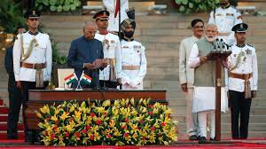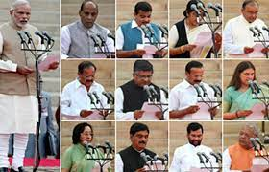

Legislative Power

- The president summons and prorogues all the sessions of the parliament
- No bill can be become a law without the president’s signature.
- The president promulgates ordinances when the parliament is not in session.
- When there is deadlock in the parliament over a particular bill, the president call for a joint session
- The president can dissolve the parliament on the advice of the Council of Ministers

Judicial powers

The president can reduce or commute death sentence to life imprisonment on receiving a petition of mercy.

Emergency Powers

The president on the advice of the prime minister and council of ministers, can declare
a state of emergency

  - If there is an internal crisis or civil war like situation in the country.

  - If there is an external force threatening the sovereignty of the country

- If there is a breakdown in the constitutional machinery of a particular state.

- If there is a threat to the financial stability of the country.

Vice President

The Vice president is the ex- officio chairman of the Rajya Sabha. The powers of Vice President
- He presides over day to day matters of Rajya Sabha.

- In the absence of the president of India the vice president officiates as the president.

On the advice of the prime minister, the vice president act as the president till the newly elected president assumes power

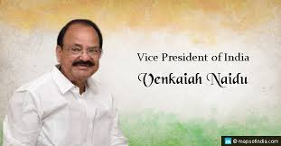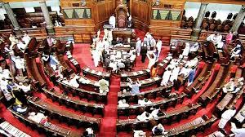

Prime Minister and the Council of Ministers

Powers of the Prime Minister

- On the recommendation of the prime – minister, the president appoints Council of ministers

- The prime – minister is the link between the parliament and the president and also between the council of ministers and the president

- It is the prime minister who advises the president on the appointment of the governors, the auditor- general, the chief election Commissioner, ambassadors, chief election commissioner, judges etc

- The prime minister advises the president to summon, dissolve, and prorogue the parliament.

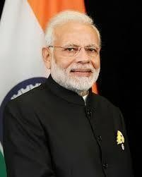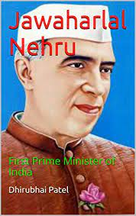

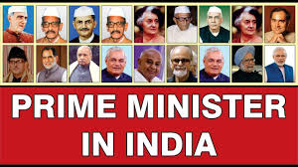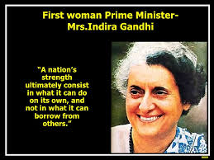

Council of Ministers

The Council has three categories of ministers

  - Cabinet Ministers
  - Ministers of State
  - Deputy ministers

The department of each minister is known as portfolio Important powers of Council of ministers
- Ministers introduce the government bills in the parliament

- The Union budget is prepared by the Council of Minister

- All the laws passed by the parliament are put into effect by the ministers

Collective responsibility

If the parliament loses its confidence in the Council of Ministers and its functioning, a motion of No- Confidence can be introduced in the Lok-Sabha and it is passed with a simple majority.

The Prime – Minister and Council of Ministers must resign collectively is called Collective Responsibility. In the Indian Democracy, the ministers are collectively responsible to the Lok Sabha as the Lok Sabha represents the people of India.

If the prime minister quits, the entire Council of Ministers will also have to resign

Civil servants
The officials who play an important role in the administration of the country and carry the day-to-day work of the Government are known as Civil Servants.
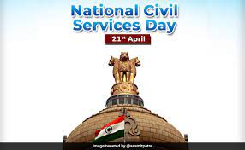

Civil servants
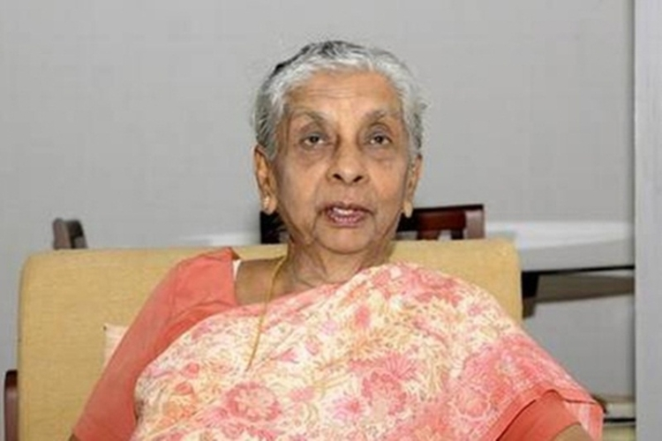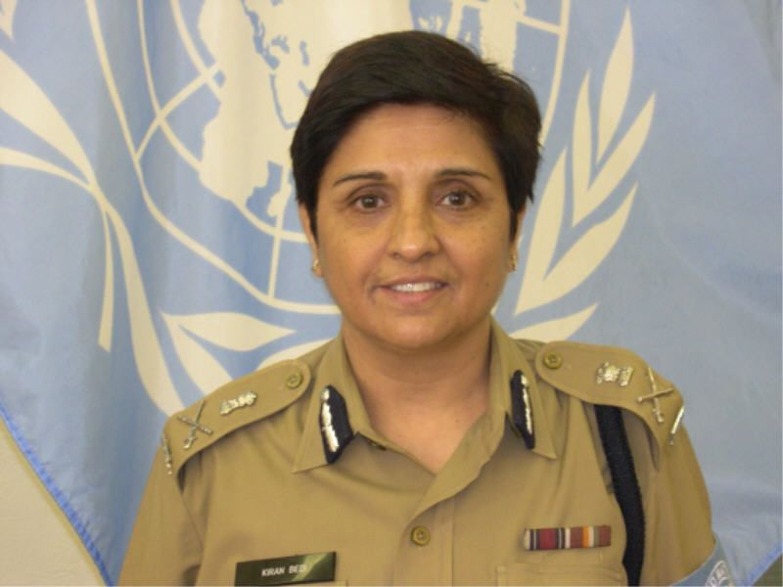
Anna Rajam Malhotra Kiran Bedi, The First Woman IPS Officer
India’s first female
IAS officer

