Chapter- 1
The French Revolution
STUDY NOTES
INTRODUCTION
- On 14th July , 1789,around 7000 men & women of Paris gathered in front of the town hall. They destructed number of buildings in search of arms.
- The king ordered his troops to move into the city. Several hundred people stormed the Bastile, the fortress prison of Paris. The commander of the Bastile was killed and seven prisoners were released.
- The Bastile was hated by all French people as it symbolised the despotic power of the king. The fortress was demolished .

EVENT OF 14 JULY 1789 → OUTBREAK OF FRENCH REVOLUTION
↓
- STORMING OF PERSON
- DEMOLISHING OF FORTRESS[BASTILLE]
- RIOTING IN PAIRS AND COUNTRYSIDE
FRENCH SOCIETY DURING THE LATE EIGHTEENTH CENTURY
- In 1774, Louis XVI of the Bourbon Dynasty became the king of France. He married to the Austrian princess Marie Antoinette. When he became the ruler he found an empty treasury, long years of wars and the extravagant lifestyle had drained the financial resources of France.
- IN 1774 , LOUIS XVI OF BOURBON FAMILY
↓
- MARRIED TO AUSTRIAN PRINCESS MARIE ANTOINETTE
↓
- UPON HIS ACCESSION HE FOUND AN EMPTY TREASURY

- FEUDAL SOCIETY [OLD REGIME→ BEFORE 1789]
- French society was divided into three estates:-

CLERGY
1ST ESTATE

NOBILITY
2ND ESTATE

PEASANTS, MERCHANTS, LABOURS ETC.
3RD ESTATE

- ENJOY PRIVILEGES BASED ON BIRTH
- EXEMPTION FROM PAYING TAX

THEY WERE OBLIGED TO PAY TAXES RENDER SERVICES
- Two types of taxes collected from the common people:
- Tithes Tax levied by the church from the peasants
- Taille Tax to be paid directly to the state

REASONS FOR EMPTY TREASURY
- Long years of wars and the extravagant lifestyle had drained the financial resources of France.
- Louis XVI helped the thirteen American colonies to gain their independence from Britaincommon enemy.
- The war added more than a billion livres to a debt that became more than two billion livres.
- High interest on loans Large amount was spent on paying taxes
- Regular expenses { Army, Court, Government Offices or Universities}
- Tax was paid by the third estate.

THE STRUGGLE TO SURVIVE
- A Subsistence crises which can be defined as an extreme situation where the basic means of livelihood are endangered.
- Causes of Subsistence Crises:-
- Increase in population from 2 million in 1715 to 28 million in 1789
- Rapid increase in demand for food grains
- Bad harvest due to drought

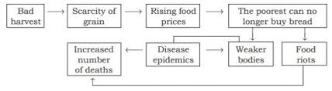

EMERGENCE OF MIDDLE CLASS
- In the 18th century, a new social group emerged who were known as the middle class. The merchants, manufacturers, lawyers and administrative officials believed that no group of society should be privileged by birth, but their positions depend on merit.
- Demanded a society based on freedom and equal laws and opportunities and inspired by the philosophers.
- Enlightened the ideas Discussed in public places spread among people.
Two Treatises of Government
Criticized the doctrine of the divine and absolute right of the monarch
JOHN LOCKE

Equal voting, democratic Government

The Social Contract Theory
J.J.ROUSSEAU

Separation of powers: Legislative, Executive and Judiciary
The Spirit of Laws
MONTESQUIEU

THE OUTBREAK OF THE REVOLUTION

- Louis XVI planned to impose taxes
- In order to increase the taxes he called the meeting of Estates General to pass the proposal on 5th May, 1789 at Versailles.
- The Estate General was a political body to which the three estates sent their representatives.
- The first and the second estate sent 300 representatives and the third estate sent 600 representatives.
- The Estate General demanded a democratic method of voting. The members of the third estate demanded that voting should be conducted b where each member would have one vote..
- This proposal was rejected by the king,
- The representatives of the third estate assembled in the hall and declared themselves a national assembly.
- Drafted a constitution for France to limit the powers of monarch which was led by Abbe Sieyes (priest) and Mirabeau (noble).
- Abbe Sieyes wrote an influential pamphlet “What is the Third Estate?”

FRANCE BECOMES A CONSTITUTIONAL MONARCHY
- The national assembly completed the draft of constitution in 1791.
- Its main objective to limit the powers of monarch. The powers were separated and assigned to different institutions – the legislature, executive and judiciary.
- The constitution of 1791 gave power to make laws in the national assembly. which was indirectly elected.
- Not all citizens had the right to vote.

Men above 25 years, who paid taxes equal to at least 3 days of labour’s wage entitled to vote
ACTIVE CITIZENS

The remaining men and all women
PASSIVE CITIZENS

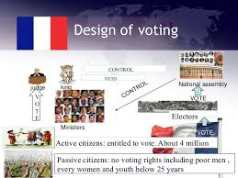

FRANCE ABOLISHES MONARCHY AND BECOMES A REPUBLIC

- Louis XVI had signed the constitution but he entered into secret negotiation with the King of Prussia.
- The national assembly declared war against Prussia and Austria.
- The patriotic song Marseillaise composed by the poet Roget de L’isle
- Thousands of volunteers joined army, sang the patriotic song and marched into Paris.
- The Marseillaise which became the national anthem of France.
- The constitution of 1791 gave political rights only to the rich people of the society.
- Political clubs became important from rallying point of view in which most successful club was that of Jacobins.
- Their leader was Maximilian Robespierre.
- Members of Jacobin were from less prosperous sections of society which includes small shopkeepers, artisans, painters, servants etc. They planned to imprison the royal family and elections were held.
- Dress code long stripped trousers
- The newly elected assembly was called Convention In 1792 it abolished the monarchy and declared France a republic.
- Louis XVI was executed on 21 January 1793 publicly at the Place de la Concorde.

REIGN OF TERROR
- The period from 1793 to 1794 is referred to as the regime of terror. Robespierre followed a policy of severe control and punishment.
- All those whom he saw as being ‘ enemies’ of the republic- ex- noble and clergy, members of other political parties even members of his own party did not agree with his method were arrested and imprisoned.
- If the court found them guilty, they were guillotined.
- Guillotine Device to execute people named after Dr. Guillotine {Inventor}
Changes brought by Robespierre:
- His government issued laws placing a maximum ceiling on wages and prices.
- Meat and bread were rationed. Promotion of equality Bread.
- Peasants were forced to transport their grain to the cities and sell it at prices fixed by the government.
- Instead of traditional Monsieur (Sir) and Madame (madam) Citizen
- Churches were shut down Converted into barrack and offices.
- Robespierre was convicted by court in July 1794.

A DIRECTORY RULES FRANCE

Fall of Jacobin Club Wealthier Middle classes acquired power

New Constitution Denied vote to non- propertied Section
- Elected Legislative Council Directory { an executive made of 5 members}

- The directors often clashed with the legislative council, who then sought to dismiss them.
- The political instability of the directory paved the way for the rise of military dictator, Napoleon Bonaparte.

REVOLUTION OF WOMEN
- Women were active participants in the events which brought about changes in French society. They hoped that their involvement would pressurize the revolutionary government to improve their lives.
- Most women of the third estate had to work for their living. They were disappointed that their constitution of 1791 reduced them to passive citizens who had no political rights
- Women started their own political clubs and newspapers to express their views and demands. One of their main demands was that women enjoy the same political right as men.
Changes brought by revolutionary government-->
- Creation of state schools, compulsory schooling.
- They could not be forced to marry against their wish
- Divorce was legal.
- They were allowed to train their job, become artist or run small business.

THE ABOLITION OF SLAVERY
- Slave trade began in 17th century; the colonies in the Caribbean like Martinique, Guadeloupe and San Domingo were important suppliers of commodities like indigo, sugar, tobacco and coffee. This was met by triangular slave trade between Europe, Africa and America.
- The slaves were packed tightly into ships for three months long voyage across the Atlantic to Caribbean and there to plantation owners.
- The national assembly held a long debates, passed a law in 1794, which declared slavery illegal and freed all slaves in France’s overseas colonies. Finally slavery was abolished in French colonies in 1848.

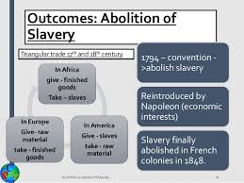

THE REVOLUTION AND EVERYDAY LIFE
- The French Revolution brought many changes in the lives of men and women.
- The revolutionary government passes many laws that would translate the ideals of liberty and equality.
- The abolition of censorship.
- Old Regime censors of king
- New Regime Declaration of the rights of Man and Citizen
- Freedom of speech and expression.

RISE OF NAPOLEON BONAPARTE
- In 1804 Napoleon Bonaparte crowned himself as emperor of France.
- Conquered many neighboring countries
- He was considered as a modernizer of Europe. He introduced many laws such as the protection of private property and a uniform system of weights and measures provided by the decimal system.
- Many saw him as a liberator who would bring freedom for the people but soon his armies came to be viewed as an invading force.
- Finally Napoleon was defeated in the battle of Waterloo in 1815. Legacy of French Revolution
- The ideas of liberty and democratic rights were the most important legacy of the French revolution which spread all over Europe, leading to abolition of feudal systems and colonized nations.
- Tipu Sultan and Raja Rammohan Ray are some of the Indians who were inspired by the idea the French Revolutions.

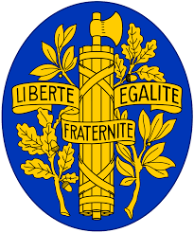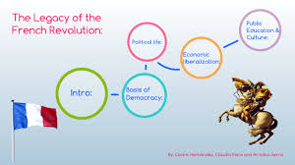

MIND MAP (A)
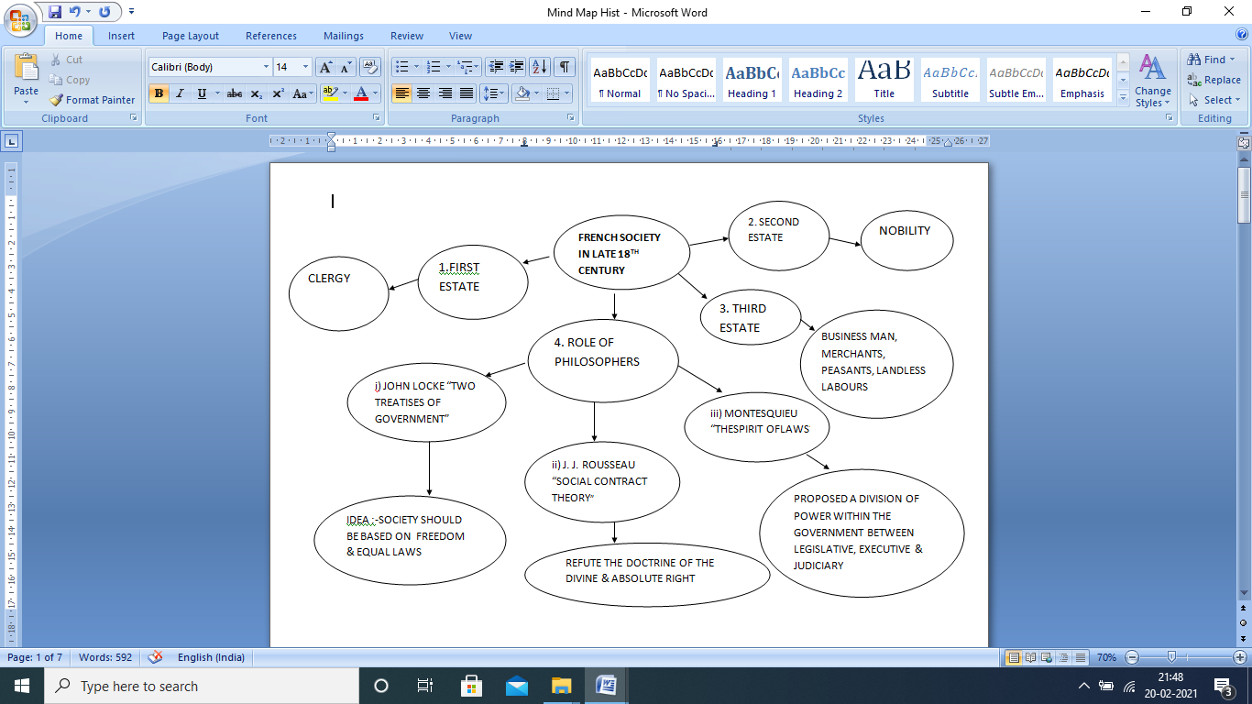

MIND MAP (B)
