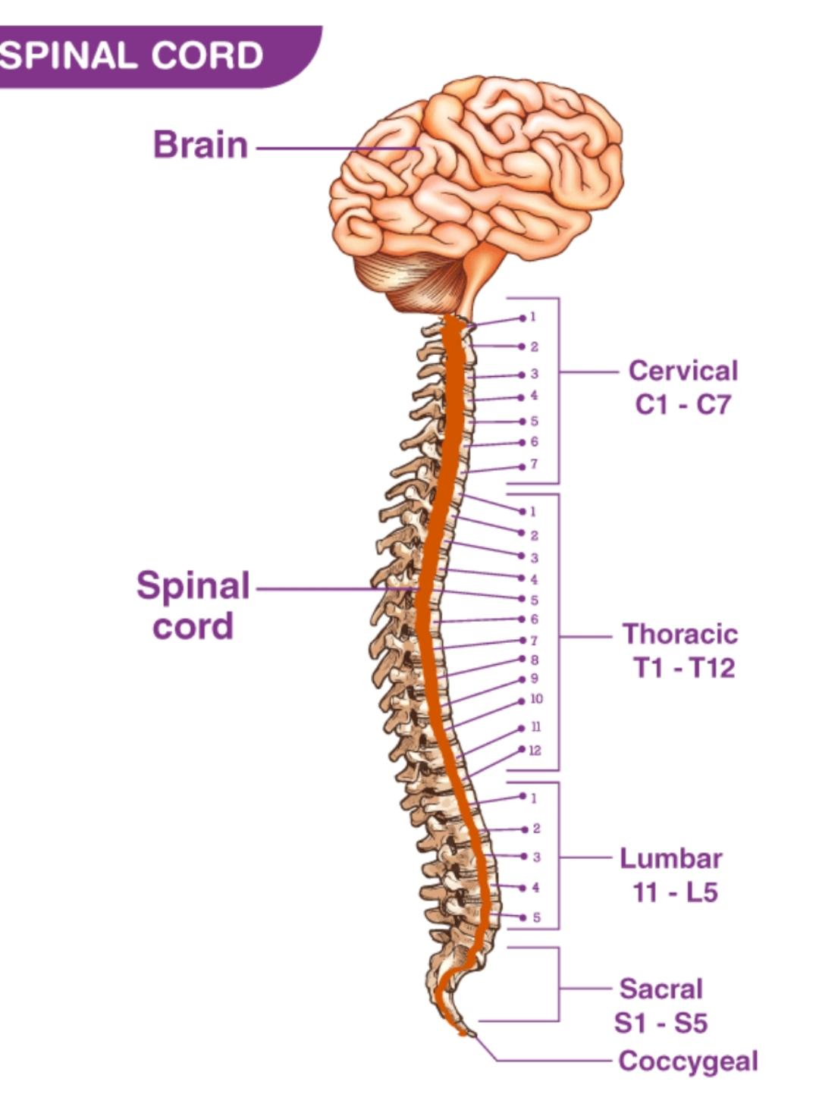
The spinal cord is a part of the central nervous system. It is a long pipe-like structure arising from the medulla oblongata, part of the brain consisting of a collection of nerve fibres, running through the vertebral column of the backbone. It is segmented with a pair of roots (dorsal and ventral roots) consisting of nerve fibres joining to form the spinal nerves.

Function Of Spinal Cord
Important functions of Spinal Cord are mentioned below:
- Forms a connecting link between the brain and the PNS
- Provides structural support and builds a body posture
- Facilitates flexible movements
- Myelin present in the white matter acts as an electrical insulation
- Communicates messages from the brain to different parts of the body
- Coordinates reflexes
- Receives sensory information from receptors and approaches towards the brain for processing.
Spinal cord injuries can range from sensory loss to incomplete or complete paralysis. A person should always wear protective equipment when playing sports or during other activities to reduce their risk of injury.

- What is the Spinal Cord?
- What are the levels of spinal cord?

Explain the structure and function of spinal cord?

