Chapter- 5
ADVERTISING AND MEDIA
STUDY NOTES
INTRODUCTION
WHAT IS ADVERTISING?
- It is the process of publicizing a productor service; of trying to sell a product or service
by drawing people's attention to the product.
- Advertising is a means of communication between the seller and the buyer.
- Advertisements focus on all the good points of the product to make it appear as attractive as possible, so that people are tempted to buy it.
- Often the success or failure of a product depends on the effectiveness of the advertising strategy.
.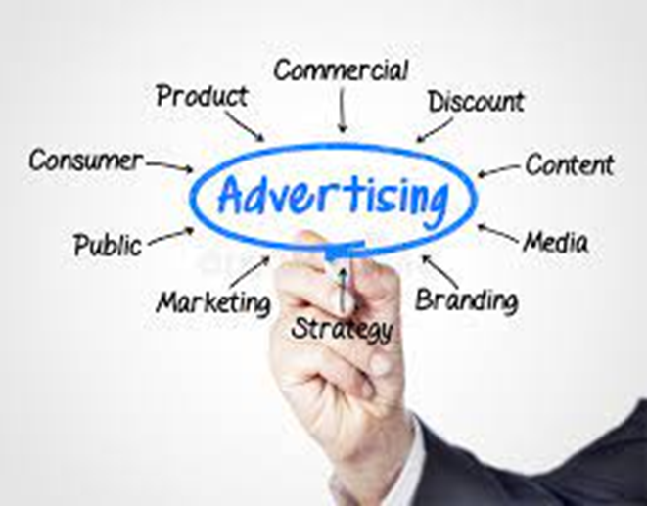

WHY DO WE NEED ADVERTISING?

There are several reasons for advertising. The main
reasons include—
• Increasing the sales of the product/service.
• Giving information about the product/service to prospective buyers.
• Creating and maintaining a brand identity or brand image.
• Communicating a change in the existing product line to consumers.
• Creating awareness among consumers before launching or introducing a new product or
service.
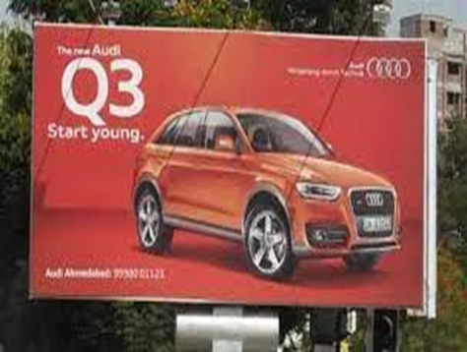

ADVERTISING AND BRAND BUILDING
- Advertisements are used to build brands. A brand is a name given to a product or service.
- For example, there are several companies in India today that manufacture soap. All of them are competing for a share of the market. So how does a soap manufacturer get people to buy his or her soap instead of the competitor's soap? The soap maker creates a brand image for the soap. He or she gives the soap a name, and then tries to associate that name with certain qualities like cleansing, moisturizing, disinfecting, beautifying etc.
- Advertisements are made focusing on that particular quality of the product. So the name of the product, or the brand, gets associated with certain qualities. This becomes the brand image.

ADVERTISING AND MEDIA
- Advertising and the media are heavily dependent on each other.
- The media earns revenue through advertisements, on which it is largely dependent.
- Television is usually the costliest means of advertising but also has the most impact on the viewers. Companies advertise their products on television in a variety of ways.
- Some advertisers on the other hand, prefer to sponsor the programme itself.

TYPES OF ADVERTISING

Commercial Advertising
Social Advertising
Political Advertising
Covert Advertising

COMMERCIAL ADVERTISING
- Commercial advertising seeks to sell a product or service for which a variety of techniques are used.
- Some advertisers try to fix their product in the minds of the people through constant repetition.
- Some advertisers of products like toothpastes and cooking oil play the health card—citing references of doctors and dentists to make consumers believe that their product is the healthy choice.
- Some advertisers use celebrities to endorse their products, and some use catchy slogans or jingles to attract consumers. Some attract consumers by offering discounts on price or by announcing a sale.



SOCIAL ADVERTISING

- When advertising is done for non-commercial purposes, and is used instead to educate, inform
or motivate the public, it is called social advertising.
- It includes advertising for social issues like energy conservation, public health, national integration, deforestation, etc.
- Many national celebrities lend their names to social advertising such as Amitabh Bachchan, a renowned Hindi film actor, appeared in a series of advertising campaigns that sought to eradicate polio from India. Wasim Akram, the Pakistani cricketer appeared in advertisements that sought to increase awareness regarding diabetes.
- The government often uses the media to get messages through to the public or to justify
certain decisions it may have taken.



POLITICAL ADVERTISING
- Political advertising involves the use of the media and public spaces by political parties to inform the public about their agendas and programmes.
- It becomes more common as elections approach.
- Political parties place advertisements in newspapers and other related media, listing out their manifestos and highlighting their achievements. 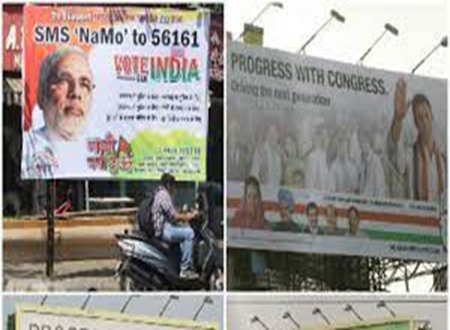

COVERT ADVERTISING
Covert advertising happens when a product or brand is embedded or hidden in some other form of entertainment and media. For example, in a movie, an actor would use a product belonging to a particular brand; the product will be featured clearly but no obvious reference will be made to it. The public associate the product with the actor using it and may be tempted to buy it.
DISADVANTAGES OF ADVERTISING

- To stay ahead of competition many companies issue advertisements that mislead people. For eg ; when they announce a new improved version of the product they may have not made any improvements in the product , just changed its packaging.
- Advertisers often do not give correct information about the product. For eg; fizzy drinks like colas are known to damage the teeth but they do not mention these.
- Advertisers are well aware that advertisements in the media with a few catchy slogans or attractive models can make a vast difference to their sales. The constant repetition of such advertisements often tempts the consumers to buy things that have no immediate use for them. Thus it encourages consumerism and materialism.

