Chapter- 4
Media and Democracy
STUDY NOTES
INTRODUCTION
To communicate means to exchange ideas and information.
Some of the different ways of communication used by people in the modern world are:-
- Talking to parents and friends.
- Read the news and people’s view in the newspapers.
- Watch television where ideas are communicated through news, cartoons, serials.
- Listen to the radio.
- Chat with friends on social networking sites.
- Browse the internet.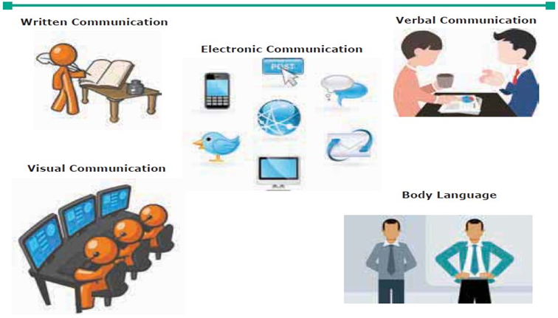

MEDIA
It refers to the different mediums or channels used to communicate information in everyday life. Eg: newspapers, television, telephones, magazines, films, radio, advertising, internet.
Mass media is a means of communication that reaches a large section of people or the masses anywhere in the globe in a short time.

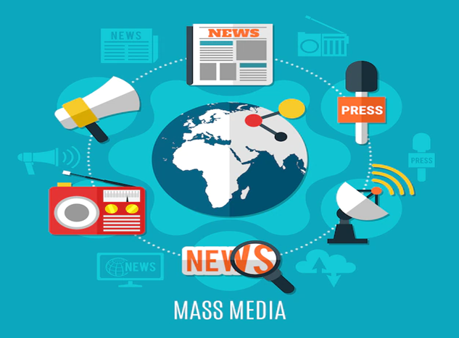
CHANGING NATURE OF MEDIA
The nature of media has changed vastly over years:
- In ancient days people used drums to communicate over long distances.
- Runners carried information.
- Pigeons and men on horses carried messages over long distances.
- Now with invention of telephone, mobile, internet people are able to reach others in seconds.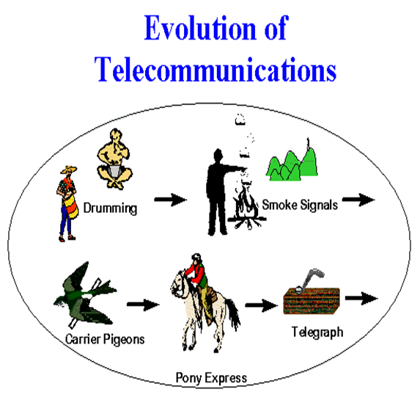
MEDIA AND DEMOCRACY
In a democracy citizens should be aware and well informed.
People are mostly informed about happenings around them only through media.
So it is important that the media should provide correct information and in an unbiased manner so that it helps people to have a valid and informed opinion.

FREEDOM OF EXPRESSION AND PUBLIC OPINION.
In a democracy people have the right to express their views freely that forms the public opinion. It keeps changing –views differ from person to person and from time to time. The opinion of public is mainly expressed through the media.
In India during the struggle for independence several fighters like Lokmanya Tilak, Aurobindo Ghosh and Mahatma Gandhi started writing newspapers in which they criticized the British and awoke the nationalistic feelings among masses.
Opinions of people are greatly influenced by what they see and read in media so in a democracy it is expected to function with great responsibility.

WHY DO WE NEED AN INDEPENDENT MEDIA?
- A free and uncensored media has the responsibility of providing unbiased coverage of events. In this way it acts as an important check on the power and actions of the government.

- An independent media also keeps the judiciary under check by reporting on the way the court decides cases.

- If a democracy has to have free and fair elections it needs a press that will cover candidates from all parties in an unbiased manner, issues that need to come up before elections.

- The media assess the performance of the government impartially so that people can know how effective the government has been.

MEDIA AND ACCESS TO INFORMATION
Access to information is essential in democracy.
- Armed with knowledge citizens make responsible, informed choices.
- The media also monitors whether elected representatives carry out the wishes of those who elected them.
- Media helps proper governance by exposing corrupt activities of people in power.

MEDIA’S NEED TO SERVE PUBLIC INTEREST.
Public interest means well-being of the general public. So media should not be concentrated in a few hands. In other words, the media should cover as many viewpoints as possible. There should be equally powerful providers of media and not controlled by few powerful groups.
For eg, if the media is controlled by a powerful baby-food making company and a journalist finds out that the food that the company sells can harm babies, the journalist’s story will not be aired by the media. So here the public will never know the truth because the story would be suppressed. This weakens the democracy.
As media keeps on bombarding people with vast amounts of information each day, people should be careful to see if anyone, any power-group, is trying to manipulate their thoughts, feelings and opinions.
MEDIA AND ACCOUNTABILITY
The media in a democracy is accountable to the people and government.
The government has laid down laws and codes of conduct, like the newspaper and broadcasting code of 1962 to regulate the media.
As general rule media should not:
- incite people to violence with their tone of coverage.
- Malign individuals or communities.

RIGHT TO INFORMATION (RTI) ACT
This landmark act which was passed in October 2005, has given people the right to information. According to this act a citizen of India has the right to demand information from any government body. But it does not include information that might compromise the country’s security. It has helped make the working of government more transparent and accountable.

