THE JUDICIARY
| CIVICS| STUDY NOTES

Chapter- 5

THE JUDICIARY
STUDY NOTE

The Structure of the Judiciary

The Judiciary is organized hierarchically. The apex court in this structure is Supreme Court situated in New Delhi. Next come High Court, each state has its own High Court except Punjab and Haryana. Next in the hierarchy are District Court and other Subordinate Courts

Supreme Court


The Supreme Court is the highest Court in India. It is located in New –Delhi. The Chief Justice is appointed by the President of India.
Required Qualifications

- He must be a citizen of India.

- He will be either an Advocate of High Court with 10 years’ experience / a High Court Judge with 5 years’ experience

- Must be a distinguished jurist (expert in Law) Term of office
The Retirement Age of Supreme Court Judge is 65 years.
But if found guilty of misuse of Authority the parliament can remove him from the office through the process of Impeachment.

Powers and functions of the Supreme Court

2. Supreme Court and High Court have three types of Jurisdictions Original Jurisdiction
Appellate Jurisdiction Advisory Jurisdiction

Original Jurisdiction

The Supreme Court has the authority to hear certain types of cases for the first Time came to known as original jurisdiction. 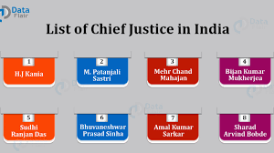 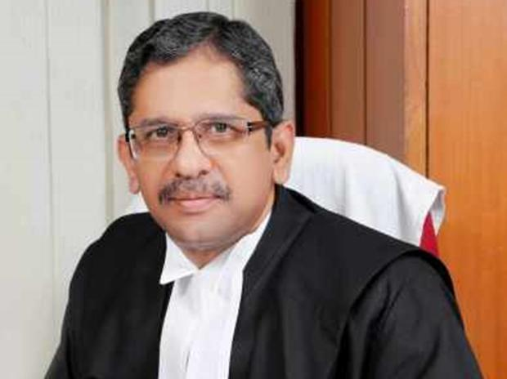


THE Judiciary
| CIVICS| STUDY NOTES
1.. Cases that involve disputes over the interpretation of the Constitution can be brought directly to the Supreme Court
2.Cases dealing with violation of Fundamental Rights

3.Disputes that arise between the central Government

4.Disputes between two state governments or more Appellate Jurisdiction
If a person is not satisfied with a judgement given by the High Court, he / she can Appeal to the Supreme Court. The Supreme Court will then hear the case and give the final judgement
Advisory Jurisdiction

The Supreme Court advises the President and the Council of Ministers, on matters Of Constitutional issues or issues of public importance. The President also can seek the advice of the Supreme Court.
JUDICIAL REVIEW


Any law or policy made by the government, that is not in accordance with the intention of the Constitution judiciary has the right to declare it as illegal.
COURT OF RECORDS

All the cases brought before the Supreme Court and the judgments have been given, are maintained as record by the Supreme Court.

CONTEMPT OF COURT

Contempt of Court refers to any behavior that opposes or defies the authority or dignity of the court
Kalyan Singh ex chief minister of UP was punished by the Supreme Court to one day imprisonment for contempt of court in connection with the Babri Masjid Demolition Case.

PUBLIC INTEREST LITIGATION (PIL)

Any citizen of India can go to the court if the interest of the public has been affected by the deeds of the government is known as Public Interest Litigation.

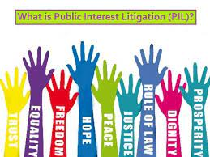
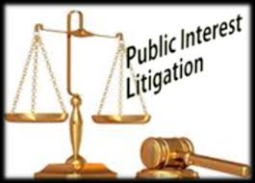

HIGH COURT

The High Court is the apex court in the state. The chief justice of the high court is appointed by the president on the recommendation of and in consultation with the chief justice of India and the Governor of the state concerned.

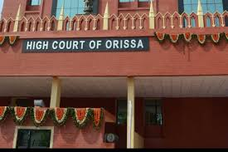
THE JUDICIARY
| CIVICS| STUDY NOTES

QUALIFICATION

- Must be a citizen of India.
- A high court advocate with at least ten years’ experience or a judicial officer with at least ten years’ experience.

RETIREMENT
A high court judge retires at the age of 62. He or she can also face impeachment on charges of misconduct.

.

JUSTICE S MURALIDHAR—CHIEF JUSTICE OF ODISHA HIGH COURT SINCE 4TH JANUARY 2021.

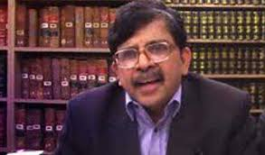

POWERS AND FUNCTIONS OF THE HIGH COURT
  - Original Jurisdiction of High Court
  - Case involving the enforcement of fundamental rights,
  - High Court can issue writs.
  - Appellate Jurisdiction of High Court
  - High Court hears appeals of both civil and criminal cases against the decision taken by the lower courts.
  - Supervisory Jurisdiction of High Court
  - Supervisory Jurisdiction involves supervising the activities of the lower courts.

SUBORDINATE COURTS

The district court and the courts below it are called Subordinate Courts. There are separate courts for civil and criminal cases.
The Court of the district judge is the highest court for Civil Justice in the district level

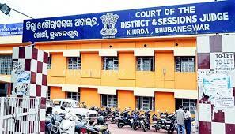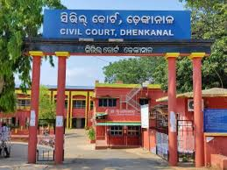
Court of the civil judge and the court of the Munsif are the Subordinate Courts under it The court of sessions judge is the highest court in the district dealing with criminal cases.
The courts of the chief judicial magistrate, the first class judicial magistrate and second class judicial magistrate are the Subordinate Courts under it .

THE UNIFIED INDIAN JUDICIARY.

The Indian Judiciary is a single unified judiciary. In India all courts function under the aegis of the Supreme Court. So if a citizen is dissatisfied with the judgment given in any lower court, he or she can appeal to a higher court. People should not take law into their own hands, and any matter of dispute should be taken to the court for a decision. If a fundamental right is violated, the citizen can either appeal to the High Court or Supreme Court.

A Writ is a court order preventing someone from doing or permitting someone to do, something. It could also be a summons iss ued to someone by the court.

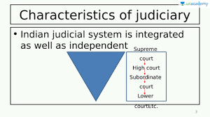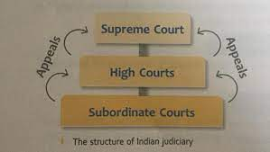
THE JUDICIARY
| CIVICS| STUDY NOTES

LOK ADALATS FOR SPEEDY JUSTICE

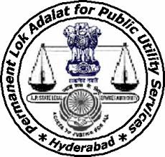

The word Adalat means court. Lok Adalat means People’s court. The first Lok Adalat was held in Delhi in 1885.Lok Adalats were established by an Act of Parliament.
The number of courts and judges are highly inadequate to deal with the large number of cases that are being registered each day. As a result there was a heavy backlog of cases in all the courts. In an effort to speed up the process of settling cases Lok Adalat was established.

ADVANTAGES OF LOK ADALAT.
- Lok Adalats, which offered free legal aid, ensured that justice was not denied to the poor for economic reasons.
- Lok Adalats settle disputes through conciliation and compromise.

- In Lok Adalat both the parties in dispute should agree for a settlement.
- In Lok Adalat both the parties in the dispute can interact with the Lok Adalat judge directly, and explain their stand in the dispute. This is not possible in the regular court.

5 Disputes can be brought before the Lok Adalat directly instead of having to go to the regular court first.

6. In Lok Adalat is fast and free of cost.

