Chapter- 17
Data handling
STUDY NOTES
LEARNS ABOUT:
- PICTOGRAPH
- TALLY MARKS
- BAR GRAPH
We collect information about various things and people in different forms. The information we collect is known as data.
The presentation of collected information in an arranged and sorted way is known as data handling.
PICTOGRAPH
Pictograph is a way of representing the numeric data in the form of picture.
EXAMPLE
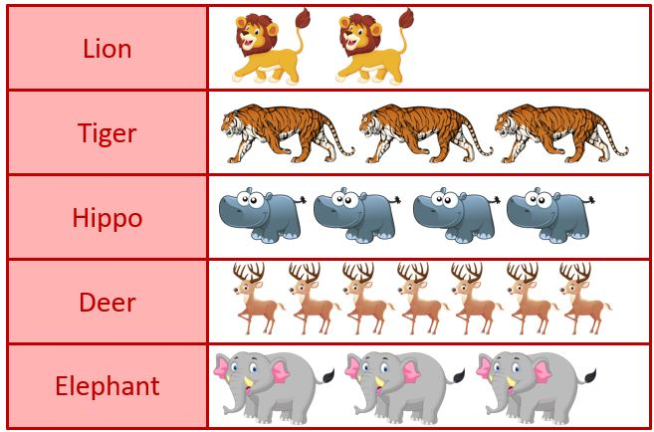
The pictograph shows the number of animals in a zoo. Answer the questions that follow.

- Which animal is the maximum in number? Deer
- How many tigers are there? 3
- Which animal is the least in number? Lion
- How many elephants are there? 3
- How many hippos and deer are there in the zoo? 11

TALLY MARKS
Another way of representing a large data is through tally marks. Here, numbers are represented in groups of five by drawing lines.
One vertical line is made for each of the first four numbers and the fifth number is represented by a diagonal line across the previous four vertical lines.
EXAMPLE
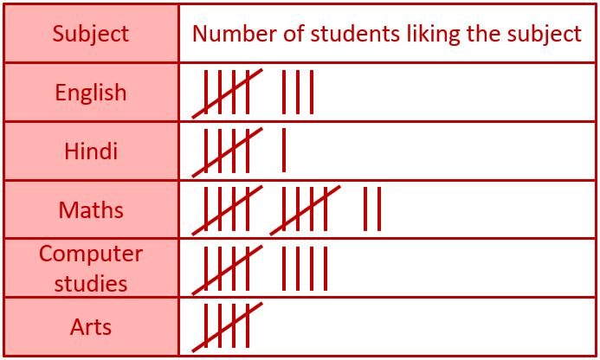
There are 40 students in a class. Students have different favourite subjects. The representation below shows the detailed information of the data. Read the data and answer the following questions.

- Students’ most favourite subject is . Maths
- Students’ least favourite subject is . Arts
- How many students like English? 8
- How many students like Computer Studies? 9
- How many students like Hindi and Arts? 11
BAR GRAPH
A bar graph is the representation of numerical data in the form of rectangular bars having standard width but variable length according to the scale chosen.
There are two types of bar graph:
- Vertical bar graph
- Horizontal bar graphs

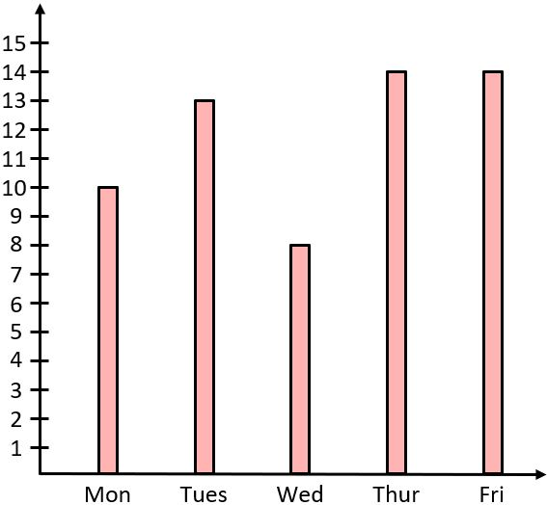
Vertical Bar Graph
Vertical bar graphs are those graphs
in which data is represented in vertical bars.
The vertical bars are drawn from bottom going
upwards.
The graph given alongside is
representing the number of people visiting a
cinema hall on five different days of a week.

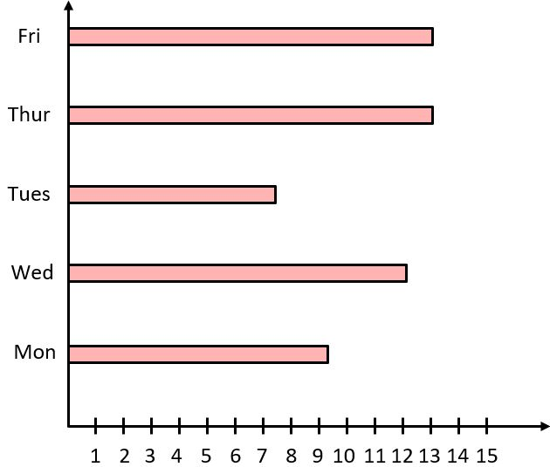
Horizontal Bar Graph
Horizontal bar graphs are those graphs
in which data is represented in horizontal bars.
The horizontal bars are drawn from left to
right.
The graph given alongside is representing
the same data as shown in the vertical bar graph.

EXAMPLE
Daily sale of sugar in a department store is shown in the bar graph below.
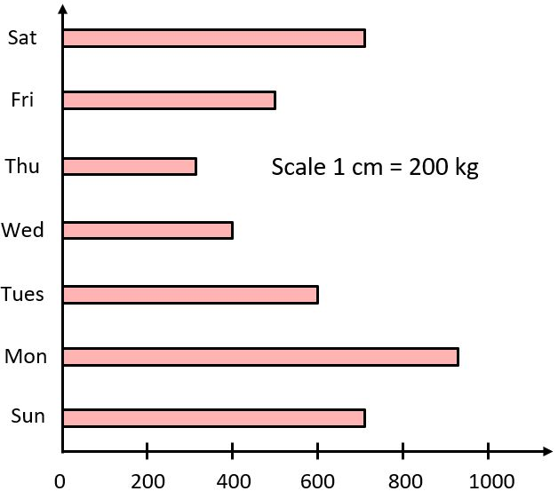

- Which day has the maximum sale? Monday
- Which day has the least sale? Thursday
- Calculate the total sale of the week. 4,100 kg
- Which two days have the same sale? Saturday and Sunday

---------------X---X---X--------------

