[WOMEN AND REFORM]
| HISTORY| STUDY NOTES

Chapter- 9

WOMEN AND REFORM
STUDY NOTES

The Status of women in the 18th century

WOMEN AND REFORM

- Women across the world have been exploited and oppressed for centuries. This was particularly true of 17th and 18th century India. In the 19th century, Indians exposed to western ideas and thought, understood that no society could progress until the women of that society progressed. Educated women, especially an educated mother, had a powerful influence on society.

The position of women in society

Women were treated as objects. It was believed that women could not think for themselves and that they should be kept inside the house. Women did not have right to inherit their father’s property.

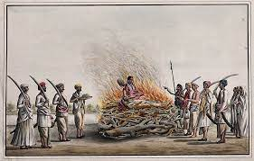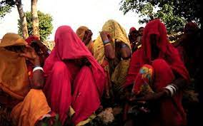

Limited access to education.

Women were discouraged from attending schools and colleges. It was believed that once educated, women would be unwilling to do household work or obey their husbands in unquailingly.

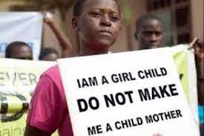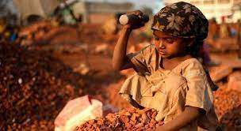

Child Marriage
Girls were married off at a very young age, sometimes when they were just 5 or 6 years old. They became mothers when they were barely 15 or 16 years old, when they were neither physically nor emotionally ready for marriage or motherhood.

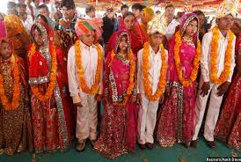

The plight of widows.
Widows, even child widows in many Hindu families were not allowed to remarry. Their head was shaven. They were forced to wear only white clothes; they were allowed to eat only bland vegetarian food. They were treated as outcastes.

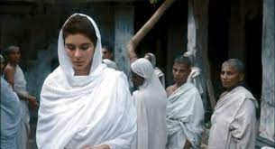

[WOMEN AND REFORM]
| HISTORY| STUDY NOTES

Sati
One of the most barbaric acts practiced in North India was Sati, the burning alive of women on the funeral pyre of their husbands. Widows were told that this was the only way they could attain salvation.

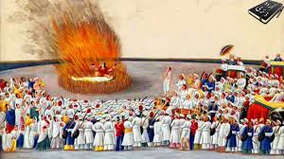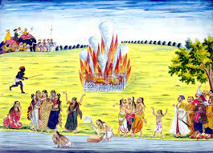

Female infanticide.

The birth of a girl child was seen as a curse in many parts of India. Many female infants died of neglect, while some were deliberately kill.

The Social Reformers.
In the 19th century, several social reformers fought hard to change the treatment of women in Indian society. They felt that education was the first step towards women’s emancipation. Once educated, women would themselves become aware of their rights

.

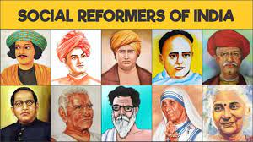

Raja Rammohun Roy.

Raja Rammohun Roy was born into an orthodox Bengali family in 1772. When he was 16, he witnessed a forced sati in his family and was shocked by it. He started the Atmiya Sabha and began to persistent struggle against the social evils prevalent in Bengal. His greatest achievement was the founding of the Brahmo Samaj in 1830. It aimed to preach monotheism to improve the position of women in the society, to rid Hinduism of idol worship and rituals and to remove the superstitious practices. He persuaded the British Government to abolish Sati which Lord Bentinck did. For his achievement, he is called the Father of Modern India.
- Raja Rammohun Roy encouraged the study of English and firmly believed in the advantages of Western Education. He was instrumental in the opening of the Hindu College in Calcutta and in the setting up of a modern Indian Newspaper.

[WOMEN AND REFORM]
| HISTORY| STUDY NOTES

Ishwar Chandra Vidyasagar

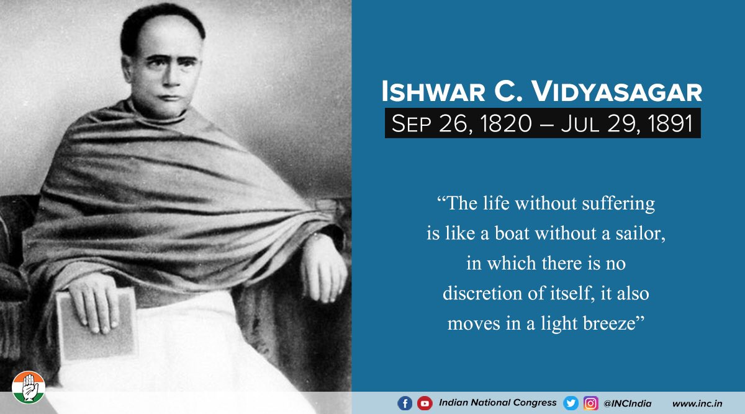

- Born into a poor Brahmin family, Ishwar Chandra Vidhyasagar was a great Sanskrit scholar and became the principal of a Sanskrit collage. He was a man of simple living. His whole life was spent in the upliftment of woman and girls.

- Ishwar Chandra Vidyasagar started a movement in favour of widow re marriage and was instrumental in the passing of the Widow Remarriage Act of 1856. He opened several schools for girls and ran some of them at his own expense

Swami Dayanand Saraswathi and the Arya Samaj

Swami Dayanand Saraswathi was born in Gujarat in 1824.A brilliant Sanskrit Scholar, he spoke out strongly against idol worship at the age of 14. He quoted the Hindu scriptures to support his stand on various issues. He condemned Sati, supported widow remarriage, and opposed child marriage. He preached against caste differences and untouchability.

Sir Syed Ahmad Khan

- Sir Syed Ahmad Khan was a great supporter of women’s liberation. He was against the purdah system and the Muslim practice of divorce by saying the word talaaq thrice.
- As a result of the efforts of these social reformers, Indian society started changing. The British passed the Sharda Act in 1929 fixing the minimum marriageable age as 14 for girls and 18 for boys.

