Chapter Name: TENSE
Tenses of Verbs:
DEFINITION: -
The term ‘TENSE’ derived from the Latin word “TEMPUS” meaning ‘TIME’, is defined as the form of the verb that states the relation between time and action.
Tense implies a verb-based method used to indicate the time, and sometimes the continuation or completion of an action or state concerning the time of speaking.
Tense is the time described by a Verb shown by its grammatical form.

TYPES OF TENSES:
The concept of tense in the study of English Grammar is a method that we use to refer to Time –Past, Present and Future. Hence, the future is a reference for Time. We often use the Present Tense form of the Verbs to express a future action.

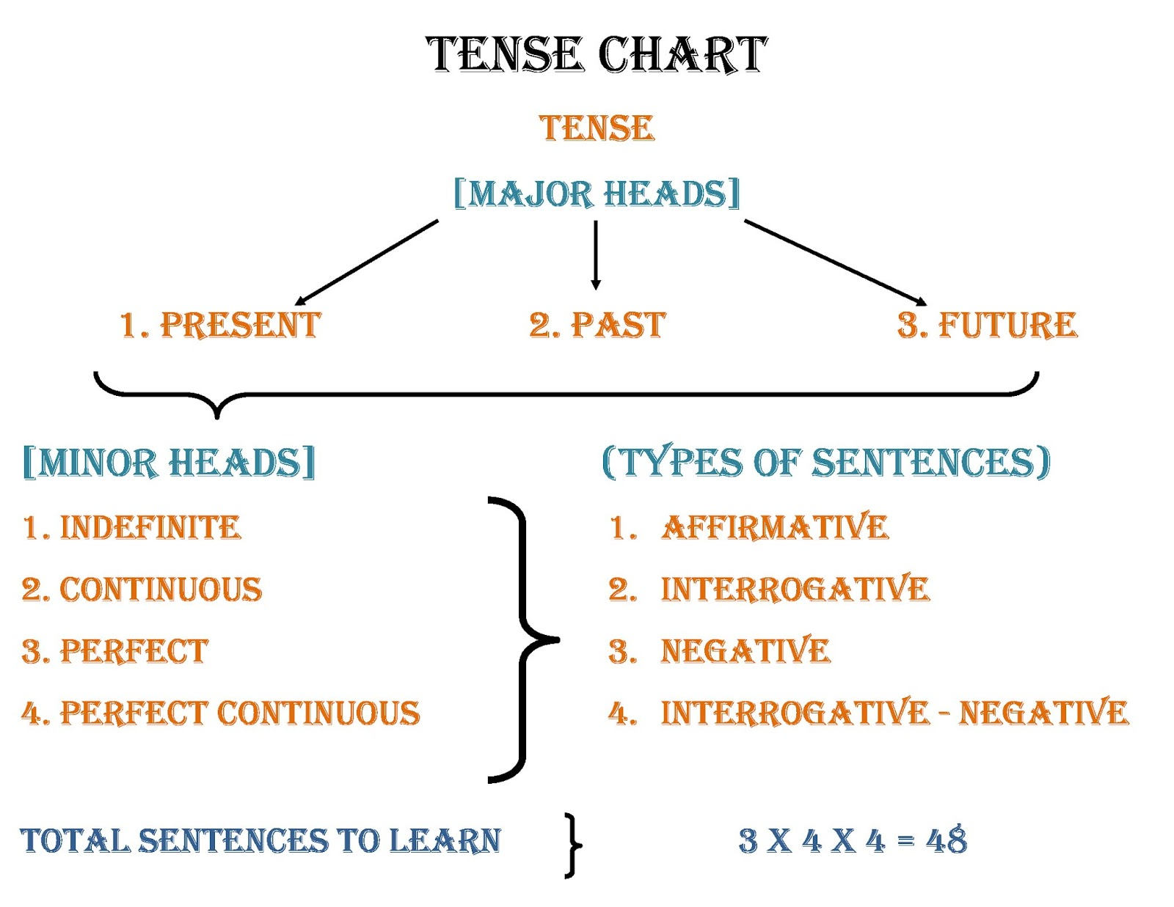

PRESENT TENSE
The Simple Present/ The Present Indefinite
The Simple Present Tense form of the verb implies----
- Expresses a habit or often repeated action. Adverbs of frequency such as, often, seldom, - -
- sometimes, never, etc. are used with this tense.
Primary Aux. (do/ does ) + M. V. (Base Form )
The ‘ Be – Verb of the Present form ---is /am /are is used as the Main Verb.
The choice of the auxiliary shall be strictly according to the person and number of the subject in a sentence.
Snow falls in December in Minnesota.
Water boils at 100 degrees Celsius.

USAGE OF PRESENT INDEFINITE:
This form of the verb is used to denote .....
- Universal / Permanent / General Truth
- Present Habitual Action/ Customs / Traditions
- Proverbial Sayings/ Quotations
- A Future Event which is a part of a plan or arrangement

- Vivid narration as a substitute for the Simple Past Form

EXERCISE
Fill in the blanks putting the verbs bracketed into their appropriate tense form.
Use the given adverbs in the appropriate places.
- My mother ....... me to work hard (always/advise).
- It.....in July (usually/rain).
- My father ....tea thrice a day (take ).
- My friend ....talking to strangers (normally/avoid ).
- One’s manners ....one’s character (reveal).
- Our character ....what we are in the dark (be).
- The first plane from Bhubaneswar to Singapore....at 9 a.m. every day (take off).
- My annual examination ....from Monday next (commence).
- John Keats ...., “A thing of beauty is a joy forever (say).
- Do you know what.........’ Swine Flu’ (cause)?

PRESENT PROGRESSIVE:
The Present Progressive tense form implies the continuity of an action at the time of speaking at present.
The verb structure of Present Continuous---
Sub. +Aux. (is/am/are) + Verb + ‘ ing ‘ +O/C.
The choice of the auxiliary shall be made strictly according to the Person and Number of the Sub.
USAGE ---- -This form of the verb is used to denote.....
- An action in progress at present.
- An action not occurring now at the time of speaking but in progress.
- An action that has been pre-arranged to take place shortly.
- Persistent and undesirable habit, especially with adverbs like –
always, continually , constantly, frequently.
- References of Time---now, right now, at present, nowadays, at the moment etc.
EXCEPTIONS---
Some specific verbs don’t take the progressive ( ‘ ing’ –form ), but they denote the continuity of the actions. They are----Verbs of Perception /Sense... See, hear, smell, notice, recognise
Verbs of Appearance... Appear, seem, look.
Verbs of Thinking ... Think, suppose, believe, agree, consider, remember , forget, know, imagine, mean
Verbs of Emotion... Want, wish, desire, feel, love, hate, prefer etc.

EXERCISE:
Re-write the following sentences correctly.
1. Are you hearing any noise?
2. What do you do at present?
3. Are you remembering the name of the man we met at the station last night?
4. My birthday is falling on a Saturday this year.
5. Look! Smoke comes out of the storeroom.
6. When do you plan to go abroad?
7. I’m smelling something burning.
8. What do you do this evening?
9. My elder sister gets married the next week.
10. This dictionary is costing seven hundred rupees.

PRESENT PERFECT:
The Present Perfect tense form of the verb is used to talk about an event that began
in the past and continues up to the present.
This form is also used to talk about an event that was completed in the past, but the
the specific time of the event is not important.
The Structure of the Form----
Sub. + Aux. (has / have ) + V3/ V ( Past Participle) +O/C....
The Adverbs used with this form of the Verb--- already, just , recently, yet, ever, never etc.
Examples---
I’ve already submitted my assignments to my Class Teacher.
Mother hasn’t finished cooking yet.
Father has just arrived.
Have you ever been to Nandankanan?

EXERCISE
- Devanshi .....( recently/get) a new car.
- Nidhi ........not(come) back yet.
- I ......... ( already/see) this film.
- The postman.......not (come) so far.
- She ......(be) a teacher since 2000.
- They .....(know) us for several years.
- She .....(join) a college recently.
- The old man........(live) here all his life.
- He........not (wear) the new shirt yet.
- Tom left school some time ago. He ..........not (return) yet.

PRESENT PERFECT PROGRESSIVE:
The Present Perfect Progressive tense form of the Verb is used to denote ----An action
started sometime in the past and is continuing now even at the time of speaking at present.
This tense is used to describe the duration of an action that began in the past and continues
into the present.
It is also used to describe events that have been in progress recently and are rather temporary.
The Structure of the Verb---
Sub. + Aux.( has / have ) + been + V.+ ‘ ing’ +O/C....
Examples:
I’ve been practising Odissi since my childhood.
It has been raining since last morning.

EXERCISE:
Fill in the blanks with the correct forms of the verbs given in brackets
- It.............(rain) since morning.
- The students.......(work) well this year.
- What you ........(do) all these years?
- They ...........(live) in this house since 1990.
- The boys .......(play) tennis all morning.
- He.......(study) medicine here since 1999.
- We ......(search) the missing pen for half-an-hour.
- I .......(teach) in this school for twenty years.
- How long you ........(wait) for me?
- The teacher.........(mark) the answer books since morning.

SIMPLE PAST:
We use the simple past to indicate exactly when an action or event took place in the past.
The simple past is used to describe actions and/or events that are now completed and no
longer true in the present.
The Structure of the Verb----
Sub. + V2 { Aux.(did) + V ( Base Form) } + Past Ref. of Time ( ago ,yesterday, in the past etc.)
This form of the Verb is used to denote----
An action that happened in the past and to report completed action ....often used in recounts
and narratives.
Past habits or repeated events that are now over.
Historic Events, Discoveries, Inventions etc.
Habitual past by using ‘used to ‘.
Indicate another action which happened in the middle of a longer action.
Examples:
She met me last year.
We visited the Taj Mahal six months earlier.
The great Italian painter Leonardo da Vinci painted ‘MONALISA’.
India sought its freedom in 1947.
Madame Curie discovered radium.

EXERCISE:
Fill in the blanks with the correct Past tense forms of the verbs given in brackets.
- I told him that he……..(not care)for me.
- She ……….(sing)very beautifully at the function.
- Prices ……..(rise) by twenty per cent last year.
- Gandhiji never………..(tell) a lie.
- I ………..(work) all day yesterday.
- It ……….( not rain) heavily last summer.
- She……..(eat) her dinner at ten last night.
- Shakespeare ……...(write) ‘Hamlet’.
- His health has improved since he………(go) to Puri.
- The Sepoy Mutiny ………(break out) in 1857.

PAST PROGRESSIVE :
The past progressive form of the verb is used to talk about an activity that was in progress at a specific point of time in the past. The emphasis is on the duration of the activity in the past.
The past progressive is often used with the simple past to show that one action was in progress when another action occurred.
This form of the verb is used to denote----
An action that was happening at some time in the past without a clear indication of the time of the action.
Persistent habits in the past ( using words like...always / continually )
The Structure of the Verb---
Sub. + Aux. (was/ were) + V. + ‘ ing ‘ + O/C....
Examples: - I was watching TV for the whole evening.
- He was very unruly. He was always disturbing others.
EXERCISE:
Fill in the blanks with the correct Past Tense forms of the verbs given in brackets.
- When you telephoned me, we………(play)
- I saw her as I…………(pass) the street.
- She found that the milk ……….(boil) over.
- We………just (leave) when it began to rain.
- I dropped my watch as I ………..(wind) it.
- His sister was reading, while he…….(sleep)
- While Anju was singing, Manju ……….(dance)
- Ram ……..(read) a magazine when the bell rang.
- Who ….(talk) to you when I joined you?
- I ………..(rest) on the roof when it started raining.

PAST PERFECT:
The Past Perfect tense form of the Verb describes completed events that took place in the past
before another past event.
It is used to denote---
An action that was completed before a definite time or before another action that took place in the past
Desires in the past that have not been fulfilled.
Conditions of the past that were impossible to fulfil.
The Structure of the Verb :
Sub. + Aux. ( had) + V.3 + O/C....
Examples :
By the time Gandhiji died, India had already sought her freedom.
I wish I had not wasted my precious time.
We reached the station after the train had left.
If you had taken your Parents’ advice, you might not have got into such difficulty.

EXERCISE
Fill in the blanks with the correct forms of the verbs given in brackets.
- The train ……….(leave) before I reached the station.
- The guard refused us entry until he………..(examine) our pass.
- She………(not play) her fee until yesterday.
- He ………..(not revise) the course till then.
- She ……..(finish) her work already.
- When he……..(sleep) for two hours, I woke him up.
- They left the hotel when they …………(take) meals.
- Rohit’s father wished he……..(pay) more attention to his son’s progress at school.
- I wish I………(accept) the offer.
- He thanked the audience after he…….(finish)his talk.

PAST PERFECT PROGRESSIVE
The Past Perfect Progressive tense form of the Verb is used to emphasize the duration
of an action that was completed before another action or event in the past.
It is used to indicate an action which began in the past and continued up to a certain
point of time in the past.
The Structure of the Verb :
Sub. + Aux. ( had) + been + ‘ ing ‘ + O/C....
Examples :
When we met in Bangalore, she had been studying in the Chancellor’s College for
three years.
Had you not been reading the book since morning?

EXERCISE
Fill in the blanks with the correct forms of the verbs given in brackets.

- I ………(read) for an hour when the lights went off.
- He ………(try)to solve the problems for two hours before he found the answer.
- By 10 p.m. he was tired because he……….(work)since dawn.
- They ……….(wait) for the bus for an hour before it came.
- He ………(sleep) for an hour when I went to his house.
- The doctor……….(treat) the patient for three weeks before she died.
- The farmers ………..(plough) their fields for two months before it rained.
- We………(watch) the match for an hour when it began to rain.
- Ravi ……..(look)for his pen for two hours when he found it in his pocket.
The workers ………(raise) slogans since morning when the police arrested them

SIMPLE FUTURE

The Simple Future tense form of the Verb is used to indicate---
What we believe or think will happen in future.
Things which we can’t control and are factual.
Instant decisions.
The Structure of the Verb ---
Sub.+ Modal Aux. ( will/ shall ) +V.1 + O/C..... + Future Time Reference.
Examples :
I believe she will join our organisation.
It’s their first wedding anniversary. They’ll give you a precious gift.
Why will you not attend the party?

EXERCISE
Fill in the blanks with the correct forms of the verbs given in brackets.
- He……..(be) sixteen next March.
- I ……….(go) to school tomorrow.
- When the bell rings, the students……..(go)to their classrooms.
- If she works hard, she ……..(get) good marks.
- I ………(not take)the test tomorrow?
- The teacher ………..(give) us a test tomorrow?
- I ………(carry)your luggage to the train?
- She ………(attend) the party if she is invited.
- Unless you mend your ways, you ……..(not succeed)
- When she returns, she……….(tell) you the whole story

FUTURE PROGRESSIVE
The Future Progressive tense form of the Verb is used to describe an event or action
that will occur over a while at a specific point in the future.
This form of the verb is used to indicate –
An action that will occur in the normal course.
An action that will be in progress at a given point of time in the future.
The Structure of the Verb ---
Sub. + Modal Aux. ( will/shall ) + be + V.+ ‘ing’ + O/C....+ Future Time Reference.
Examples :
I will be meeting her tomorrow.
My elder sister will be going to Germany the next year.

EXERCISE
Fill in the blanks with the correct forms of the verbs given in brackets.
- The farmers ……….(water)their fields in the morning.
- She ……..(sing) after lunch.
- When you call on him, he……..(write)a letter.
- She ……..(make) tea in the evening?
- When you arrive, I probably ……..(weed) the plants.
- At 9 a.m tomorrow he…….(sit) in his office.
- When I reach Shimla, it probably ……….(snow) there.
- We………(enjoy)our holidays next month at Konark.
- She …….(wait)for us at the appointed hour tomorrow.
- The cook……….(cook)food at this time next Sunday.
FUTURE PERFECT
The Future Perfect tense form of the Verb is used to describe an event or
action that will be completed before another event or time in the future.
This form of the verb is used to describe ---
An action which will be completed at some point of time in the future.
The Structure of the Verb:
Sub. + Modal Aux. (will/ shall) + have + V.3 + O/C....+ Future Time Reference.
Examples:
We shall have cooked the food by the evening.
You will not have read this novel before next Friday.

EXERCISE
Fill in the blanks with the correct forms of the verbs given in brackets.
- The workers ………(complete)this task by next month.
- I ……..(revise) my course by tomorrow.
- The patient ……..(die) before the doctor arrives.
- The shopkeepers ………..(close) their shops when we reach there.
- I ……(go) to bed by the time father arrives from Chennai.
- Hari ……….(finish) this job till lunch tomorrow.
- I ………..(take) meals by the time you come back.
- The farmers ……..(plough) their fields before the sunsets.
- We ……….(start) on our journey before the day dawns.
- The bank………(open)when we reach there.

FUTURE PERFECT PROGRESSIVE
The Future Perfect Progressive form of the Verb describes an action that has been in
progress for a duration of time before another event or time in the future.
It describes an action that will be in progress over some time that will end in the future
The Structure of the Verb :
Sub. + Modal Aux. ( will/ shall ) + have + been + ‘ing ‘ + O/C... + Future Time Reference.
Examples :
At noon, Kumar Sanu will have been singing the song for an hour.
I will have been working round the clock for twenty-two years next July.

EXERCISE:
Fill in the blanks with the correct forms of the verbs given in brackets.
- She …….(be) seventeen on her next birthday.
- I ……..(come) if you so desire.
- You ……(sing) a song at the party?
- By next Sunday, I …….(stay) in the hostel for four months.
- By the end of this year, he ……(get)married.
- When you arrive, we probably ……..(mow) the lawn.
- The annual examination for 10+2 class ……..(commence) on 5 th March 2004.
- More and more people ………(come)to cities in the days to come.
- The teacher ……(take) the students on a historical tour in the coming autumn break.
- What you ……..(do) this time tomorrow?

