ODM STUDY NOTE SUBJECT—HISTORY STD-VIII


CHAPTER-2: THE ESTABLISHMENT OF COMPANY POWER
(FROM TRADE TO TERRITORY)
Introduction - The British came to India only for trade .Their Trade Company was known as British East India Company.
But in this lesson we are going to study how the British became the rulers of India. 
Voyages of discovery
Between 7th and 14th centuries Arab traders dominated the trade between the East and the West. They took spices, textiles, sugar, indigo (which is used for dyeing cloth) and saltpeter (which is used for making gun power) from India by sea route to Persian Gulf and Red sea. From there, they carried goods over land to Europe.
But in 1453 , Constantinople, the capital of the Eastern Europe conquered by Turks, the Arabs could no longer take goods safely over land to Europe . So, the Europeans forced to find a direct sea route to the East.
To find out a direct sea route to the East a series of voyages were undertaken by European Explorers. As a result a direct sea route was found by a Portuguese explorer Vasco da Gama; he landed at Calicut in Kerala state in 1498.
Thus The Arab domination of the Indian Ocean was replaced by the Portuguese who were the first Europeans to establish a trade base in India. Followed by them, the Dutch, the British, and the French reached India for trade
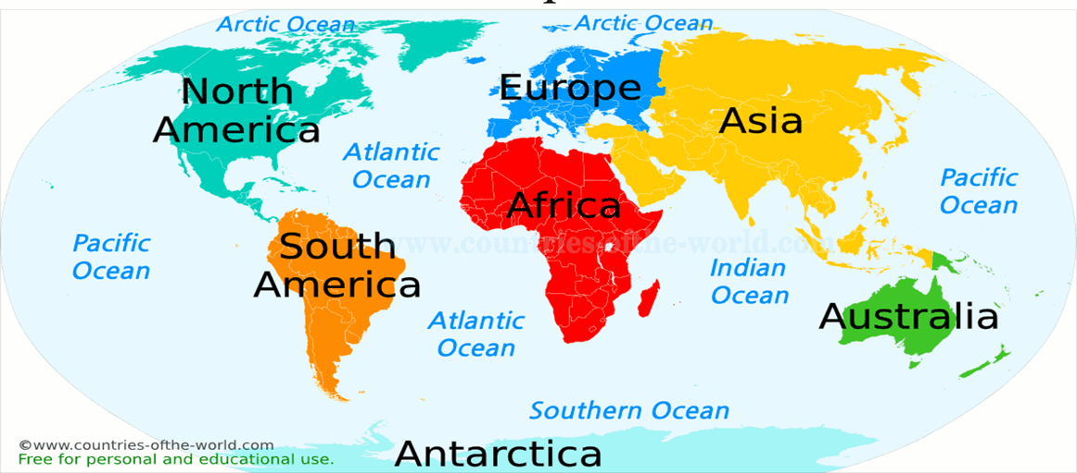

The Formation of European Trading Companies in India
The Portuguese had trade settlements at Goa, Daman and Diu. Salsette, Bassein and Santhome near Chennai. (Salsette is an island in the state of Maharashtra on India’s west coast. Bassein is situated about 70 kms North of Bombay in the Arabian Sea.)
The Dutch East India Company was formed in 1602 and established factories in Masulipatnam (Andhra Pradesh), Surat and Cochin.
The French were the last European power to enter India. The first French factory came up at Surat in 1668. They also acquired Mahe in Malabar on the west coast in 1724.

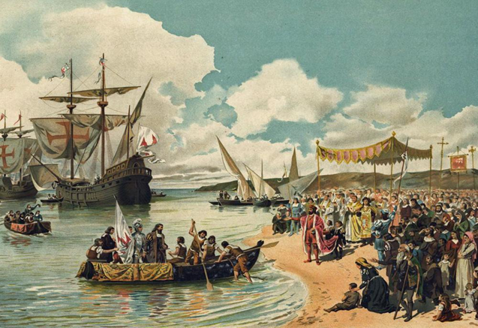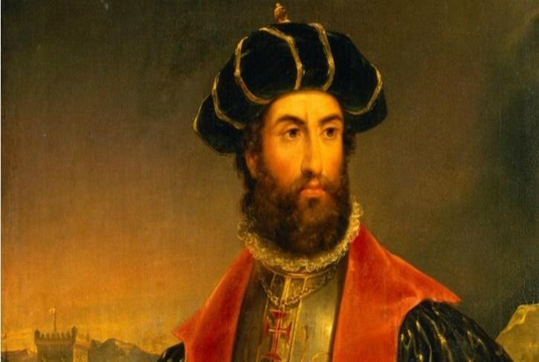The British East India Company
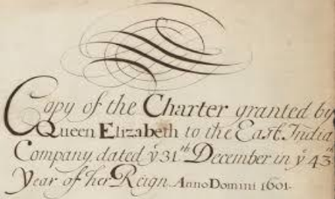
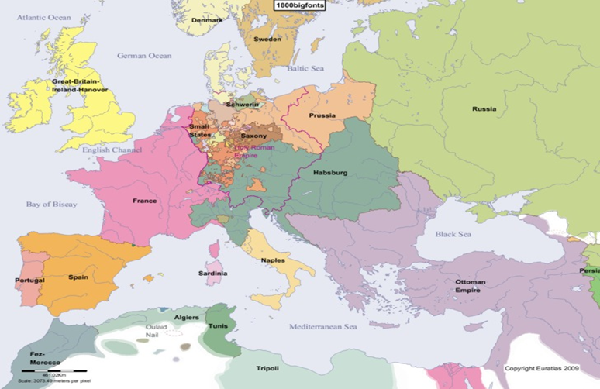

The British East India Company was founded in 1600 by a group of enterprising businessmen. On 31 December 1600, Queen Elizabeth 1 gave permission to the company to trade with India, in return for a share of its profits

.
From Trading post to Presidency
The European trading companies used to come by ships, and the captains of the ships asked permission to the local rulers for trade. If trade proved profitable the captains set up trading posts which came to known as Factories.
In the more successful areas, groups of factories developed came to known as Settlements. And the developed settlements came to known as Presidencies.
A British official Captain William Hawkins landed in Surat in 1612 and obtained permission from Mughal Emperor Jahangir to set up factories in Surat.
In 1615 King James 1 of England sent Sir Thomas Roe and he received permission from Jahangir to set up factories in any part of Mughal Empire.

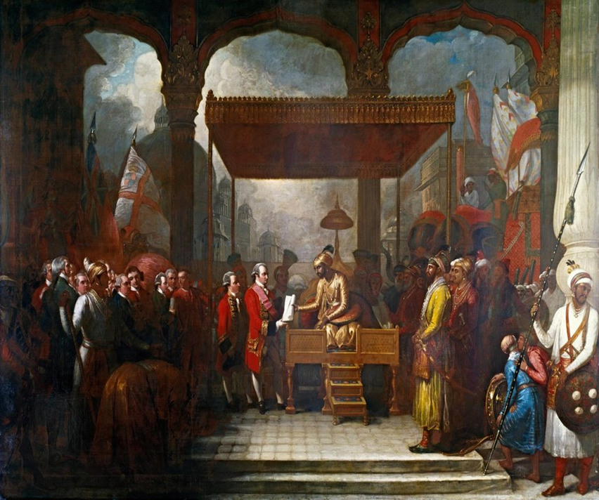

From Traders to Rulers—The British Conquest of India
Starting from small trading settlements, the Europeans soon established powerful colonies in India. Colony is a country or region that is politically controlled by another distant country and Colonialism is a rule of a country for a long period by another one. Now India is a Colony of British Now the problem is British wanted to dominate not only over Indians but also over other European Countries. So in order to eliminate other European countries they started Wars. In 1580 Spain conquered Portugal, so they unable to retain most of the possession in India. Dutch decided to focus on their possessions in the East Indies. The two countries left were France and Britain. In Europe France and Britain were already rivals.
The Carnatic Wars
In order to eliminate France from India Britain fought a War came to known as Carnatic Wars the conflict between the French and the British was focused around the Carnatic region. The south eastern part of the Indian Peninsula was known as Carnatic Region. There Hyderabad, Carnatic and Mysore were in constant conflict with each other. Taking advantage of this conflict among the local rulers Britain and France fought three wars between 1746 and 1763 came to be called the Carnatic Wars. By the end of third Carnatic war the British defeated French and French detained in Pondicherry and Chandernagore.
The result of the Carnatic War was The British became the main European Power in India.

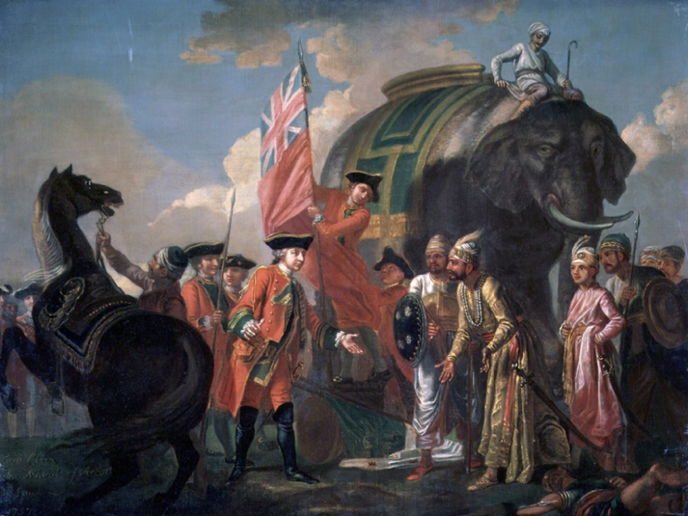

The Conquest of Bengal
The province of Bengal included present day Bihar, Jharkhand and Odisha. It was one of the richest provinces of the Sub- Continent known for its textiles and silk.
The Battle of Plassey. -: The reason for the Plassey war
1. The British started fortifying their factory at Fort William in Calcutta.
2. Sirajuddaulah, the Nawab of Bengal, asked British to demolish the fortifications. 3. The British refused. So Sirajuddaulah marched to Calcutta and occupied FortWilliam. 4. So Robert Clive, the commander of the British troops declared war on Sirajuddaulah.

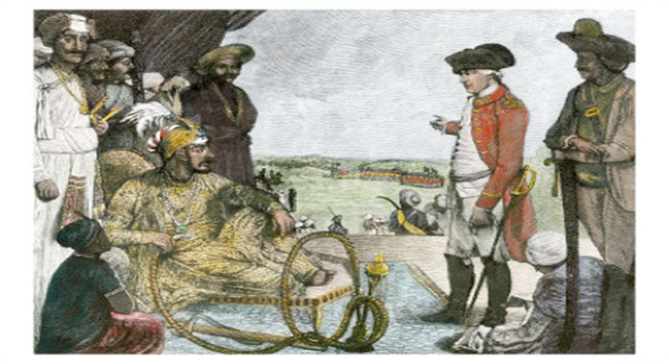

The reasons for the victory of British
Robert Clive promised Mir-Jafar, the commander in – chief of the Nawab’s army to make him the Nawab if he helped Clive to defeat Sirajuddaulah.
Mir-Jafar agreed. The two armies met at Plassey in 1757.
Process of the War- Finding that Mir –Jafar had turned traitor Sirajuddaulah fled the battlefield. The British won the war. According to the promise Mir-Jafar was made Nawab of Bengal by the British. However , when Mir –Jafar tried to control the corrupt trading practices of the British he was replaced by his son – in law Mir- Qasim by British in 1760 now the British were not just traders but became the rulers.
Result of the War
The battle of Plassey paved the way for British rule in India.
The Battle of Buxar-: Reasons of the War
Mir-Qasim soon grew tired of British control and set about consolidating his power and position. To improve his finances he tried to force the employees of East India Company to pay duty for their private trade. When he was unable to do so, he granted free trade to all Indians.
In1763, Mir-Qasim went to Awadh and entered into an alliance with nawab Shujauddaula and the Mughal emperor Shah Alam, who was a refugee after the third battle of Panipat. In 1764, the combined forces of Mir-Qasim, Shujauddaula, and Shah Alam met the British at the Battle of Buxar.
Result of the War.
Clive defeated them. Mir –Qasim fled. While others signed a Treaty known as Treaty of Allahabad with the British
As a result all territories were returned to the Nawab of Awadh. The first Nawab Mir –Jafar was brought back as a nawab of Bengal.
Though the nawab continued to be responsible for the administration of the province, the revenue from the land went to British, which was called The System of Dual Government.
When Warren Hastings became the Governor of Bengal, he abolished this system of Dual Government.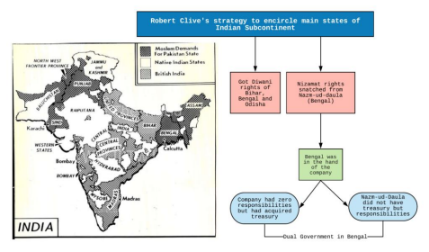
The Anglo- Maratha War (1775-1818)
After the death of Shivaji the governors of different provinces called as Peshwas started to rule Maratha Kingdom. The British wanted to annex Maratha Kingdom so they fought three wars that came to be known as The Anglo Maratha wars.
Result of the war:
In the third Anglo Maratha war the British defeated Marathas.
The post of the Peshwa was abolished.
Large part of the Maratha kingdom was annexed by the British.
The Anglo-Mysore war (1776-1779)

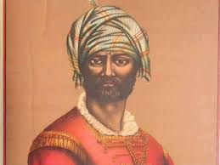

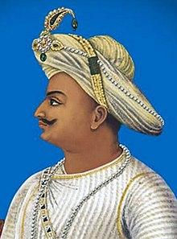

Mysore was under the control of Hyder-Ali and after his death his son Tipu Sultan became the ruler. He transformed Mysore into a powerful kingdom. In order to annex Mysore four battles were fought between the British and the kingdom of Mysore.
In the third Anglo Mysore war (1790-1792) Lord Cornwallis, the Governor General of Britain, entered into an alliance with Marathas and the Nizam of Hyderabad. Their joint forces defeated Tipu Sultan. In 1799 the British defeated Tipu at Seringapatam in the fourth Anglo Mysore war.
Result of the war:
The victory over Mysore paved the way for the total control of India by the British.
Strategies used by the British:
The British used three strategies other than war to annex Indian territories. They are 1. Subsidiary alliance
2. Doctrine of Lapse
3. Annexations
Subsidiary Alliance
In the Subsidiary Alliance system an Indian ruler had to maintain British troops in his state either by giving some of his territory or by paying for the maintenance of the troops. Rulers like Nizam of Hyderabad and the Nizam of Awadh joined in this system.

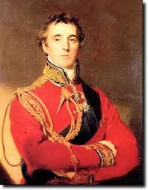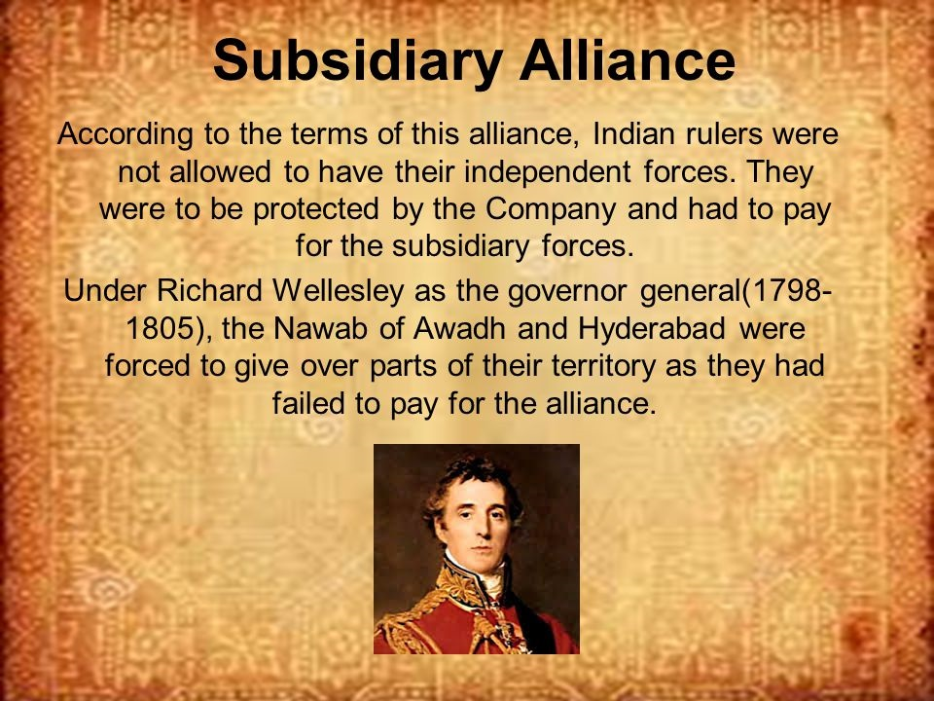

Annexation
Annexation means to take control of a neighboring territory, usually with the use of force. The states annexed through this policy were the kingdom of Travancore, Surat and Carnatic. Lord Wellesley introduced this policy.
Doctrine of Lapse
When a ruler of a subsidiary or protected state died without a natural heir, the state could not pass to the adopted child but was annexed to British territory. It was introduced by Lord Dalhousie. The territories annexed were Satara, Nagpur, Jhansi, Sambalpur, and Udaipur.

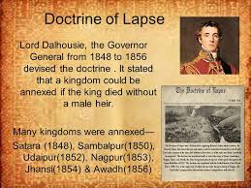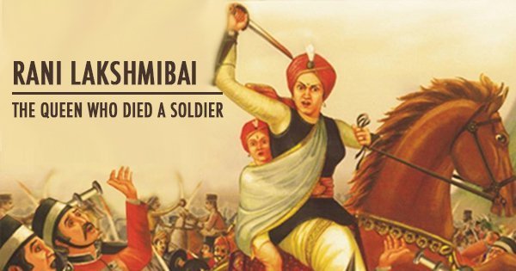
The Anglo Sikh War
Taking advantage of the declining power of the Mughal Empire, the Sikhs established a powerful empire in the 18th century under the leadership of Ranjit Singh. He maintained a friendly relationship with British. After his death, there was anarchy in Punjab and Khalsa became powerful. The Khalsa distrusted the British and at the same time the British wanted to annex Punjab. Two wars fought between Punjab and the British under the leadership of Lord Dalhousie. During the second Anglo Sikh war the Sikhs were defeated and Punjab became a vassal state of British.

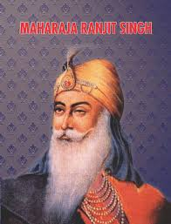

The Annexation of Awadh(1856)
In 1856 Dalhousie annexed Awadh without any proper provocation and its ruler Wajid Ali Shah was deposed. This act of British was universally condemned and became one of the main causes of the revolt of 1857. Thus by 1856 the whole of Indian was under British rule.
Reasons for the success of the British
1. Absence of a strong central leadership- With the decline of Mughals there was no strong central leadership in India to check the activities of the British.
2. Lack of Unity among the Indian states- The Indian states were unable to form a United Front against the British, and the British took advantage of their rivalries and put a strong base in India.
3. The weakness of Indian rulers- Many rulers chose subsidiary alliance with the British rather than fight them as they wanted to protect their comfortable lifestyle. They did not carry out any reforms for the benefits of the people.
4. Britain’s superior Army and Navy- the British soldiers had better firearms than the Indian soldiers. They were also better disciplined and better trained than the Indian soldiers.

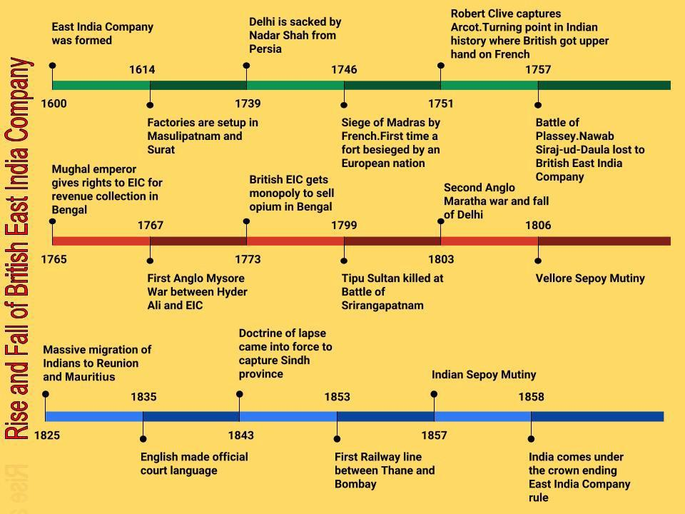

Conclusion:
Within a span of just around 100 years (1757-1857) the British in India transformed themselves from traders to the rulers of the most powerful empire of the 19TH century
Chapter-2

The Establishment of Company Power AT A GLANCE

Portuguese
The Portuguese had trading settlements at Goa, Diu, Salsette, Bassein and

Voyages of Discovery
Vasco Da Gama, Portuguese landed at Calicut
And discovered a sea route to East
France
The French who were the last European power Santhome

Dutch
The Dutch East India Company was formed in established factories inMasulipatanam , Surat, and Cochin.

1602 and
Britain
Established Supremacy In India through wars
enter India set up factory at Surat and acquired Mahe in Malabar on the west coast.
The Anglo Maratha War
^{The Carnatic War} The wars which fought with French to
eliminate them from India came to known as Carnatic Wars. The three states of
Carnatic region—Hyderabad, Carnatic,
and Mysore were in constant conflict with each other Taking advantage of this
conflict both British and French fought
three wars between 1746 and 1763. The British defeated French and the British
became the main European power in India
The British Conquest of India
After the death of Shivaji the governors of different provinces called as Peshwas started to rule Maratha Kingdom. The British wanted to annex Maratha Kingdom so they fought three wars that came to be known as The Anglo Maratha wars.
The Anglo Mysore War
The Battle of Buxar
Mir-Qasim soon grew tired of British control and set about consolidating his power and position. To improve his finances he tried to force the employees of East India Company to pay duty for their private trade. When he was unable to do so, he granted free trade to all Indians.In1763, Mir-Qasim went to Awadh and entered into an alliance with nawab Shujauddaula and the Mughal emperor Shah Alam, who was a refugee after the third battle of Panipat. In 1764, the combined forces of Mir-Qasim, Shujauddaula, and Shah Alam met the British at the Battle of Buxar
Annexation means to take control of a neighbouring territory, usually with the use of force. The states
The Battle of Plassey The war between British and the nawab of Bengal came to known as Plassey war. The British started fortifying their factory at Fort William in Calcutta.Sirajuddaulah, the Nawab of Bengal, asked British to demolish the fortifications. The British refused. So Sirajuddaulah marched to Calcutta and occupied Fort William.So Robert Clive, the commander of the British troops declared war on Sirajuddaulah.
Strategies used by the British to annex Indian territories
The Anglo Sikh war
British also annexed Punjab through war came to be known as Anglo Sikh War Taking advantage of the declining power of the Mughal Empire, the Sikhs
established a powerful empire in the 18th century under the leadership of Ranjit Singh. He maintained a friendly relationship with British. After his death, there was anarchy in Punjab and Khalsa became powerful. The Khalsa distrusted the British and at the same time the British wanted to annex Punjab. Two wars fought between Punjab and the British under the leadership of Lord Dalhousie. During the second Anglo Sikh war the Sikhs were defeated and Punjab became a vassal state of British.
In order to annex Mysore four battles were fought between the British and the kingdom of Mysore.
In the third Anglo Mysore war (1790-1792) Lord Cornwallis, the Governor General of British entered into an alliance with Marathas and the Nizam of Hyderabad. Their joint forces defeated Tipu Sultan. In 1799 the British defeated Tipu at Seringapatam in the fourth Anglo Mysore war
Reasons for success of British *Absence of strong central leadership
*Lack of unity among Indian states *Weakness of Indian Rulers *Britain’s superior Army and Navy
annexed through this policy were kingdom of Travancore, Surat and Carnatic. Lord Wellesley introduced this policy
Doctrine of Lapse means when a ruler of a subsidiary state died without a natural heir, the state could not pass to the adopted child but was annexed to British Territory
In the Subsidiary Alliance system, an Indian ruler had to maintain British troops in his state, either by giving some of his territory or by paying for the maintenance of the troops.

