

ODM STUDY NOTE

SUBJECT—CIVICS STD-VIII CHAPTER-2
IDEAS AND IDEALS OF INDIAN CONSTITUTION

Introduction
India as we know was under British rule for almost 200years. Under British rule, we were compelled to obey loss that favoured our rulers and not for us. Hence in 1946, a group of some the wisest thinkers of India were elected to form a Constituent Assembly, whose main purpose was to frame a constitution for independent India. They took almost three years to complete our constitution. They had to draft the constitution keeping in mind the needs and aspirations of the various ethnic, religious, linguistic and cultural groups that made up India.

The Preamble
The Key features of the Indian constitution

The Directive principle of state policy
- Fundamental Rights

Federal structure of government
- Parliamentary government

The Preamble:
Our Constitution begins with a introduction came to known as Preamble. It highlights the goals and aspirations of the Indian people, and it describes India as Sovereign, socialist, secular, democratic, republic country.

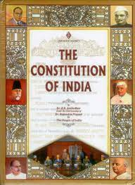

Sovereign Country
India is now independent. It is no longer governed by any external authority.

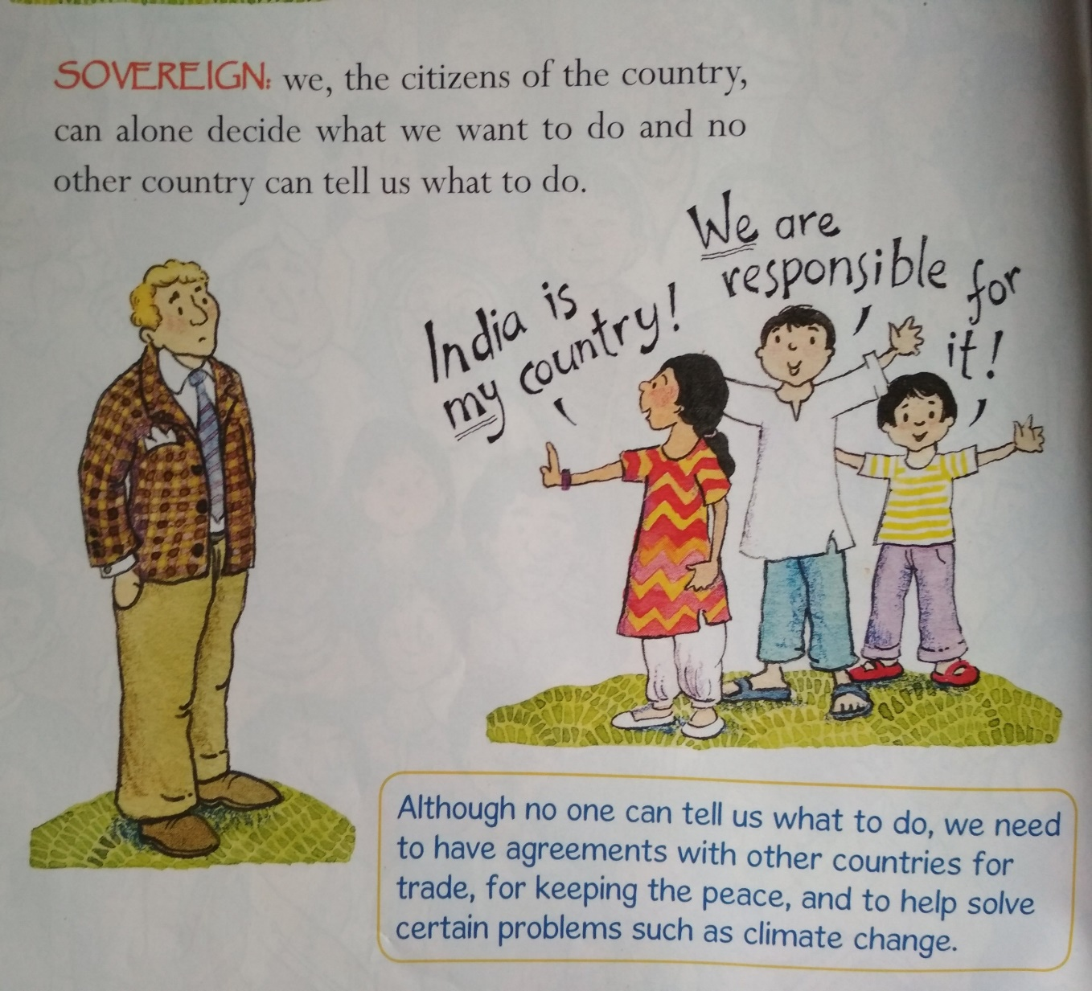

Socialist Country
Everyone is given equal opportunities to make use of the resources of the country.



Secular Country
Every citizen has the freedom to profess, practice, and propagate the religion of his liking and no discrimination on the basis of religion.

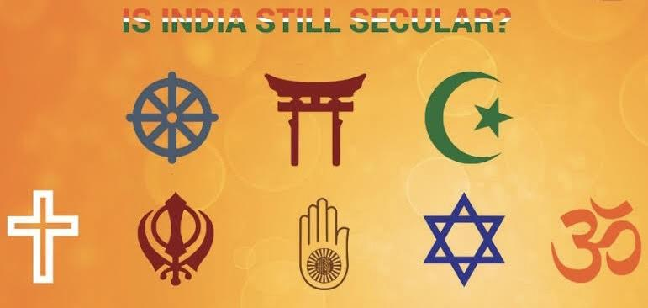

Democratic Country
The country which is governed by elected representatives. Election is conducted at fixed intervals.

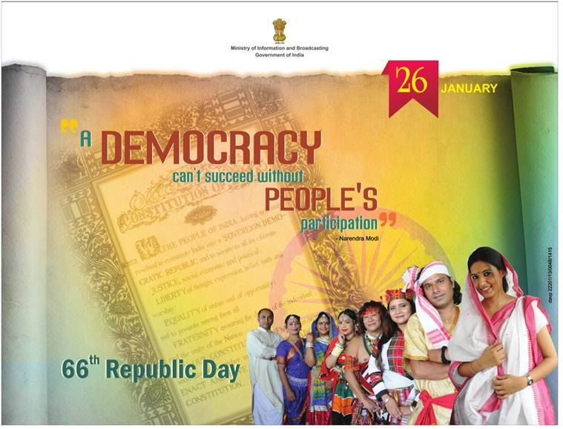

Republic Country

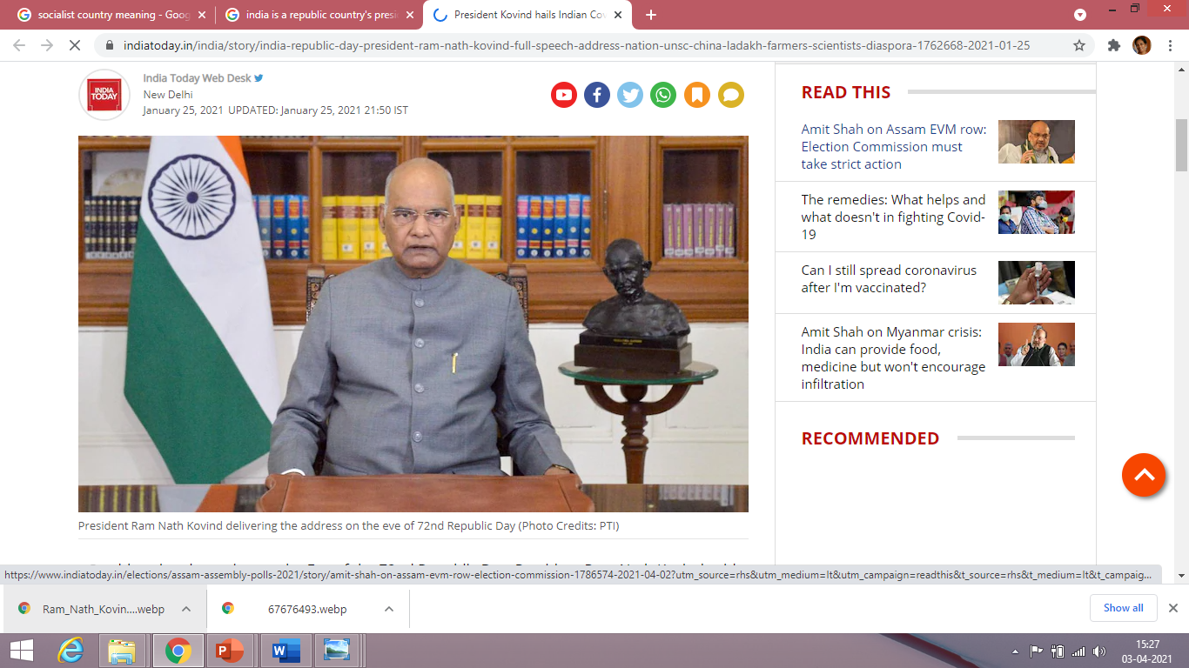Republic Country

India is a Republic country because our head of the state –president is an elected person not a hereditary one. He is elected for 5 years which is a fixed term of office.

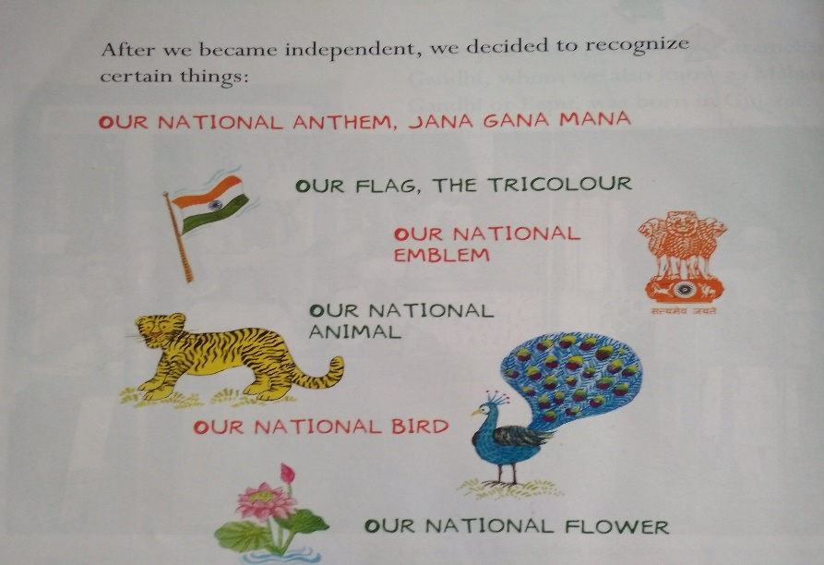

The Indian Constitution added with some universal moral values to ensure comfortable life of people.
They are justice, liberty, equality and fraternity.

Justice
Indian constitution strives to ensure an equitable and just society by reducing economic and social inequality. For ex. Reservations are given to those who belong to schedule caste and schedule tribe in education institutions and government jobs etc.

Liberty
The Constitution gives the citizens the freedom to express their opinion, follow their own path and also choose the occupation of their choice.

Equality
All citizens are considered equal before law. All kinds of discrimination are deemed illegal and therefore punishable by law.

Fraternity
India is a land of contrast and diversities and home for different faiths, cultures, traditions and languages. To preserve the unity and oneness of India it is necessary to develop a sense of fraternity or brotherhood among the people of India.

The Directive Principles of State Policy
Every Govt which comes to power is expected to be guided by some principles when making policies and laws. For example the directive principle directs the state to provide free and compulsory education up to the age of14 and need to have uniform civil laws for all religions.
It denotes the ideals that the State should keep in mind while formulating policies and enacting laws. It constitutes a very comprehensive economic, social and political programme for a modern democratic State which aimed at realising the high ideals of justice, liberty, equality and fraternity as outlined in the Preamble to the Constitution. They embody the concept of a ‘welfare state’ which was absent during the
colonial era.
The directive principles cannot be enforced in a court of law.

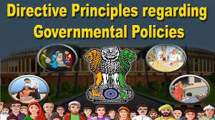

Fundamental Rights
The Rights which are guaranteed by the Constitution and have legal sanction are called Fundamental Right.
- Right to freedom
- right to equality
- right to religion
- Right against exploitation,
- Cultural and Educational Rights
- Right to constitutional remedies

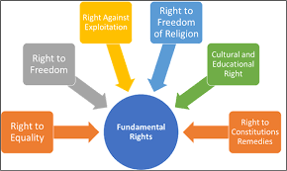

Right to freedom
It includes freedom of Speech and expression, freedom of Associations, freedom to move freely
inside the country, freedom to practice any profession etc. Though we are free to criticize or comment through the press we cannot do so without sufficient proof. We are allowed to form associations or club so long as they do not indulge in violence.
Right to Equality
All the citizens are entitled to equal treatment before law and there shall be no discrimination whatsoever among citizens. All enjoy equal rights and opportunities.

Right to Freedom of Religion
Every citizen has the freedom to profess, practice, and propagate the religion of his / her liking. There can be no discrimination on the basis of religion.

In India we have many religions. Each and every religion has the same freedom to profess, practice, and propagate their religion.

Right to Cultural and Educational Rights

The Constitution states that all minorities, religious or linguistic, can set up their own educational institutions in order to preserve and develop their own culture. India is a plurastic country so the people belonging to all cultural groups have the right to preserve and practise their language and culture

Right against Exploitation

It protects people from being exploited. Don’t force anybody especially adults and children to work for long hours or under un healthy conditions, Constitution prohibits human trafficking, forced labour, and employment of children under 14 years of age.

Right to Constitutional Remedies
Our fundamental rights are legal and justifiable
This allows citizens to move the court if they believe that any of their Fundamental Rights have been violated by the State.

Significance of Fundamental Right:
- They constitute the foundation stone of the democratic fabric of the country.
- They provide necessary conditions for moral and material protection of human beings.
- They protect the interest of minorities and weaker sections of the society.
- They strengthen the secular nature of the nation.
- They lay the foundation for an equitable society based on social justice and social equality
- They check the absolute authority of the government.

Fundamental Duties

Each citizen has their own duties. All rights come with certain duties
The Indian Constitution also lays down a list of Fundamental Duties.

According to the 42nd amendment of our Constitution enacted in 1976, a set of duties is prescribed for this prescribed for the citizen. These duties are not enforceable by law; all citizens should faithfully carry them out

For example it is the duty of every citizen to uphold the ideals of our Constitution, respect the National Flag, National Anthem, and National Flag. It is the duty of every citizen to protect the sovereignty
And integrity of the Nation.

.

Federal Structure
Federal structure of Govt means the power is distributed between centre govt, state govt
and local Govt

Each level has-been assigned separate areas of subjects.

Union List, State List, Concurrent List.

The Union Lists consists of 100 subjects like Defence, foreign affairs, and finance. The State List consists of 61 subjects like police, health, sanitation, and agriculture .The Concurrent Lists of
52 subjects like education, electricity, labour welfare etc

Parliamentary form of government
In a Parliamentary form of Govt there is a nominal head of the Govt, president. The real power lies in the hands of The Prime – minister and council of ministers
In a parliamentary democracy the three organs of the Government – the legislature, Executive and Judiciary are independent of each other and there is a clear-cut separation of power among them The Executive is answerable to the Legislature for its actions.
Both the Executive and Legislature are in turn answerable to the judiciary.

