[THE REVOLT OF 1857] | SOCIAL SCIENCE| STUDY NOTES

Chapter-VII
The Revolt of 1857 STUDY NOTES
ODM Educational GroupPage 1
[THE REVOLT OF 1857] | SOCIAL SCIENCE| STUDY NOTES
Introduction:
The Revolt of 1857 was also known as The First War of Indian Independence because It had made some far-reaching Consequence in every field of India
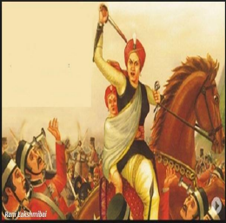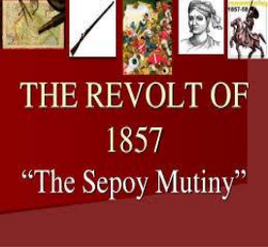Economic Causes
1. Britain used India as a source of raw materials for its own industries. In turn it flooded India with cheap machine- made goods from Britain. As a result, Indian industries suffered a steep decline and millions of Artisans became jobless.
2. The land revenue policies of Britain were so high, both peasants and Zamindars found it difficult to pay 3. Due to Commercialisation of Agriculture, recurring famines and many suffered extreme poverty 4. Almost all the High post in the Army, Civil service, Police and Judiciary were reserved for the British
ODM Educational GroupPage 2
[THE REVOLT OF 1857] | SOCIAL SCIENCE| STUDY NOTES

Religious and Cultural cause
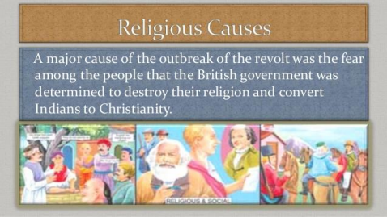
The British openly criticised some Hindu customs. Sati was banned, remarriage of widows was sanctioned by law, schools were opened for the education of women, and they stopped child marriage.
Many Indian thought that the British were interfering needlessly in their age-old customs. The introduction of English medium school especially by Christian missionaries was seen as a ploy to convert Hindus and Muslims to Christianity.
Muslim leaders in Bengal started the Wahabi movement to protest against the rapid loss of power and wealth suffered by Muslims in India. Persian- the official language of Bengal was replaced with English.
ODM Educational GroupPage 3
[THE REVOLT OF 1857] | SOCIAL SCIENCE| STUDY NOTES
Governor General Lord Bentinck had introduced many social and Economic reforms in India. Military causes
1. In the Army Indians were not allowed to rise in their jobs beyond the rank of sergeant 2. They were not allowed to wear the mark of their caste on their forehead.
3. A new act passed by British declared that the sepoys were forced to go abroad to fight wars, though the Hindu faith prohibited them from crossing the sea.
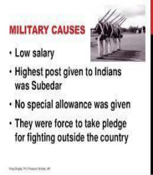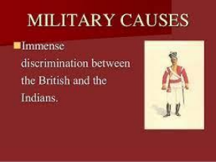ODM Educational GroupPage 4
[THE REVOLT OF 1857] | SOCIAL SCIENCE| STUDY NOTES
Political cause
1. The conquest of India by the British had dispossessed many Indian rulers of their territories.
2. The British policies of annexing territories like subsidiary alliance and doctrine of lapse caused resentment among the Indian rulers.
3. Once the state was annexed the Army was disbanded so that all the soldiers lost their job and income.
Immediate Cause
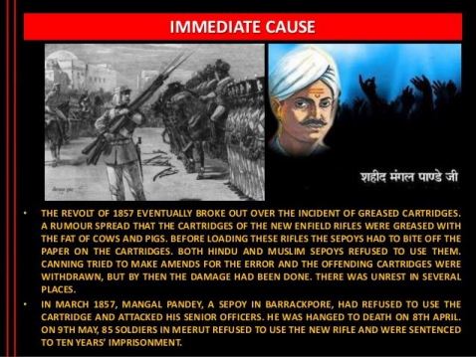
In 1857 the British introduced a new Enfield rifle which was smeared with grease. Before loading it one end of the cartridge had to be bitten off. A rumour spread that the grease used was the fat of cows and pigs which hurt the feelings of both Hindu and Muslim soldiers. The soldiers refused to use the cartridge
ODM Educational GroupPage 5
[THE REVOLT OF 1857] | SOCIAL SCIENCE| STUDY NOTES
Mangal Pandey who led the revolt was hanged.
Outbreak of the Revolt
On 9th MAY In Meerut a group of soldiers refused to use the greased cartridge. They were dismissed and sentenced to imprisonment for 10 years. On hearing this other soldier stationed at Meerut and revolted. ON 10TH May they realised the imprisoned soldiers, killed their British officers and marched to Delhi. There they proclaimed the old Mughal emperor Bahadur Shah Zafar as the emperor of India.
Spread of the Revolt
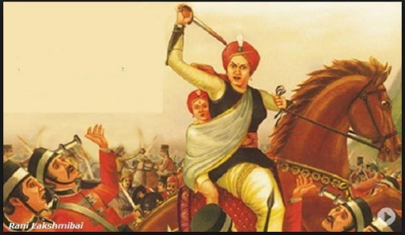ODM Educational GroupPage 6
[THE REVOLT OF 1857] | SOCIAL SCIENCE| STUDY NOTES
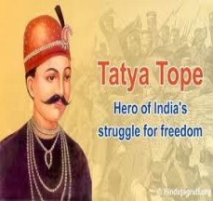
The Revolt in Kanpur was led by Nana Saheb with the help of his commander Tantia Tope and Azimullah In Lucknow the Revolt was led by Hazrat Mahal and Maulvi Ahmadullah. In Jhansi the Revolt was led by Rani Lakshmibai. With the defeat of Rani Lakshmibai, the Revolt was almost completely crushed by the British.
The end of the Mughal Empire
Under the command of General O’Neil, British troops launched a massacre in Delhi. Bahadur Shah Zafar‘s sons were captured and killed. The old emperor was exiled to Rangoon
In Burma where he died. Thus the Mughal Empire came to an end.
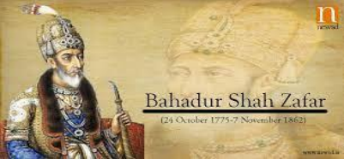ODM Educational GroupPage 7
[THE REVOLT OF 1857] | SOCIAL SCIENCE| STUDY NOTES
Reasons for the failure of the Revolt
1. Lack of Unity among Indians- The revolt did not involve the entire region or all the sections of the Indian society. Many of the Indian rulers and big zamindars refused to join the rebellion. Most of the educated, westernized Indians did not support the revolt.
2. Lack of National Leader- There was no single leader who could unite the various groups for the revolt. The freedom fighters were not inspired by modern ideas of nationalism, Liberty, equality and democracy.
3. Lack of resources- The rebels could not match the modern weapons and materials of war used by the British. Though the Indian soldiers were fearless and brave but they lacked organisation and discipline. The British had the railways at their disposal and an excellent system of communication.
Results of the Revolt
1. The rise of Nationalism- The greatest consequence of the revolt was the rise of a feeling of nationalism in India the common people were inspired by the leaders like Jhansi Rani, Tantia Tope and Nana Saheb.
2. Reorganization of British Empire in India- India was brought directly under the crown. reorganization of the Army
3. Queen Victoria’s proclamation- In 1858, Queen issued a proclamation which granted unconditional pardon to all rebels and their change in attitude towards Indians.
4. Tenancy Act- the Bengal Tenancy Act of 1859 was passed to ensure the welfare of the people that any peasant who could prove that he had occupied a piece of land for 12 years was granted tenancy rights and could not be evicted from the land.
Video Link: https://www.youtube.com/watch?v=ataW-bloIEY&t=596s
Conclusion
Lord Canning became the first Viceroy of India and India passed on to the crown from the British East
ODM Educational GroupPage 8
[THE REVOLT OF 1857] | SOCIAL SCIENCE| STUDY NOTES
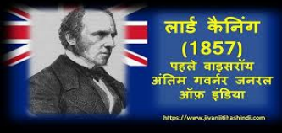India Company.
ODM Educational GroupPage 9

