Chapter- 5
EDITING TEXT IN MS WORD 2016
STUDY NOTES
Microsoft Word 2016 is a word processing application software that allows us to create a variety of documents, including letters, resumes, and more.
It was introduced by Microsoft Corporation.
Word 2016 has power and flexibility to –
- Produce letters, reports, notices, newsletters, books, bills etc., in a presentable manner.
- Modify and beautify the text using colour, style, font size, border, shading while typing and after typing.
- Insert graphics and make use of various drawing tools to draw pictures.
- Copy and move the text from one location to another.
- Share documents on internet and invite people to view and edit the shareable documents.
- Preview the text before printing it, and take multiple printouts.
Starting word 2016 :-
Click on ---- Start --------- Word 2016
- In Microsoft Word 2016, there is an option for the Backstage View. Backstage View is accessible by clicking the "File" tab near the top-left of the application window.
- The backstage view provides access to saving, opening, info about the currently open file (Permissions, Sharing, and Versions), creating a new file, printing, and recently opened files.
- The Backstage View also provides some information (properties) about the file, including the following.

- file size
- number of pages and words
- creation date
- last modified date
- author
- Word will open a new blank document with a temporary name Document 1.
- The small blinking vertical line that we notice on the screen is known as Cursor.
- Cursor is the insertion point and indicates the position where the next typed text will appear.
- As we start typing, the cursor automatically shifts to the right.
Entering text :-
Word wrap is a word processing feature that forces all text to be confined within defined margins. When a line of text is filled, the word processor automatically moves the text to the next line, so the user doesn't have to press the return key after every line.
Selecting and editing the text :-
- Making changes in a document is called editing.
Selecting the text using mouse:-
- To select a word, double-click it.
- To select a single line of text, click in the left margin next to the line.
- To select a sentence, hold down [Ctrl] and then click anywhere in the sentence.
- To select a paragraph, click three times in the paragraph. Alternatively, click twice in the left margin next to the paragraph.
- To select the entire document, click three times in the left margin. Alternatively click anywhere in the selection area while holding down the Ctrl + A key.
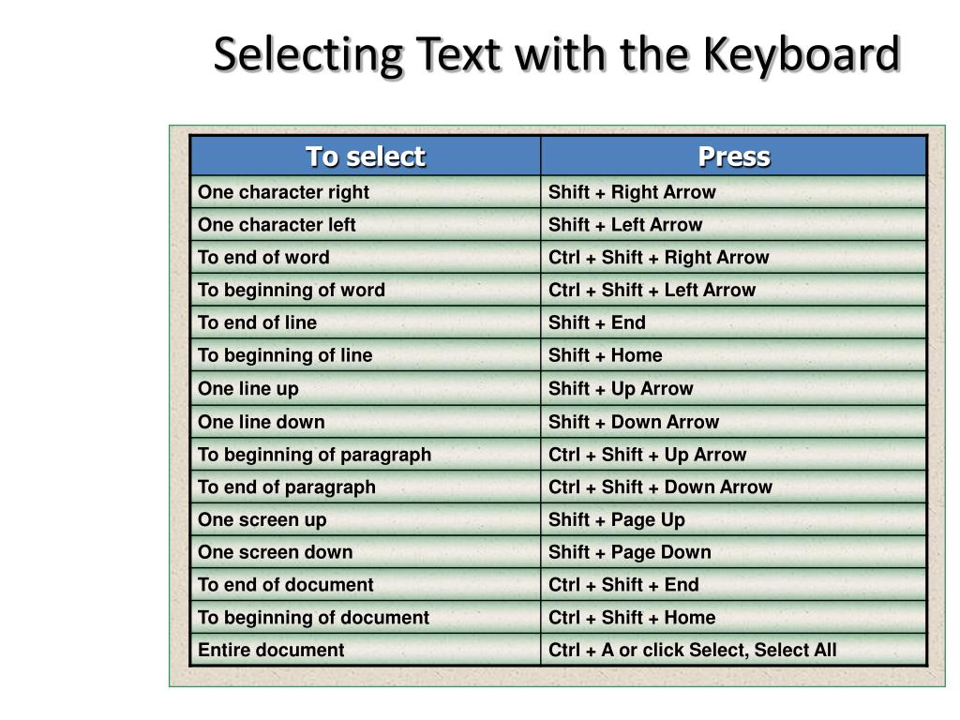
INSERTING THE TEXT
- BY USING INSERT MODE
While in Insert mode, the new text that is added to a document moves the current text forward, to the right of the cursor, to accommodate the new text as it's typed or pasted into the document. It's the default mode for text entry in Microsoft Word.
- To select the insert mode, right – click on the Status bar. The customize status bar menu appears.
- Click on Overtype option. The Insert option appears on the status bar which shows that the insert mode is selected.
- Now to enter the text, place the pointer to the right of the character where we want to insert the text and type the text.
- BY USING OVERTYPE MODE
In Overtype mode, when text is added to a document where there is existing text, the existing text is replaced by the newly added text as it's entered, character by character.
- Click on Insert option in Status bar. It will change the existing mode into overtype mode.
- Now place the cursor before the letter and start typing.
MOVING THE TEXT :-
- This feature is used to move the text from its original location to new location
- Cut using Ctrl+X, move your cursor to the new location of text, then paste to the new location with Ctrl+V .
COPYING THE TEXT :-
- This feature is used to copy a text from one location to another within a document and also from one document to another.
- Copy using Ctrl+C, move your cursor to the new location of text, then paste to the new location with Ctrl+V
- Right-click selected text, select either Copy or Cut, then right-click the new location of text and select Paste
DELETING THE TEXT
- Using delete key
- Using backspace key

DIFFERENCE BETWEEN DELETE AND BACKSPACE KEY:
DELETE KEY | BACKSPACE KEY
1. Erases character on the right side of cursor | 1. Erases character on the left side of cursor
2. Two delete keys are there in keyboard | 2. Two delete keys are there in keyboard
UNDO COMMAND
- Undo is a function performed to reverse the action of an earlier action.
- For example, the undo function can undo deleted text in a word processor.
REDO COMMAND
- The redo function restores any actions that were previously undone using an undo.
- For example, if we typed a word, and then deleted it using an undo, the redo function restores the word we deleted.
- Shortcut key to use Undo and Redo commands are Ctrl + Z and Ctrl + Y respectively.
CHECKING SPELLINGS AND GRAMMAR
- Word 2016 has a built- in dictionary and a set of grammatical rules to check spellings and grammar of text document.
- Incorrectly spelled words are displayed with single red wavy line under them.
- Grammatical errors are indicated with a blue wavy line.
Method to check spellings of any word :-
- Right click on the word with red wavy line.
- A shortcut menu with various suggestions opens.
- Select the correct spelling from list
- The incorrect word is automatically replaced with correct one.
- The shortcut key to check spellings and grammar is F7.
USING THESAURUS
- The Thesaurus is a software tool that is used in the Microsoft Word document to find synonyms (words with the same meaning) and antonyms (words with the opposite meaning) for the selected word.
- Generally, the Thesaurus is used in the Word documents when we write an email, letter, project report, or research papers.
INSERTING THESAURUS
- There are the following steps to use Thesaurus using the Review tab -
- Step 1: Open the new Word document or an existing Word document.
- Step 2: Type the word in the document that you want to look up (Thesaurus)
- Step 3: Go to the Review tab on the Ribbon and click on the Thesaurus option in the Proofing section or you can simply press shortcut key Shift + F7.
- Step 4: The Thesaurus task pane opens on the right side of document window, displaying the list of synonyms.
- Step 5: Move the mouse pointer on the selected word, click on drop down button and select the insert option.

BRAIN DEVELOPER
SECTION – A
- Fill in the blanks .
  - The selection area is a blank area in the left margin of a document.
  - The clipboard is a reserved place that stores data temporarily.
  - Making changes in a document is called editing.
  - To print the document, click on print tab > file option.
  - Incorrectly spelt words can be seen with red wavy line under them.
  - The thesaurus option provides a list of synonyms and antonyms.
- State true or false .
- The shortcut key to close a document is Ctrl + C. False
- In MS Word you can share documents on the internet. True
- The shortcut key to jump to the end of the current document is Shift + Ctrl + End. True
- To select a sentence, hold down the shift key and click anywhere on the sentence. False
- To select a paragraph, double click anywhere in the paragraph. False

- Match the following.
- Ctrl + A | - Selects the entire text.
- Shift + Home | 2. Selects the text from current position to the beginning of the line.
3. Ctrl + X, Ctrl + V | 3. Cuts the text and places it at a new place.
4. Ctrl + C, Ctrl + V | 4. Copies the text from one place and pastes it at another place.
5. Ctrl + Delete | 5. Deletes one word to the right.
D. Application – based questions.
1. Raman has made a project, but he does not know how to check the spellings and grammatical mistakes in a document.
Ans) Raman will follow the steps as follows –
- Right click on the word with red wavy line.
- A shortcut menu with various suggestions opens.
- Select the correct spelling from list
- The incorrect word is automatically replaced with correct one.
2. Sonam has added some extra paragraphs in her document. The teacher has asked her to delete them. How will you help her to do this?
Ans) Sonam will –
- Click at the beginning of the text, and while pressing the shift key, she will click at the end of the text.
- Now Sonam will place the delete key.
SECTION – B
A. Multiple choice questions.
1. In how many ways you can insert text in an existing document?
a. 3 b. 2 c. 4
2. Grammatical errors are indicated with a _____________.
a. red wavy line b. green wavy line c. blue wavy line
3. Which of the following shortcut keys is used to select one character to the right?
a. Shift + b. Shift + c. Shift +
4. Which is the shortcut key for Undo command?
a. Ctrl + Y b. Ctrl + U c. Ctrl + Z
B. Answer in one word or one sentence.
1. Which shortcut key is used to check spelling and grammar in Word document?
Ans) F7
2. Which command is used to reverse the action of the Undo command?
Ans) Redo
3. Name the mode that is used to replace the existing text in a document.
Ans) Overtype mode
4. Write the shortcut key to delete one word to the left.
Ans) Backspace key
C. Answer the following questions –
1. List any three features of a word processing software.
Ans) The three features of a word processing software are –
- Produce letters, reports, notices, newsletters, books, bills etc., in a presentable manner.
- Modify and beautify the text using colour, style, font size, border, shading while typing and after typing.
- Insert graphics and make use of various drawing tools to draw pictures.
2. What do you understand by editing? How can you insert text in a document?
Ans) Making changes in a document is called editing.
Text can be inserted in a document by the two modes –
- Insert mode.
- Overtype mode.
3. Explain the use of Thesaurus option in Word 2016.
Ans) Use of Thesaurus option in Word 2016 –
- It is used in the Microsoft Word document to find synonyms (words with the same meaning) and antonyms (words with the opposite meaning) for the selected word.
- Generally, the Thesaurus is used in the Word documents when we write an email, letter, project report, or research papers.
4. Differentiate between moving the text and copying the text.

Moving the text | Copying the text
- This feature is used to move the text from its original location to new location | - This feature is used to copy a text from one location to another within a document and also from one document to another.
- The shortcut key of moving the text is –  Ctrl + X ( To cut)  Ctrl + V ( To paste) | - The shortcut key of copying the text is –  Ctrl + C ( To copy)  Ctrl + V ( To paste)

