STD-X- ECONOMIC
- Study the above graph carefully and choose the correct answer. (1)

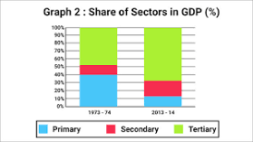
Which is the Least producing sector in 2013-14?
- Secondary sector
- Tertiary sector
- Primary sector
- None of these
- What constitutes the unorganized sector in urban areas? Why do workers in this area need protection?
- How does service sector help in the development of primary and secondary sectors? Explain with examples.
- With the example of sugar cane, explain the interdependence of all the three sectors of economy.
- Explain the working condition of workers in unorganized sector.

