
WELCOME TO THE VIRTUAL CLASS SOCIAL SCIRNCE
SUBJECT : CIVICS
CHAPTER NUMBER: 06
CHAPTER NAME : POLITICAL PARTIES
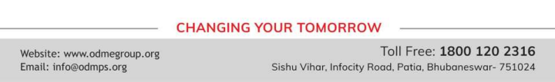
INDIAN NATIONAL CONGRESS
• Popularly known as the Congress Party. One of the oldest parties of the world. Founded in 1885 and has experienced many splits. Played a dominant role in Indian politics at the national and state level for several decades after India’s Independence. Under the leadership of Jawaharlal Nehru, the party sought to build a modern secular democratic republic in India.
• Ruling party at the centre till 1977 and then from 1980 to 1989. After 1989, its support declined, but it continues to be present throughout the country, cutting across social divisions.
• A centrist party (neither rightist nor leftist) in its ideological orientation, the party espouses secularism and welfare of weaker sections and minorities.
• Supports new economic reforms but with a human face.
• Leader of the United Progressive Alliance (UPA) government from 2004 to 2014. Currently it is the principal opposition party in the Lok Sabha.
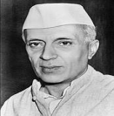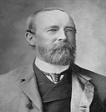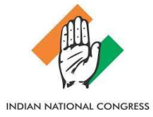
COMMUNIST PARTY OF INDIA – MARXIST
• Founded in 1964. Believes in Marxism Leninism.
• Supports socialism, secularism and democracy and opposes imperialism and communalism.
• Accepts democratic elections as a useful and helpful means for securing the objective of socioeconomic justice in India.
• Enjoys strong support in West Bengal, Kerala and Tripura, especially among the poor, factory workers, farmers, agricultural labourers and the intelligentsia.
• Critical of the new economic policies that allow free flow of foreign capital and goods into the country.
• Was in power in West Bengal without a break for 34 years. In the 2014 Lok Sabha elections, it won about 3 per cent of votes and 9 seats.
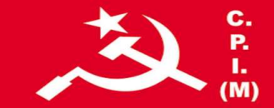
COMMUNIST PARTY OF INDIA
● Formed in 1925. Believes in Marxism-Leninism, secularism and democracy.
● Opposed to the forces of secessionism and communalism.
● Accepts parliamentary democracy as a means of promoting the interests of the working class, farmers and the poor.
● Became weak after the split in the party in 1964 that led to the formation of the CPI(M). ● Significant presence in the states of Kerala, West Bengal, Punjab, Andhra Pradesh and Tamil Nadu. ● Its support base had gradually declined over the years. It secured less than 1 per cent votes and 1 seat in the 2014 Lok Sabha elections. Advocates the coming together of all left parties to build a strong left front.

CHALLENGES TO POLITICAL PARTIES
● Lack of internal democracy within parties: All over the world there is a tendency in political parties towards the concentration of power in one or few leaders at the top.
● Dynastic succession: Since most political parties do not practice open and transparent procedures for their functioning, there are very few ways for an ordinary worker to rise to the top in a party.
● Money and muscle power: In parties, especially during elections. Since parties are focused only on winning elections, they tend to use short-cuts to win elections.
● Meaningful choice to the voters: In recent years there has been a decline in the ideological differences among parties in most parts of the world.
THANKING YOU
ODM EDUCATIONAL GROUP

