
WELCOME TO THE VIRTUAL CLASS SOCIAL SCIRNCE
SUBJECT : CIVICS
CHAPTER NUMBER: 06
CHAPTER NAME : POLITICAL PARTIES
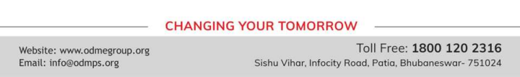
NATIONAL PARTIES
NATIONAL PARTIES & STATE PARTIES STATE PARTIES
• There are some countrywide parties, which are called ‘national parties’. These parties have their units in various states.
• A party that secures at least six per cent of the total votes in Lok Sabha elections or Assembly elections in four States and wins at least four seats in the Lok Sabha is recognized as a national party.
• Parties that are present in only one of the federal units are called state parties.
• A party that secures at least six per cent of the total votes in an election to the Legislative Assembly of a State and wins at least two seats is recognized as a State party.

ALL INDIA TRINAMOOL CONGRESS PARTY
• Launched on 1 January 1998 under the leadership of Mamata Banerjee.
• Recognized as a national party in 2016.
• The party’s symbol is flowers and grass. Committed to secularism and federalism. Has been in power in West Bengal since 2011.
• Also has a presence in Arunachal Pradesh, Manipur and Tripura.
• In the General Elections held in 2014, it got 3.84% votes and won 34 seats, making it the fourth largest party in the Lok Sabha.
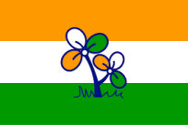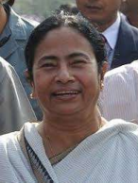
BAHUJAN SAMAJ PARTY
● Formed in 1984 under the leadership of Kanshi Ram. Seeks to represent and secure power for the Bahujan Samaj which includes the dalits, adivasis, OBCs and religious minorities.
● Draws inspiration from the ideas and teachings of Sahu Maharaj, Mahatma Phule, Periyar Ramaswami Naicker and Babasaheb Ambedkar.
● Stands for the cause of securing the interests and welfare of the dalits and oppressed people. It has its main base in the state of Uttar Pradesh and substantial presence in neighbouring states like Madhya Pradesh, Chhattisgarh, Uttarakhand, Delhi and Punjab.
● Formed government in Uttar Pradesh several times by taking the support of different parties at different times. In the Lok Sabha elections held in 2014, it polled about 4 per cent votes but did not secure seat in the Lok Sabha.
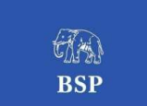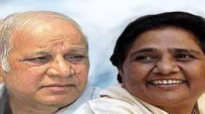
BHARTIYA JANTA PARTY
● Founded in 1980 by reviving the erstwhile Bharatiya Jana Sangh, formed by Syama Prasad Mukherjee in 1951. Wants to build a strong and modern India by drawing inspiration from India’s ancient culture and values; and Deendayal Upadhyaya’s ideas of integral humanism and Antyodaya.
● Cultural nationalism (‘Hindutva’) is an important element in its conception of Indian nationhood and politics.
● Wants full territorial and political integration of Jammu and Kashmir with India, a uniform civil code for all people living in the country irrespective of religion, and ban on religious conversions. Its support base increased substantially in the 1990s.
● Earlier limited to north and west and to urban areas, the party expanded its support in the south, east, the north-east and to rural areas.
● Came to power in 1998 as the leader of the National Democratic Alliance (NDA) including several regional parties. Emerged as the largest party with 282 members in the 2014 Lok Sabha elections. Currently leads the ruling NDA government at the Centre.
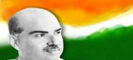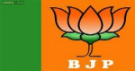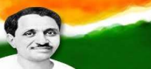
THANKING YOU
ODM EDUCATIONAL GROUP

