
WELCOME TO THE VIRTUAL CLASS SOCIAL SCIRNCE
SUBJECT : CIVICS
CHAPTER NUMBER: 06
CHAPTER NAME : POLITICAL PARTIES
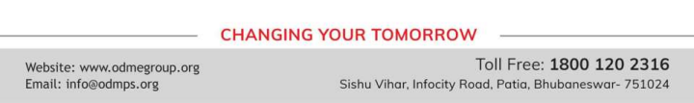
WHAT ARE POLITICAL PARTIES?
A political party is a group of people who come together to contest
elections and hold power in the government.
They agree on some policies and programs for the society with a view to promote the collective good.
Since there can be different views on what is good for all, parties try to
persuade people why their policies are better than others.
They seek to implement these policies by winning popular support through elections.
SOME IMPORTANT FEATURES OF POLITICAL PARTIES
• Parties reflect fundamental political divisions in a society.
• Parties are about a part of the society and thus involve PARTISANSHIP.
• Thus a party is known by which part it stands for, which policies it supports and whose interests it upholds. • A political party has three components:
l) the leaders,
2) the active members and
3) the followers
WHAT ARE THE NECESSITIES OF THE POLITICAL PARTIES?
● We can understand the necessity of political parties by imagining a situation without parties. ● Every candidate in the elections will be independent. So no one will be able to make any promises to the people about any major policy changes.
● The government may be formed, but its utility will remain ever uncertain.
● The rise of political parties is directly linked to the emergence of representative democracies. As we have seen, large societies need representative democracy.
● As societies became large and complex, they also needed some agency to gather different views on various issues and to present these to the government.
● They needed some ways, to bring various representatives together so that a responsible government could be formed.
● They needed a mechanism to support or restrain the government.
THANKING YOU
ODM EDUCATIONAL GROUP

