STD-IV SOCIAL SCIENCE
ANNUAL REVISION WORK - 2
- Give an answer in one word.
- Where all religions are treated as equal is called ___________
- To instantly send written messages or picture, we can use ______________
- A famous Buddhist stupa. __________.
- The practices handed down to us from the past. ____________
- The courier offered by the post offices in India is known as _________
- Electricity generated by the force of water. ___________

B. Answer the following questions.
- Describe about two means of personal communication and two means of mass communication.
- How is it that so many people in Puducherry know French?

C. Map Skill.

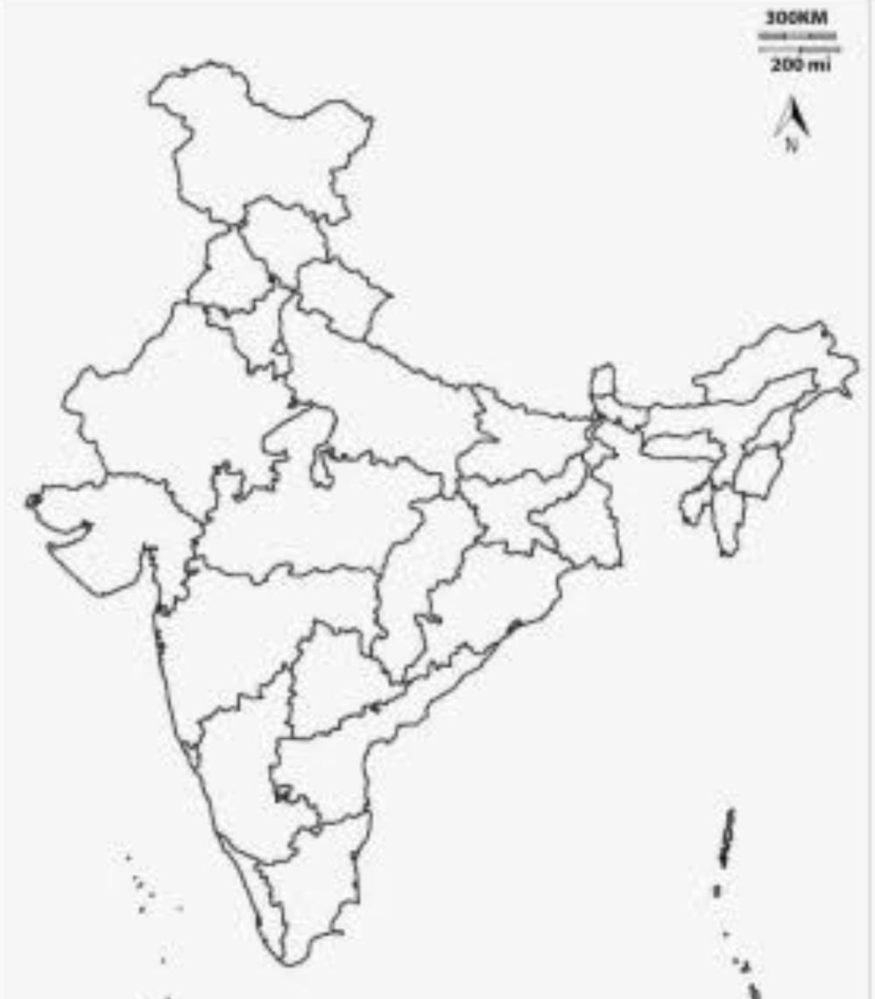

- Colour and indicate the union territory - Daman and Diu
- Colour and locate one Eastern coastal state.
- Indicate the capital of Haryana.

Answer Key.
- Ans. Secularism
- Ans. FAX
- Ans. Sanchi Stupa
- Ans. Heritage
- Ans. Speed post
- Ans. hydroelectricity
- Ans.
Personal communication - The exchange of information between the individuals is called personal communication.
For example - telephone, telegraph
Mass communication - exchanging information on a large scale to a wide range of people at the same time.
For example - television, radio
8 Ans. Earlier Puducherry people were ruled by the French so the people here speak Tamil and English and some people speak French.

