STD-IV SOCIAL SCIENCE
ANNUAL REVISION WORK - 1

- Fill in the blanks.
- The farther away a place from the equator, the _________ it is expected to be.
- The soil erosion from the wind and water can be prevented by ___________.
- The __________ is the fastest and most convenient means of sending spoken messages.
B.Correct the sentences by changing the underlined words.
- The largest and most important soil-group in India is Laterite soil.
- The Western Coastal plains lie between the Western Ghats and Bay of Bengal.
- The directive principle to our constitution describes India as a democratic, Socialist, Secular, Republic.

C. Identify the picture and name it.

a. Name the famous person. ____________.
b. Name the famous dance form ____________.
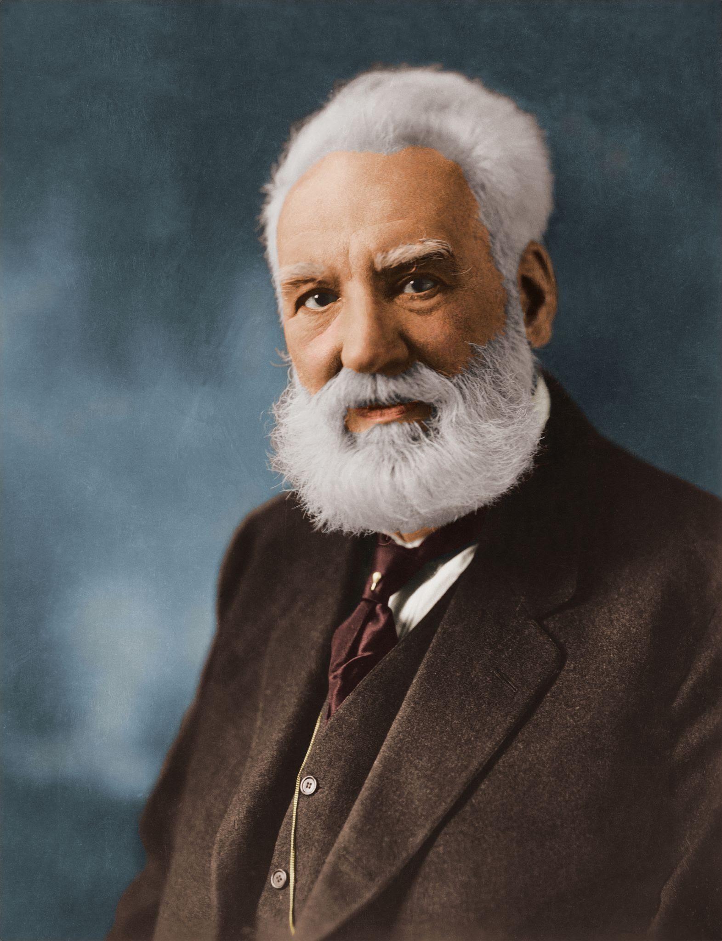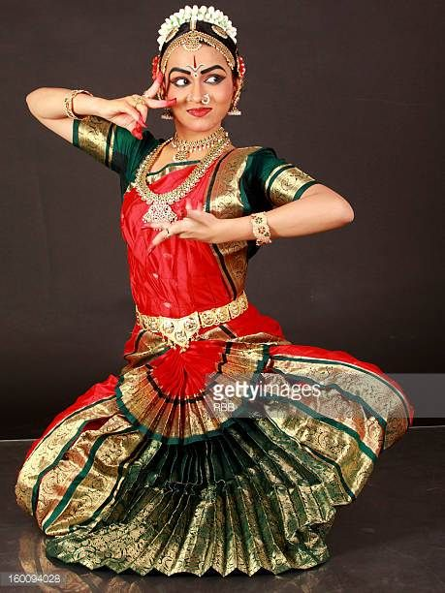
D. Choose the correct option.
- The Northern part of the Western Coastal Plains is called ______ Coast.
- Konkan coast
- Malabar coast
- Gujarat coast
9. Messages are sent by letter and by email using _______ language.
- Telephone
- Computer
- television
E. Answer the following questions.
10. Democracy is better than Monarchy. Give reasons.
11. It is important to save minerals such as coal and petroleum. Why?
12.Differentiate between the principle of socialism and the principle of secularism.

Important
NOTICE- Paste three (3) outline maps of India (Political) in your test notebook for practice.

Answer Key.
1 Ans. colder
2 Ans. afforestation
3 Ans. telephone
4 Ans. Alluvial soil
5 Ans. the Arabian sea
6 Ans. preamble
7 Ans.a. Alexander graham bell
b. Ans. Bharatnatyam
8. Ans. Gujarat coast
9 Ans. computer
10.Ans. Democracy is better than monarchy because in democracy people can choose their own leaders who will work for their betterment but monarchy is a form of government in which a person, the monarch, is a head of state, he will be the only person who will take all the decisions, no freedom will be there to speak about our problems.
11 Ans. It is important to save minerals such as coal and petroleum because these mineral resources are non-renewable, once used up it will not be available to us anymore.
12. Ans.
a. Principle of Socialism –
- It means that all the people of the country will be treated as equals.
- Government will not differentiate on the basis of caste, religion etc.
b. Principle of Secularism- It means that all the people in the country would be free to follow whatever religion they want. This is known as the principle of secularism.

