Chapter-12
MONEY
STUDY NOTES
* Revision
* Conversion
* Adding Money
* Subtraction
* Word problems

- Revision
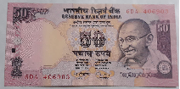
- EXPLANATION
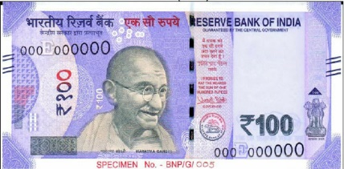
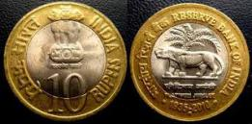

What is MONEY???

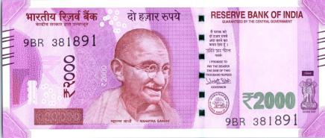
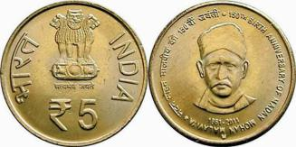

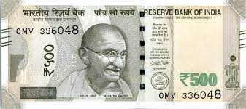

Money is government issued currency of
INDIA



The monetary unit in INDIA is
RUPEES and PAISA




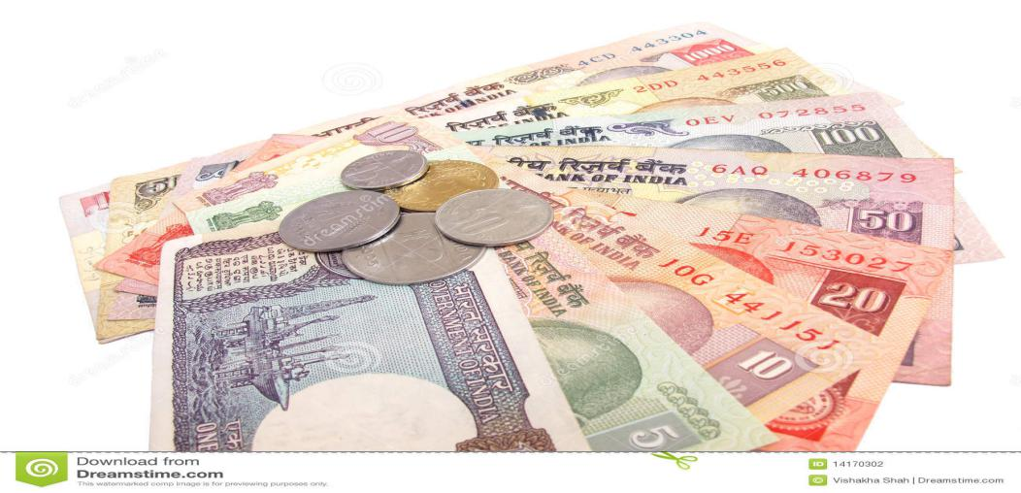

Money is any object that is generally accepted as payment for goods and services and repayment of debts in a given country or social-economic context. The main functions of money are distinguished as: a medium of exchange; a unit of account; a store of value; and, occasionally, a standard of deferred payment.
The part (or section) that is repeated is the unit of pattern.


EXAMPLE
PAISE
p

RUPEES
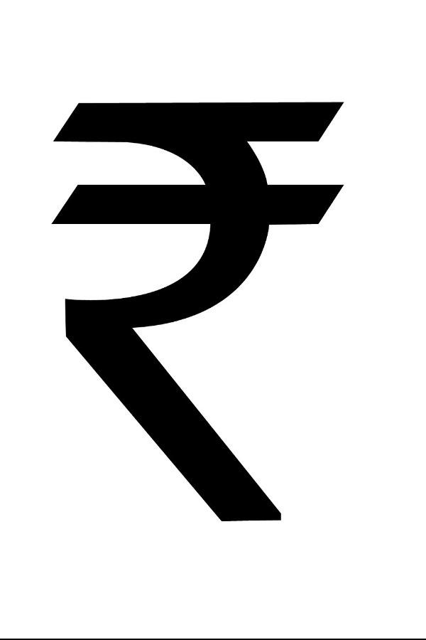

10 note and one 50 paise coin can be written in figure as:
10.50

This shows the RUPEES
This shows the PAISA

A dot seperates the RUPEES from the PAISA

* We write only the symbol of RUPEES not PAISE
- Conversion


- EXPLANATION

₹1 = 100 paisa

To convert ‘rupees’ into ‘paise’ we multiply with 100

To convert ‘rupees and paisa’ into ‘paise’ we multiply the amount in the rupees by 100 and add the amount in paise to it.



If money is written as
₹ 15.75, then to convert into paisa, simply remove the dot.

- For example:
- 700 = 700 x 100 = 70000p
- 12 rupees 50 paisa = 12 x 100 + 50 = 1200 + 50 = 1250 p
- 300.75 = 30075p


To convert paisa into rupees, simply put a dot before two digits from the right.

- For example:
- 1 8 0 0 p = 1 8 . 0 0
- 1 7 8 5 = 1 7 . 8 5

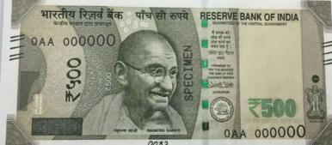
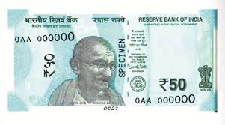
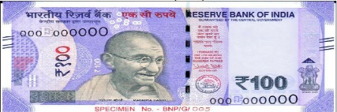

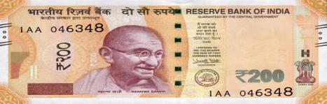
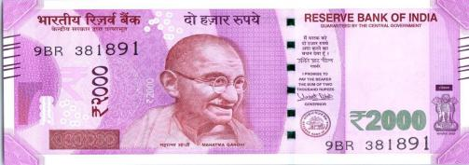

- Adding Money

- EXPLANATION


+
MONEY
REMEMBER
* 1 ₹ = 100 p.
* Arrange the amounts in such a way that all dots are in same line.
* Always start adding from the right-hand side column.
* Add the numbers as normal addition.

* Follow the steps: first add paise then add rupees.

EXAMPLE
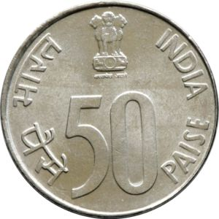
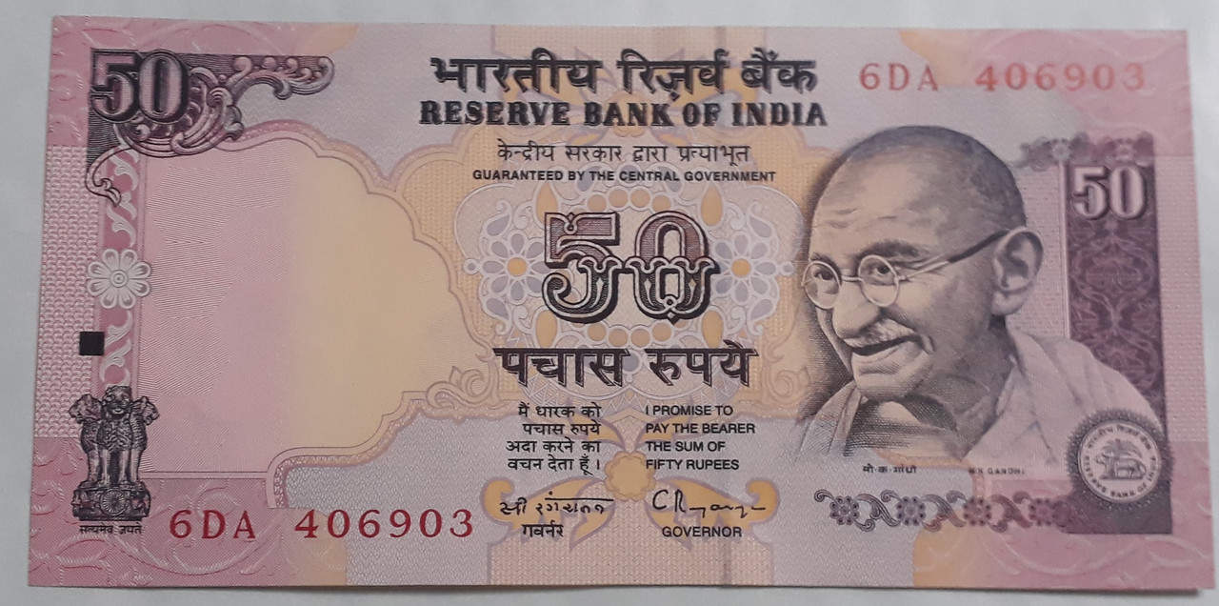
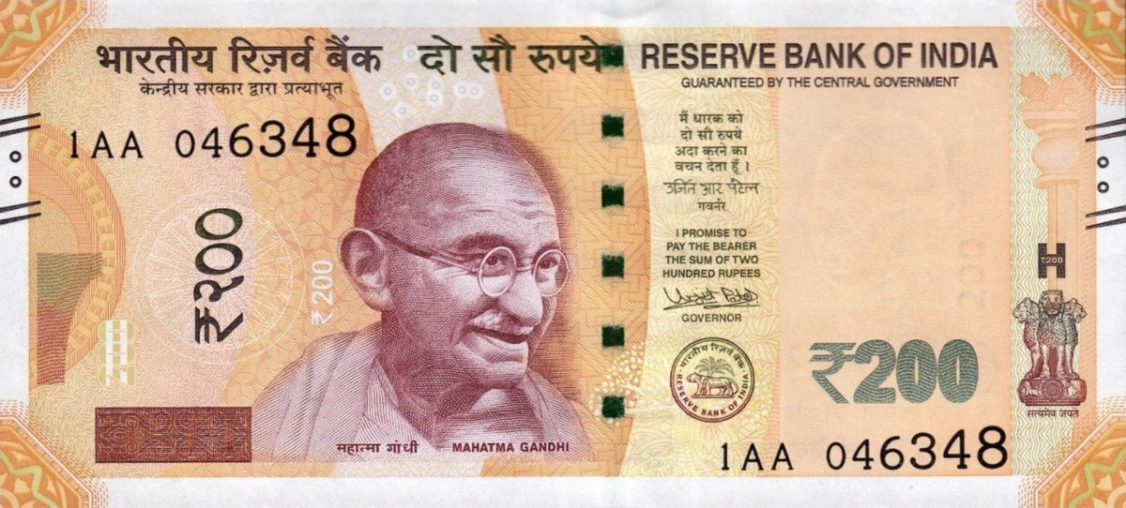
₹ 250.50
=
+
+

Arrange and add:
₹ 4445.21 + ₹ 5271.40 + ₹ 144.21
₹ p
4 4 4 5 . 2 1
5 2 7 1 . 4 0
1 4 4 . 2 1
+
1
1

9 8 6 0 . 8 2

- Subtraction

- EXPLANATION
-

MONEY



REMEMBER

* Always start subtracting from the right-hand side column.

* Subtract the numbers as normal subtraction.

* Follow the steps: first subtract paise then subtract rupees.

EXAMPLE


Subtract the following:
₹ p
4 4 5 . 2 1
2 7 1 . 4 0
-
12
8
4
3
14
7
3
1
1
₹ 445.21 - ₹ 271.40

.

COMMON ERROR

Children often make mistake while writing the numbers one below another and maintaining the point to separate rupees and paise.

- Word Problems

- EXPLANATION
STEPS
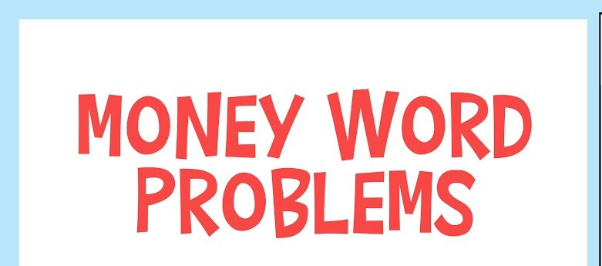
READ

FIND


DECIDE

SOLVE
SUBTRACTION
ADDITION

CHECK

SUBTRACTION
MAGIC WORDS

ADDITION

Left
Add

Difference
Altogether

Subtract
Increase
Remains
Both
Fewer
In all

Less
Sum

How many more
Total

AMAZING FACT

The highest denomination rupee note to be ever printed by our central bank RBI, was the Rs 10,000 note in 1938.

EXAMPLE

Shyam took a loan of ₹8000 from his uncle. After 1st month he paid ₹2470 and after 2nd months he paid ₹3225. What amount of loan is still owes to his uncle?

ANS
+
₹ 2 4 7 0
Amount paid after 1st month =
Amount paid after 2nd month =
₹ 3 2 2 5
5
9
6
5
₹
Total amount paid =

10
9
9
7
₹ 8 0 0 0
Amount taken as loan by Ravi =
Total amount paid =
₹ 5 6 9 5
Amount of loan still left =
5
0
3
2
₹
Amount of loan still left =

₹ 2305 left as a loan .

MIND MAP

MONEY

WORD PROBLEMS

ADDITION

REVISION

SUBTRACTION

IN WORDS

IN FIGURES

CONVERSION
RUPEES TO PAISE

PAISE TO RUPEES

-- END --

4-DIGITS NUMBERS

