Chapter- 6
Parts of the Plants
STUDY NOTES

LET’S LEARN:

ABOUT THE DIFFERENT PARTS OF A PLANT:
As the human body made up of different parts, the plant is also having different parts like Root, Stem, Leaf, Fruit, Branch, Bud and Flower.

SHOOT AND ROOT
Description | Pictures
The part of a plant which grows above the ground is called the shoot. | 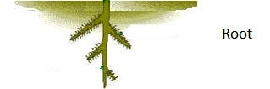

The part which grows below the ground is called the root.
The shoot has stem, branches, leaves, buds, flowers and fruits. | 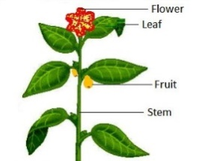

THE ROOT

There are two types of roots, tap root and fibrous root.

Description | Picture
When a main root grows from the end of the stem and many small roots grow from the main root is called tap root. Example: beans plant, mustard plant and balsam plant | 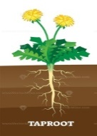
When a number of roots grow from the end of the stem is known as fibrous root. Example: plants like grass, wheat, rice and onion. | 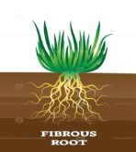

FUNCTIONS OF THE ROOT

Description

The root fixes the plant in the soil.

The plant takes salt and water from the root for making food.

Vegetables like carrots, radish and beetroot have thick and swollen roots where food is stored. This food is used by the plant as well as we eat the roots of such plants.

THE STEM
Description | Picture
The stem grows above the ground. | Trunk  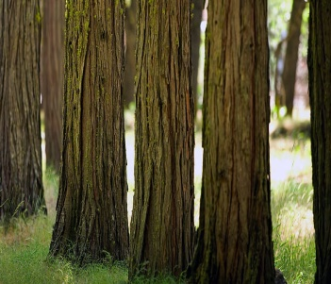

The main function of the stem is to hold the plant upright and support its branches.

The stems of neem and coconut trees are hard, strong and woody. They keep the trees upright. Such a stem is called a trunk.

The stem of the money plant is soft, green and weak. It needs support to stay upright.

The stem also carries water from the roots to the leaves. | Weak stem  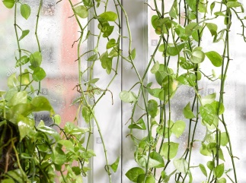

The stem also carries the food made by the leaves to different parts of the plant.

In plants like sugarcane, extra food is stored in the stem.

In plants like the potato and the ginger the stem grows underground and stores extra food.

THE LEAF

The most important part of the shoot is the leaf.
Description | Picture
The flat and broad part of a leaf is called the leaf blade or lamina. | 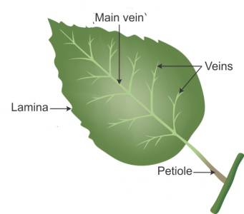

In the middle of the leaf is the main vein. A number of side veins branch out from the main vein. The veins carry water to the leaf.

The green leaf makes food for the plant with the help of air, water and sunlight. This process is called photosynthesis. The leaf is called the kitchen or the food factory of a plant.

Leaves help a plant to prepare its own food, breathe and give out extra water.

THE FLOWER

The flower is the most beautiful part of a plant.

Description | Picture
The flowers grow into fruits. | 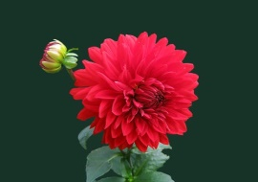

FRUITS AND SEEDS
Description | Picture
Fruits have seeds inside them. Some have one seed and others have many seeds. There are very few fruits that have no seeds. | 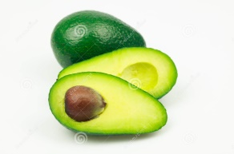
 | 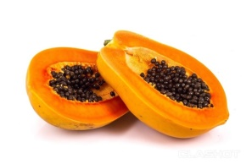

MOST PLANTS GROW FROM SEEDS

Description | Picture
Most new plants grow from seeds. Seeds are protected inside the fruit | 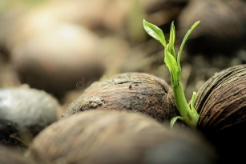

There is a baby plant and its food inside the seed of the mother plant.

The seed gets enough air, water and warmth which help the baby plant to grow into a fully grown plant. Banana seeds do not grow into new plants.

Teacher’s note:

Make a poster on ‘Save Plants and Save Life’.

Imrove your G.K.:
- An average size tree can provide enough wood to make 1, 70, 100 pencils.
- 85% of plant life is found in the ocean.
- Cricket bats are made of a tree called Willow and baseball bats are made out of the wood of the Hickory tree.
- Apple, Pears, Peaches, Apricots and Strawberries are members of the rose family.
- The first potatoes were cultivated in Peru about 7,000 years ago.
- Bamboo is the fastest growing woody plant in the world.

Let us answer:
- Tick () the correct answer.

1. In addition to the stem, branches, leaves and buds, the shoot of a plant bears.
a. flowers and roots b. fruits and roots c. flowers and fruits.

2. We eat the leaves of this plant.
a. potato b. tomato c. spinach

3. The stem of this plant is soft, green and weak.
a. neem b. coconut c. money plant

4. The leaf of a plant is called its
a. bathroom b. kitchen c. bedroom

5. Most fruits have these inside them.
a. beads b. seeds c. seats.

B. Match the statement with the correct picture.

1. | It fixes the plant in the soil. | 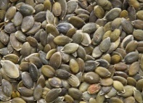
2. | It takes water from the roots to the leaf. | 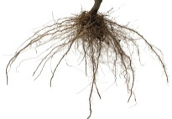
3. | It makes food for the plant | 
4. | It changes into a fruit. | 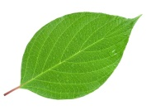
5. | It grows into a new plant | 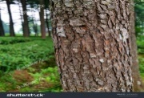

C. In which figure, are the parts of the plant correctly labelled?
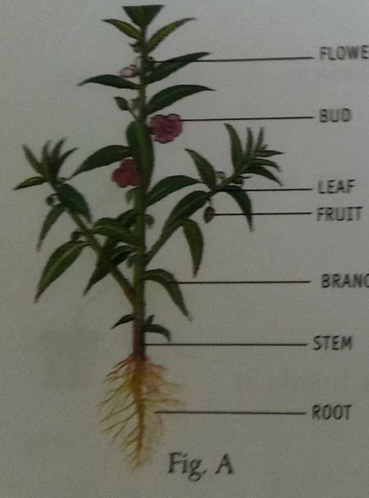 | 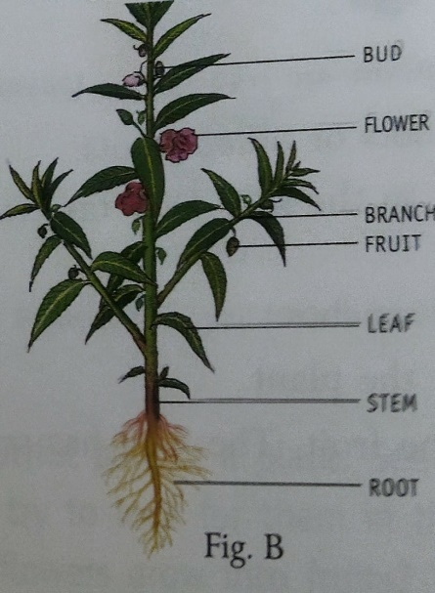 | 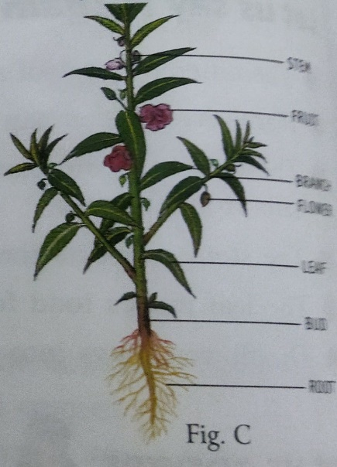

D. Read the clues and unscramble the letters to get the names of the parts of the plant. Write the names on the blanks.
S. No | Clues | Unscrambled word | Fill in the blanks
1. | It grows above the ground | TEMS
2. | It makes the food for the plant. | FEAL
3. | Most flowers grows into these | RUITSF
4. | It grows below the ground | TORO

E. Fill in the right words in the empty boxes.
We eat the stem of
Tap root is found in

balsam
ginger

F. Answer these questions.
1. How is the root of a plant different from its shoot?
2. Write two functions of the root.
3. What are the uses of the stem?
4. What does a seed need to grow into a plant?
Answer key
A. 1.c, 2.c, 3.c, 4.b, 5.b.

B. Match the statement with the correct picture.
1. | It fixes the plant in the soil. | 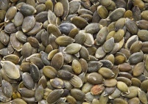
2. | It takes water from the roots to the leaf. | 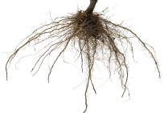
3. | It makes food for the plant | 
4. | It changes into a fruit. | 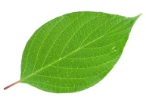
5. | It grows into a new plant | 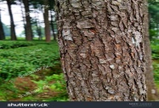

C. In which figure, are the parts of the plant correctly labelled?

Ans. Fig B.
D. Read the clues and unscramble the letters to get the names of the parts of the plant. Write the names on the blanks.
S. No | Clues | Unscrambled word | Fill in the blanks
1. | It grows above the ground | TEMS | STEM
2. | It makes the food for the plant. | FEAL | LEAF
3. | Most flowers grows into these | RUITSF | FRUITS
4. | It grows below the ground | TORO | ROOT

E. Fill in the right words in the empty boxes.
We eat the stem of
Tap root is found in

balsam
potato
mustard
sugarcane
ginger
bean

F. Answer these questions.
1. The part of a plant which grows above the ground is called the shoot and the part of the plant which grows below the ground is called the root.
2. The two functions of the root are -
- The root fixes the plant in the soil.
- It helps the plant to take water and salt from the soil.

3. The uses of the stem are –
- The stem holds the plant upright and supports the branches.
- The water taken by the roots travels through the stem to leaves also the stem carries the food made by leaves to different parts of the plant.
4. A seed needs air, water and warmth to grow into a plant.

<><><><><>

