Chapter- 4
Living and Non-Living
STUDY NOTES

LET’S LEARN:

- Our Earth is full of wonderful things.

- Some of the things are made by humans. They are called man-made things like cars, buildings, roads and bridges etc.

- Things like animals, plants, rocks, clouds, the sun, the moon and the stars have not been made by humans. They are natural things.

- Living things differ from non-living things in many ways.


LIVING THINGS MOVE:

- The movement of living things shows that they are alive.
- Animals use different body parts like dogs and cats walk, fish swim, birds and insects fly.
- Plants like the ‘touch-me-not’(Mimosa) show slow movement. The sunflower turns towards the sun. Only living things move on their own.
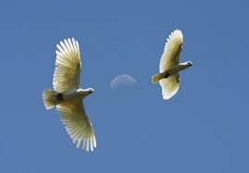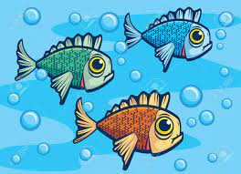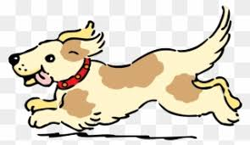
BIRD FISH DOG

LIVING THINGS GROW:
- Our body has been changing from the day we were born.
- A human baby grows into an adult, a chick grows into a hen and baby plant grows into a tree.
- All plants and animals grow and change. All living things grow.
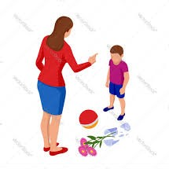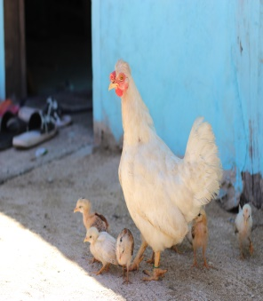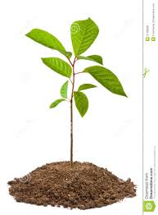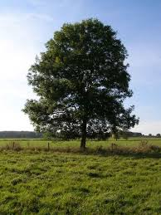
LIVING THINGS GROW
LIVING THINGS NEED FOOD:
- Living things need energy to grow, move and keep their body fit and healthy.
- Most plants make their own food with the help of air, water and sunlight.
- Animals move in search of food from place to place. Only living things need food.

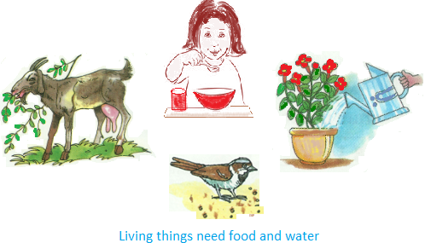
LIVING THINGS NEED FOOD
LIVING THINGS FEEL:
- All living things can feel.
- Different living things have different body parts like sense organs, feelers etc. to feel changes around them.
- A cat purrs, a dog barks at a stranger.

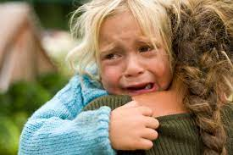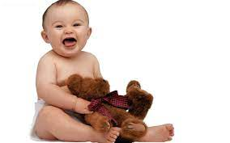
LIVING THINGS FEEL

LIVING THINGS BREATHE:
- All living things need air to breathe.
- Living things have special body parts to help in breathing.
- Animals have lungs, gills, air holes and stomata to breathe.
- Only living things breathe.

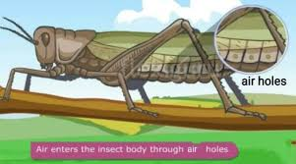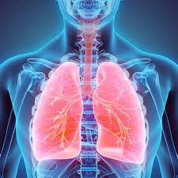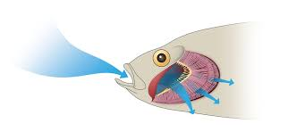
LIVING THINGS BREATHE

LIVING THINGS REPRODUCE:
- All living things produce young ones.
- The process of producing young ones is called reproduction.
- All animals give birth to their young ones or lay eggs.

MEMORY MAP

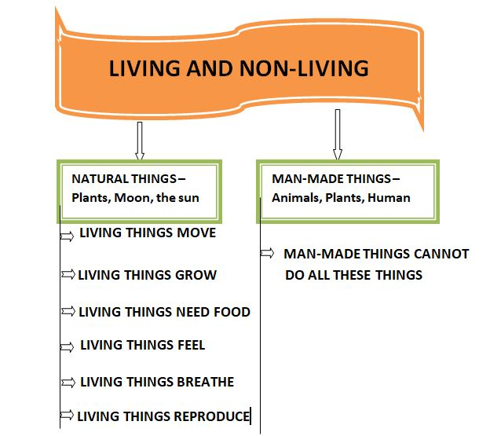

LET’S KNOW MORE:

I. Name them.
a. Body parts that help a fish to swim in water.
b. To react to something that happens.
c. The process by which living things produce more of their kinds.
d. The organs that help animals to feel the changes around them.
e. The body part that helps you to breathe.

LET US ANSWER:

- Unscramble the words on the train and write them in the correct places.

EELHAPNT EETR PCU ELNPCI ARINT NUS

Natural things - _______________ _____________ ________________

Man-made things - _______________ _______________ _______________

- Tick ( √) the correct answer

- These are living things.

- Plants b. tables c. stones

- These are man-made things.

- clouds b. stars c. roads

- These are natural things.

a. bridges b. stars c. cars

- Living things

- grow b. do not breathe c. do not need food

- Answer these questions.
1. What are man-made things? Give three examples.
2. What are natural things? Give three examples.
3. Why do living things need food?
4. Why do you need to breathe? Name two organs that animals use to breathe.

TEACHER’S NOTE:
- Make paper bags by using old new papers or a pencil holder by using old plastic bottle and decorate it.

IMPROVE YOUR GK:
- Ants are living creatures which will never sleep.
- A human bones are about 5 times stronger than steel.
- Unlike fingerprints, the human tongue also has its own unique print.
- Human teeth are the only part which cannot repair themselves

ANSWER KEY:
I. 1. Fish and tail
2. Respond
3. Reproduction
4. Sense organs
5. Nose

- Natural Things – Elephant, Tree, Sun
Man- made Things – Cup, Pencil, Train

- 1.a. plants
2.c. roads
3.b. stars
4.a. grow

C. 1. Things which are made by humans are called man-made things. Ex.-Cars, Bridges,
Roads.

2. Things which are given by the nature to us are called natural things. Natural things
include the sun, the moon and the stars.

3. Living things need food to live and to get energy.

4. We cannot live without breathing. Two organs that animals use to breathe are lungs,
gills.
<><><><><>

