[PRECIOUS SOIL]
SCIENCE | CLASS III

Chapter- 3

Precious Soil
STUDY NOTES
Let’s learn

SOIL FORMATION:


- In the beginning there was no life on earth. It was covered with hard rocks.

- The sun heated up the rocks. The rain cooled them and the wind blew over them. Thiscontinued for millions of years. As a result, the rocks broke up into small pieces.

- These small pieces broke further into smaller pieces. They were carried around by windand water. The pieces rubbed against each other till they became tiny particles of soil.

- The action of the sun, the rain and the wind broke up the rocks to make soil. It tookmillions of years for this to happen.
WHAT DOES SOIL CONTAIN?

- The soil contains humus, clay, sand, stones, moisture and air. The parts of dead plants andinsects are called humus.

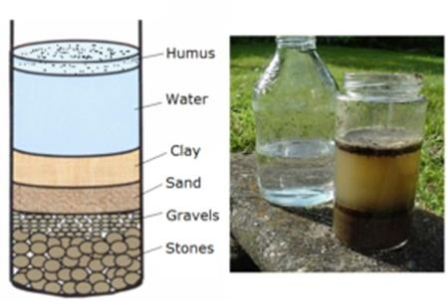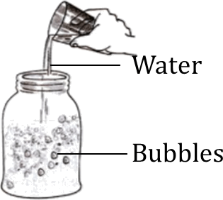

[PRECIOUS SOIL]
SCIENCE | CLASS III

TYPES OF SOIL:

- Generally there are three types of soil found. They are Sandy soil, clayey soil and loam.

- Sandy soil is generally found in the desert and on the seashore. Sand particles are big.There is a lot of air in the space between these particles. It does not hold much water.
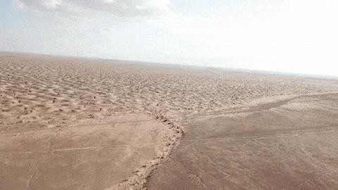

DESERT SEA SHORE

- Clayey soil is sticky and is mostly used for making pots and toys. Clay particles are veryfine. There is no space for air between the particles. It can hold a lot of water.
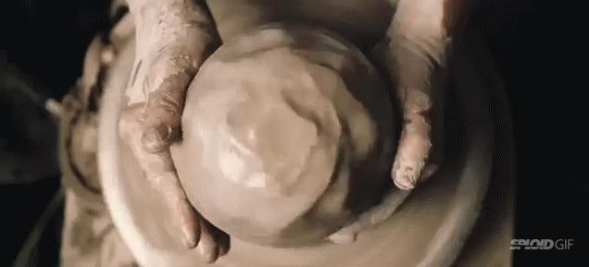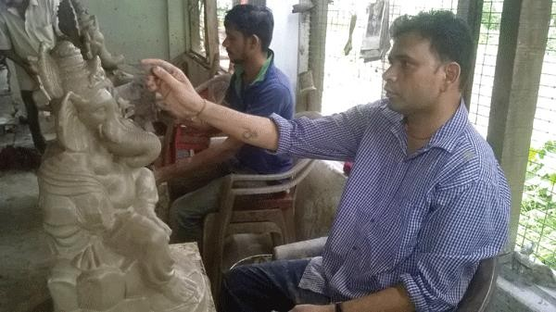

CLAYEY SOIL USED BY POTTER CLAYEY SOIL USED IN IDOL MAKING

- Loam is a mixture of sand and clay. It can hold both air and water. It has a lot of humus. Loam is the best soil for plants because it contains air, water and humus. Humus make the soil fertile.

[PRECIOUS SOIL]
SCIENCE | CLASS III

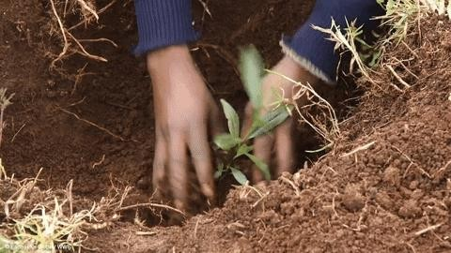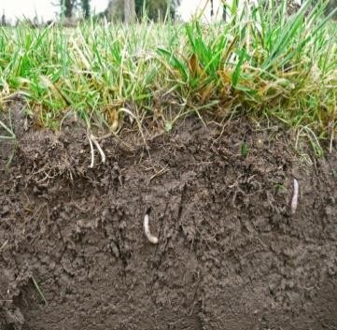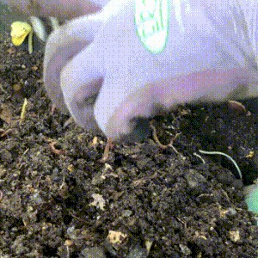

PLANTING IN LOAM SOIL
SOIL AND CROPS

- Different type of crops grows in different types of soil.
- Some needs sandy soil while some need clayey soil and others need loam.

- All types of crops grow better when manure is added.
- Manure contains cow dung and decaying leaves. Manure is added because it is rich in humus and it makes the soil fertile.

MEMORY MAP
SOIL FORMATION
DUE TO THE ACTION OF SUN, WIND AND RAIN
Soil contains stones, sand, clay and humus
soil contains water and air
PRECIOUS SOIL

TYPES OF SOIL –
LOAM IS A MIXTURE, SAND AND CLAY
STICKY AND MOSTLY USED BY POTTER
SANDY SOIL HAS LOT OF AIR AND HOLD MUCH WATER

[PRECIOUS SOIL]
SCIENCE | CLASS III

Let’s know more

Give answer in one word.

  - Formed by the breaking up of rock.

  - Particles are big and a lot of air in the space between these particles.

  - This soil can hold a lot of water.

  - This soil is a mixture of soil and clay.

  - It contains cow dung and decaying leaves.

  - The dead parts of plants and animals.

Let us Answer

Tick ( √) the correct answer.

  - Their action broke up the rocks to make soil.

a. sun and rain b. rain and wind c. sun, rain and wind.

  - The soil is sticky and mostly used for making pots and toys.

- Sandy b. clayey c. loam

  - This makes the soil rich and fertile.

- Money b. humus c. heat

  - The soil is best for plants.

- Sandy b. clayey c. loam

Fill in the blanks.

  - Different types of soils are clayey soil, _ soil and
soil.

  - Soil contains _ and stones.

[PRECIOUS SOIL]
SCIENCE | CLASS III

- Answer these questions.

  - How do rocks change to soil?

  - Is the size of the particles same in different types of soil? Explain.

  - How will you show that soil contains moisture?

  - What are the different kinds of soil?

  - Why do farmers add manure to the soil?

Teacher’s Note:
Reuse old cardboard cartons to make a dustbin for your room.

Improve your GK:

- It takes 500 years to produce just under an inch of top soil, this is the most productivelayer of soil.
- Soil is a living system.
- Soil acts as a filter for underground water, filtering out pollutants.
- Soil is at the bottom of the food chain, yet it is the corner stone of the life on earth.
Answer key:

I.

- soil

- sand

- clayey

- loam

- manure

- humus

[PRECIOUS SOIL]
SCIENCE | CLASS III

A.
1.c-sun, rain and wind 2.b-clayey
3.b-humus 4.c-loam

B.
- Sandy, loamy
- humus, clay, sand

C.
- In the beginning, the earth was covered with hard rocks. The action of the sun, the rain and the wind broke up the rocks to make soil.

- No, the size of the particles is not same in different types of soil. Different types of Soil have particles of different sizes. Some contain more water, others contain more air.

- To show that soil contains moisture put some soil in a small tin. Cover it with a lid. With the help of an adult, heat the tin on a low flame. You will see small droplets of water forming on the underside of the lid. This proves that soil has moisture in it.

- The different kinds of soil are – Sandy Soil, Clayey Soil and Loamy Soil.

- Farmers add manure to the soil because it is rich in humus and it makes the soil more fertile.

<><><><><>

