Chapter- 8
My Home
WORKSHEET
Q1. Fill in the blanks with the correct word from the bracket.
1. We _________ (play/cook) in the kitchen.
2. The house we live in with our family is our __________ (home/school).
3. Our house ___________ (live/protect) us from the heat of the sun and rain.
4. We eat our meal in the __________ (dining/bath) room.
5. We live with our ___________ (family/friends) at our home.
Q2. Write the missing letter.
1. H _ M E
2. C O _ K
3. F A _ I L Y
4. D I N _ N G
5. B R _ C K S
Q3. Circle the odd one.
1. Bed sleep cook
2. Mud flats straw.
3. Bath kitchen cook.
4. Family home school.
5. Bedroom bathroom playground.

Q4. Match the following.
A B
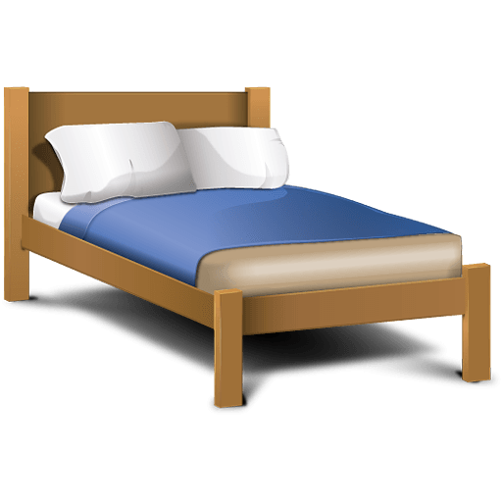 Kitchen
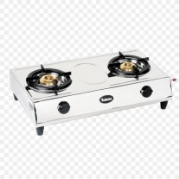 Bedroom
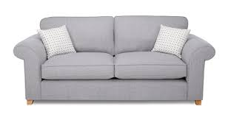 Bath room
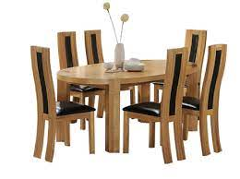 Drawing room
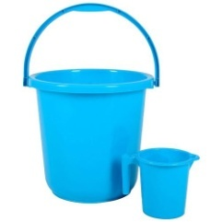 Dining room

